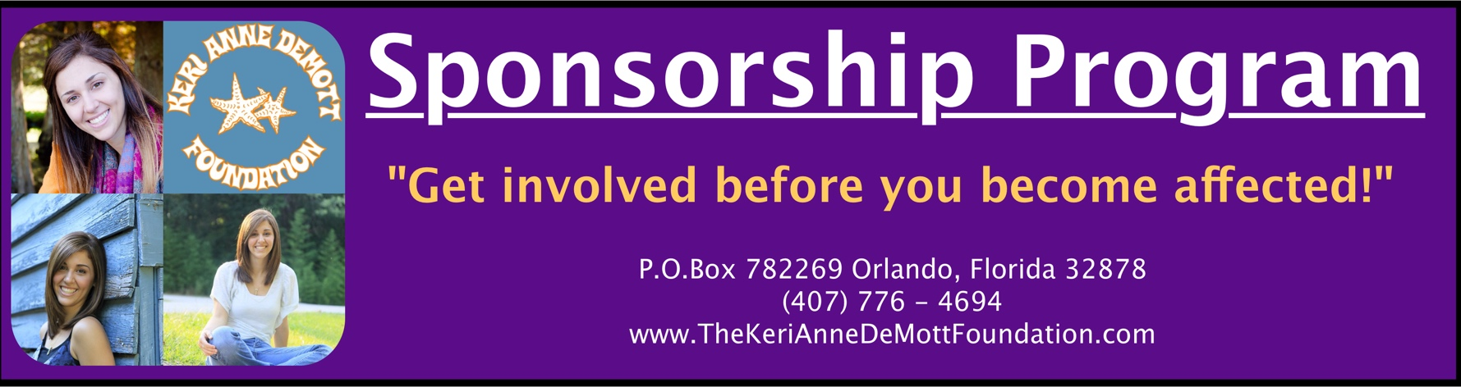

The Keri Anne DeMott Foundation
501(c)3 non-profit organization
Tax ID No.: EIN: 81-4288688

The Keri Anne DeMott Foundation was founded by the DeMott family after their twenty-year-old daughter and sister, Keri Anne, was tragically killed in a head-on collision caused by a multiple DUI offender.

As a non- profit organization, the foundation’s goal is to spread a message of education and awareness about the decisions we all make and how they affect others. By sharing Keri’s story with middle school, high school, and college students as well as community groups and local law enforcement agencies, we hope to create a positive change in the world and give back to the community in the same ways Keri had imagined doing herself.

To accomplish these goals, we are seeking the help and involvement of businesses, families, and sponsors throughout our community. We appreciate your time in reviewing our sponsorship packages. Your support will allow us to continue to grow and spread a positive, lifesaving message to all. You will be helping us #ChangeTheWorld in Keri’s name.

Thank you so much for your sponsorship consideration. Please feel free to contact us with any questions.

Lacey DeMott, Secretary

Email: ldemott@thekeriannedemottfoundation.com

The Keri Anne DeMott Foundation

Sponsorship Packages 2019

#KeriAnneDeMottMatters - ($5,000+)
- 12-month sponsorship
- Listing on The Keri Anne DeMott Foundation website with link to your website
- Banner (provided by sponsoring business) at all foundation events
- Listing on Foundation’s Facebook page
- Framed certificate of sponsorship
- Automatic Sponsorship appearance in all events held during sponsorship period
- 2 tickets to event(s) held during sponsorship period
- 4 tickets to the Annual Dinner banquet

Keri’s Promise - ($2,500)
- 12-month sponsorship
- Listing on The Keri Anne DeMott Foundation website with link to your website
- Banner (provided by sponsoring business) at all foundation events
- Listing on Foundation’s Facebook page
- 2 tickets to the Annual Dinner banquet

Changing the World - ($1,000)
- 12-month sponsorship
- Listing on The Keri Anne DeMott Foundation website with link to your website
- Listing on Foundation’s Facebook page

Decisions – ($500)
- 6-month sponsorship
- Listing on The Keri Anne DeMott Foundation website with link to your website

*Logos for website and Facebook to be provided to the Foundation by sponsor*
The Keri Anne DeMott Foundation Sponsorship Package 2019

Please complete the following:
Company Name: ________________________________________________________
Contact Person: _________________________________________________________
Email Address: __________________________________________________________
Mailing Address: ________________________________________________________
Phone (Business): ________________________ (Cell): __________________________
Website: _____________________________________ Date: _____________________

Please check sponsorship package below:
_________ #KeriAnneDeMottMatters – ($5,000+)
_________ Keri’s Promise – ($2,500)
_________ Changing the World – ($1,000)
_________ Decisions – ($500)

Please make checks payable to:

The Keri Anne DeMott Foundation
P.O. Box 782269, Orlando Florida 32878. (Attn: Kathy Gelm)

Logos can be emailed to:

Casey DeMott - cdemott@thekeriannedemottfoundation.com

#KeriAnneDeMottMatters

