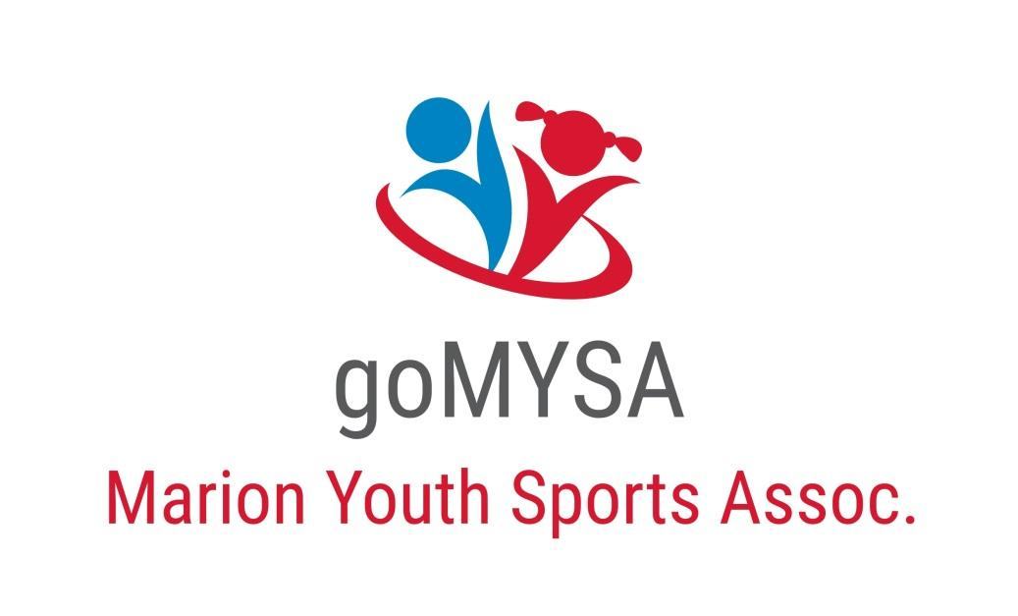

Youth Volleyball League Rules

Objective and Goals:
MYSA’s Volleyball program is designed to give all participants through participation in practices and games, the opportunity to learn and improve the fundamentals of the game of volleyball as well as increase socialization opportunities among players.
Playing Court and Equipment
- The net height will be approximately 7 foot.
- Volley Lites will be used. (official size)
- Both age groups will play full-sized boundaries.
- Coaches will not be on the court during games.
- Players are required to wear knee pads.
- All jewelry must be removed for games.
Game Play
- All games will be rally-scored, meaning a point will be awarded to one team after each play. The 1st two sets will be played to 25 and you must win by two. Each set will have a 15min time limit. If a 3rd set is necessary, it will be played to 15 and you must win by two, however there will be a 15min max during the third set as well.
- A single player will only be allowed to serve up to 5 consecutive points.
- Each team is allowed a maximum of 3 hits to return the ball to the opponents.
  - A hit includes both intentional and unintentional contact with the ball.
- It is a violation to touch the net except for insignificant contact by a player not involved in the action of playing the ball.
General Rules:
- The game officials and employees have the right to eject any player, coach, or spectator acting unsportsmanlike or not following MYSA’s code of conduct.
- Participants must accept referees’ decisions without unsportsmanlike conduct and without dispute. In case of doubt, a clarification may be requested by the coach only.
- Coaches must rotate players before each serve except for the opening serve of the game.
  - Exception: players may be substituted anytime in the case of an injury.
- Rotation must occur in a clockwise direction with the new player rotating in as the server.
- Substitutions will only be allowed for injuries.
- A team must have 4 players to start the game. A five min grace period will be allowed
  - Teams may use players from another team if they have less than 6 players. The player must be registered with MYSA and in the same age group. This does have to be approved by the opposing coach.
- Each team will have one 30 second time out per set.
- If the ball hits the ceiling and remains on the same side of the court, it is still in play. If it hits the ceiling and bounces to the other side of the court, it is considered out of bounds and a point will be awarded to the other team.
  - Lights, rafters, basketball goals and anything else attached to the ceiling counts as part of the ceiling.
- All bleachers and walls are considered out of bounds.
- A player can never touch the net while the ball is in play. A foul will be called
- A player may play the ball off of the net, but if a player’s hand or foot crosses the plane of the centerline, it is a violation.
- If the ball hits the boundary line it is considered IN.
- A ball that hits the net but continues to the opponent’s side is permitted.
- Double hits are illegal.
- Players will be expected to use proper volleyball techniques. Two handed, open palm hits or throwing hits will not be allowed.
- Referee’s discretion- if a player is attempting to perform a skill properly, but fails to accomplish it correctly, the official may allow the hit and subsequent point if won. Incidental hits may be considered legal. This is a judgment call of the Referee and it MAY NOT be argued.
Serving
- A coin toss at the start of the 1st and 3rd set will determine who serves first.
- Let serves are allowed. A let serve is a serve that hits the net but still goes over the net and is inside of the boundaries.
- Both feet of the serving player must be behind the designated serving line for his/her age group.
- Players must wait for the whistle from the referee to serve.
- Players may not attack or block the serve
- The server may move freely with in the service zone.
- In the case of a bad toss, the serving player may not touch the ball before it hits the ground.
  - If the ball is touched before hitting the ground, a side out is called, and a point will be awarded to the other team.
  - After the service error, the referee must authorize the service again.
  - One service tossing error is permitted for each service.
- Players may serve underhanded or overhanded at all age levels

MYSA officials HAVE the authority and WILL do whatever it deems necessary to ensure it does what is in the best interest of the league and the children playing in the league. ANY MYSA BOARD MEMBER HAS THE AUTHORITY TO EJECT A COACH, PLAYER OR FAN FOR ANY UN-SPORTSMANLIKE ACTIONS THAT ARE DEEMED TO BE OF A FLAGRANT NATURE AND ARE DETRIMENTAL TO THE MARION YOUTH SPORTS ASSOCIATION’S YOUTH PROGRAMS A board member present at any function has final say in any situation at any function.

