Course / Subject Code: BC02001031
Course / Subject Name: Advanced Web Technology
Category of the Course: Minor Elective Subject
Total Hours: 45
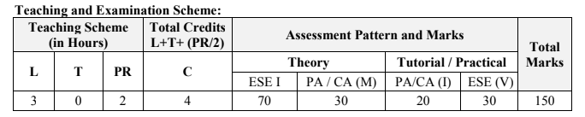
Course / Subject Code: BC02001061
Course / Subject Name: Data Analytics using Spread Sheet
Category of the Course: Skill Enhancement Courses
Total Hours: 45
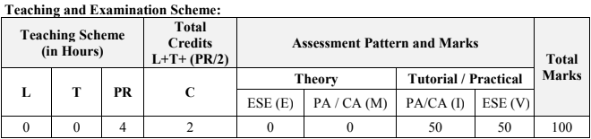
Course / Subject Code: BC02001021
Course / Subject Name: Database Management System
Category of the Course: Core Courses
Total Hours: 45
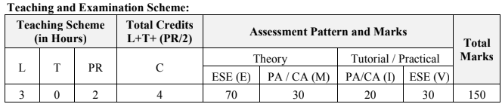
Course / Subject Code: BC02001011
Course / Subject Name: Data Structure
Category of the Course: Core Courses
Total Hours: 45
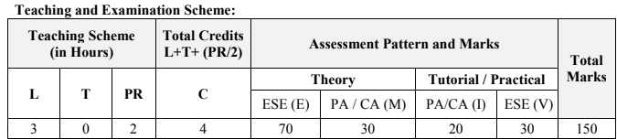
Course / Subject Code: BC02001051
Course / Subject Name: Mathematics-2
Total Hours: 45
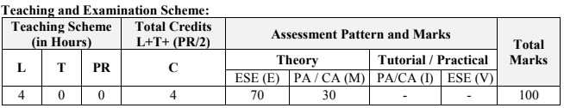
Course / Subject Code: BC02001081
Course / Subject Name: Professional Ethics
Category of the Course: Value Added Courses
Total Hours: 30
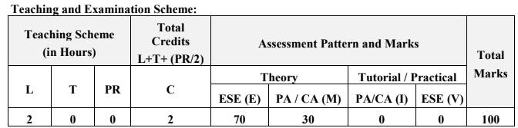
Course / Subject Code: BC02001071
Course / Subject Name: Technical Writing
Category of the Course: Ability Enhancement Courses
Total Hours: 25
