T&S Associates, LLC

Jay Trott-Owner Chuck Steely-Owner PH: 256-658-8613 PH: 919-609-0320

James.Trott@tssalesrep.com Chuck.Steely@tssalesrep.com
_________________________________________________________

Surface Mount Components: Ceramic capacitors, Choke coils, Ferrite beads, Resistors, Inductors, LED’s, Tantalum capacitors, and Thermistors

EMI Solutions is a manufacturer of filters and filtered connectors, including our revolutionary FlexFilter technology, for the military and aerospace supply chains, as well as commercial applications..

Circuit Services Worldwide is a Full-Service ISO Certified Circuit Board Fabricator. We provide a one stop shop that can schedule production for your long-range projects as well as provide top quality prototypes in 12, 24, 48, or 72 hours. Multiple manufacturing locations in Taiwan and China.

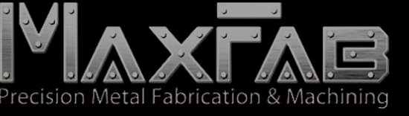

MaxFab is a full- service precision sheet metal fabricator and high -tech CNC machining provider. We offer all high tech, precision,
sheet metal fabrication solutions including CNC punching, machining, forming, stamping, welding, assembly, powder
coating, integration.

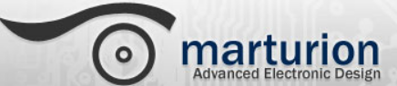

Marturion offers excellence in design of the latest electronic circuit technology and associated embedded software extensive workshop services for prototyping and testing together with a small MDD compliant production facility within which
we can manufacture small batches of product for clients.

XDry Corp a leading supplier of humidity-controlled storage cabinets for manufacturing, laboratories. XDry’s cabinet
environment can be maintained from ambient to 1% RH, providing constant and stable storage precisely the correct RH level

.

Products for the manufacturing of electronics from the circuit board assembly through final tested products. Distributor, Assembly, Component Preparation, Pick and Place, Selective Soldering.

