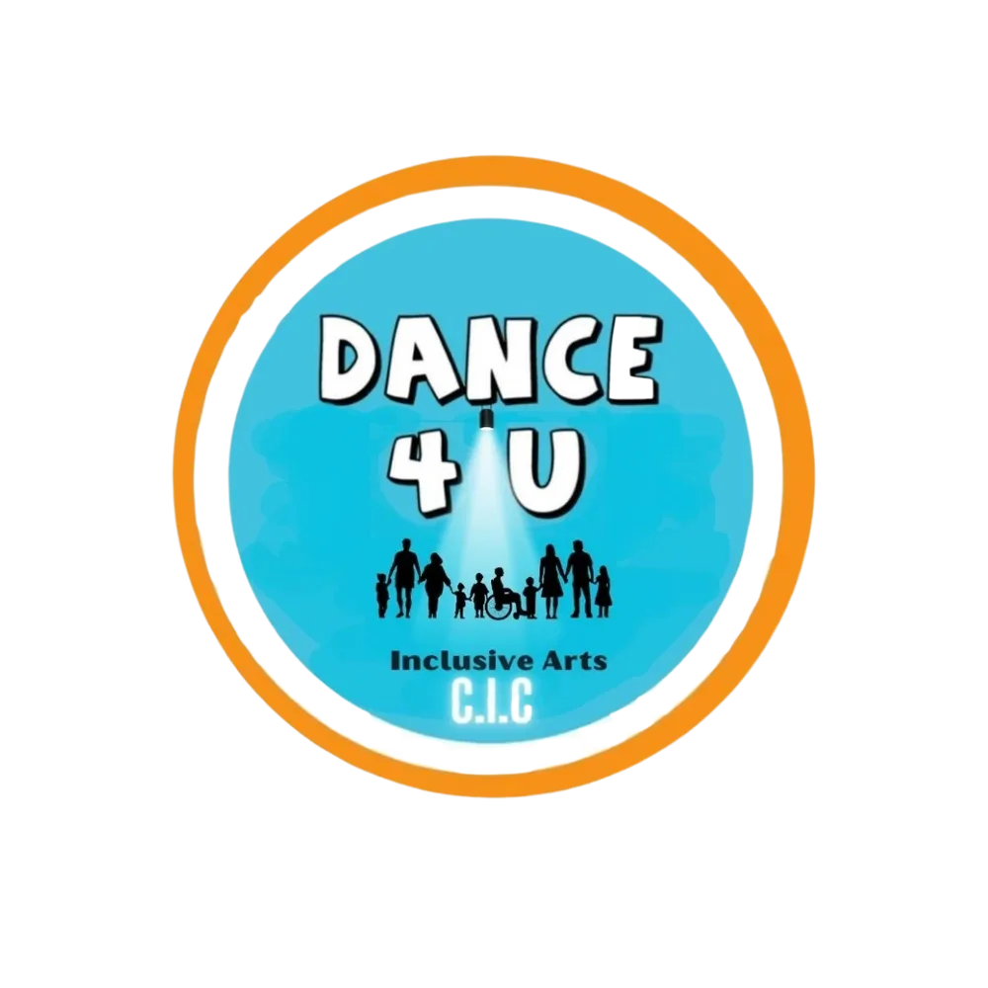
DANCE4U
INCLUSIVE ARTS CIC
SAFEGUARDING CHILDREN, YOUNG PEOPLE AND ADULTS AT RISK POLICY
Including disabled children, young disabled adults and adults at risk

Organisation | Dance4U Inclusive Arts CIC
Policy / procedure owner | Emily Bollard, Founder / Director / Designated Safeguarding Lead
Version | 1.1
Effective date | September 2026
Review date | September 2027, or sooner following legislative, statutory guidance or organisational change
Applies to | Directors, staff, sessional workers, contractors, volunteers, students/placements and anyone acting on behalf of Dance4U Inclusive Arts CIC

Contents
1. Policy Statement
2. Purpose
3. Scope
4. Legal and Local Safeguarding Framework
5. Safeguarding Principles
6. Age Framework and Adult-at-Risk Definition
7. Safeguarding Disabled Participants and Accessible Communication
8. Types of Abuse, Neglect and Exploitation
9. Recognising Possible Signs
10. Additional Safeguarding Concerns
11. Roles and Responsibilities
12. Designated Safeguarding Lead (DSL)
13. Reporting and Referral Principles
14. Responding to Disclosures
15. Early Help and Right Help Right Time
16. Allegations Against Staff or Volunteers
17. Historical Allegations
18. Child-on-Child Abuse
19. Online and Digital Safeguarding
20. Dance, Movement, Physical Contact and Therapeutic Practice
21. Professional Boundaries and Safer Working
22. Personal Care, Medication and Support Needs
23. Confidentiality, Information Sharing and Records
24. Safer Recruitment and DBS
25. Training
26. Photography, Filming and Social Media
27. Equality, Inclusion and Accessible Safeguarding Information
28. Whistleblowing and Escalation
29. Partnership Working and Host Venues
30. Emergency Procedures
31. Key Contacts
32. Related Policies
33. Compliance, Monitoring and Review

1. Policy Statement
Dance4U Inclusive Arts CIC is committed to safeguarding and promoting the welfare of children, young people and adults at risk who engage with our organisation. We provide inclusive dance, movement, performing arts, online learning, therapeutic movement, fitness and community-based activities. Every participant has the right to feel safe, respected, listened to and protected from abuse, neglect, exploitation and harm.
Safeguarding is everybody’s responsibility. All concerns, allegations and disclosures will be taken seriously, responded to promptly and handled in a child-centred or person-centred, proportionate and confidential manner.
Mandatory requirement: All workers are required to follow this policy and the separate Dance4U Safeguarding Procedure. Failure to follow safeguarding requirements may result in formal disciplinary, contractual or organisational action.
2. Purpose
• protect children, young people and adults at risk connected with Dance4U activities;
• provide clear safeguarding standards for all workers and volunteers;
• ensure concerns are recognised, reported, recorded and referred without delay;
• promote safe, inclusive, accessible and professional practice;
• support early help and appropriate statutory referral;
• ensure disabled participants and people with communication differences are heard and supported;
• create a culture in which abuse, neglect, exploitation, discrimination and poor practice are not tolerated.
3. Scope
This policy applies to all directors, employees, self-employed or sessional practitioners, contractors, volunteers, students/placements and anyone acting on behalf of Dance4U Inclusive Arts CIC. It applies to:
• face-to-face and online sessions;
• schools, colleges, community and partner venues;
• one-to-one activity, workshops, performances and holiday programmes;
• dance, movement, fitness, wellbeing and therapeutic practice;
• photography, filming, social media, messaging and digital communication;
• safeguarding information received through Dance4U work, whether or not the concern arose during a Dance4U session.
4. Legal and Local Safeguarding Framework
Dance4U works in line with applicable safeguarding law, statutory guidance and local procedures in the area where activity takes place. In England this includes, as applicable:
• Children Act 1989 and Children Act 2004;
• Working Together to Safeguard Children;
• Care Act 2014 and Care and Support Statutory Guidance;
• Mental Capacity Act 2005 and Code of Practice;
• Safeguarding Vulnerable Groups Act 2006 and DBS requirements;
• Equality Act 2010;
• Human Rights Act 1998;
• Data Protection Act 2018 and UK GDPR;
• local Safeguarding Children Partnership and Safeguarding Adults Board procedures.
For Birmingham-based work, Dance4U will follow Birmingham safeguarding procedures, including the Children’s Advice and Support Service (CASS) referral route and the Right Help Right Time framework where relevant.
5. Safeguarding Principles
Child/person-centred: Listen, take communication seriously and focus on safety, wishes and welfare.
Prevention: Create safe environments, accessible information and clear professional boundaries.
Protection: Act promptly and involve statutory agencies when required.
Empowerment: Support choice, communication and informed decision-making wherever safe and legally appropriate.
Proportionality: Use a response proportionate to risk while never minimising safeguarding concerns.
Partnership and accountability: Work appropriately with families, carers, venues, commissioners and statutory agencies, and keep clear records.
6. Age Framework and Adult-at-Risk Definition
• A child is anyone under 18. This includes any 16- or 17-year-old attending a programme described as a young adult or disabled adult programme.
• An adult is anyone aged 18 or over.
• An adult at risk is generally an adult who has needs for care and support, is experiencing or at risk of abuse or neglect, and because of those needs is unable to protect themselves from that abuse, neglect or risk.
Disability, autism, learning disability, mental health condition or communication difference does not automatically mean an adult lacks capacity or is an adult at risk.
7. Safeguarding Disabled Participants and Accessible Communication
Dance4U recognises that disabled children, young people and adults may face increased safeguarding risks or additional barriers to disclosure. Staff must not assume that an injury, distress, behavioural change, communication difficulty or dependence on another person is simply part of a participant’s disability.
• use the participant’s preferred communication method wherever possible;
• provide plain English, Easy Read, visual supports, symbols, AAC, signing, interpreters or other suitable formats depending on learning and communication needs;
• allow additional processing time and avoid rushing disclosures;
• seek the participant’s own views wherever possible, even where a parent, carer or support worker assists with communication;
• record communication needs and reasonable adjustments used.
8. Types of Abuse, Neglect and Exploitation
• physical abuse;
• sexual abuse, harassment, grooming or exploitation;
• emotional or psychological abuse;
• domestic abuse and coercive control;
• neglect and acts of omission;
• financial or material abuse;
• discriminatory abuse and hate crime;
• organisational abuse or unsafe practice;
• modern slavery, trafficking and forced labour;
• online abuse, cyberbullying, image-based abuse and sextortion;
• mate crime and exploitation through apparently friendly relationships;
• self-neglect in adults where safety or wellbeing is at serious risk.
9. Recognising Possible Signs
Indicators are not proof on their own, but may require safeguarding action. Possible signs include unexplained injuries, repeated accidents, sudden fearfulness or withdrawal, distress around a particular person, changes in behaviour, frequent absence, poor hygiene, missing medication or equipment, missing money or possessions, sexualised behaviour, unexplained infections, controlling companions, restricted access to communication, changes in online behaviour or any disclosure made verbally, in writing, through behaviour or through another person.
Staff and volunteers are not expected to investigate. They must report concerns promptly and remain professionally curious.
10. Additional Safeguarding Concerns
• child sexual exploitation (CSE);
• child criminal exploitation (CCE), county lines and trafficking;
• radicalisation and extremism;
• bullying and cyberbullying;
• honour-based abuse, forced marriage and female genital mutilation (FGM);
• peer/child-on-child abuse;
• stalking and harassment;
• mental health concerns, self-harm and suicidal ideation;
• historical allegations of abuse.
11. Roles and Responsibilities
All staff and volunteers must:
• report safeguarding concerns immediately to the DSL/Director;
• take concerns, allegations and disclosures seriously;
• record concerns accurately and promptly;
• follow local safeguarding procedures for the area in which they are working;
• maintain professional boundaries and attend required safeguarding training.
Staff and volunteers must not investigate, delay reporting or promise confidentiality.
12. Designated Safeguarding Lead (DSL)
The Designated Safeguarding Lead for Dance4U Inclusive Arts CIC is Emily Bollard, Founder / Director.
• receive and manage safeguarding concerns;
• assess risk and ensure immediate safety;
• make or oversee referrals to statutory agencies;
• liaise with Children’s Social Care, Adult Social Care, police, LADO and other safeguarding professionals;
• maintain clear, secure and confidential records;
• ensure safeguarding training and procedure updates are completed;
• promote safe practice and review safeguarding learning.
13. Reporting and Referral Principles
Any safeguarding concern must be reported to the DSL/Director without delay and recorded factually. Where there is immediate danger, urgent medical need or a serious crime in progress, emergency services must be contacted first.
For children in Birmingham, the DSL/Director will use CASS and relevant local procedures. If the DSL/Director is unavailable and a child safeguarding referral cannot safely wait, a worker must contact CASS or emergency services directly as appropriate and record the action taken.
For adults at risk, the DSL/Director will consider referral to the relevant Adult Social Care/safeguarding service, police, healthcare, domestic abuse, mental health or other specialist services.
14. Responding to Disclosures
Dance4U uses the 4 Rs as a simple response framework:
Receive: Listen carefully without interruption and accept what is being communicated.
Reassure: Reassure appropriately; do not blame and do not promise confidentiality.
React: Do not ask leading questions or investigate. Explain that safeguarding information must be shared with people who need to know.
Record: Make a factual record as soon as possible, use exact words where important, include date/time/context, and sign/date the record.
15. Early Help and Right Help Right Time
Where a child or family may benefit from support before statutory safeguarding thresholds are reached, Dance4U may work with or signpost to appropriate Early Help arrangements. In Birmingham, the Right Help Right Time framework may be used to support decision-making.
• an Early Help Assessment may be initiated where appropriate;
• family consent should be obtained for Early Help unless another lawful safeguarding basis requires action;
• a lead professional may be identified where multi-agency support is needed;
• Early Help must never be used to delay safeguarding action where a child may be at risk of significant harm.
16. Allegations Against Staff or Volunteers
Any allegation that a director, staff member, volunteer, contractor, student or other person working on behalf of Dance4U has harmed, may have harmed or behaved inappropriately towards a child or adult at risk must be reported immediately.
• the person who is the subject of the allegation must not control or conduct the safeguarding response;
• for allegations involving children, the DSL/Director must consider or make immediate contact with the appropriate LADO route and follow advice;
• no internal investigation should take place before safeguarding advice where this could compromise the statutory process;
• immediate proportionate risk-management measures may be taken;
• where the allegation concerns the DSL, it must be reported to another director or appropriate senior person who is not implicated.
17. Historical Allegations
Historical allegations must be taken as seriously as current allegations. The same reporting and recording requirements apply. The DSL/Director must consider referral to Children’s Social Care, Adult Social Care, police or other appropriate agencies and establish, where relevant, whether the alleged person causing harm currently has access to children or adults at risk.
18. Child-on-Child Abuse
Child-on-child abuse must be treated as a safeguarding issue, not dismissed as ordinary conflict or behaviour. Concerns must be reported immediately to the DSL and managed using the same safeguarding reporting and recording procedures. Support and safety planning should consider all children involved.
19. Online and Digital Safeguarding
• use approved platforms and professional accounts where possible;
• avoid inappropriate private messaging and maintain professional boundaries;
• report online concerns immediately;
• ensure content, chat and messaging remain appropriate;
• do not record sessions unless authorised and required consent is in place;
• protect personal information and manage online disclosures under the same safeguarding procedure as face-to-face concerns.
20. Dance, Movement, Physical Contact and Therapeutic Practice
Dance and movement can involve physical guidance, emotional expression and vulnerability. Staff must maintain professional boundaries, use consent-based and proportionate physical guidance, respect dignity and personal space, and respond appropriately to distress or disclosures.
• Physical contact must be necessary and appropriate to the activity, explained wherever possible and stopped if consent is withdrawn or distress is communicated.
• Therapeutic or wellbeing activity must not be used to investigate safeguarding concerns.
21. Professional Boundaries and Safer Working
• avoid humiliating, discriminatory, threatening, sexually suggestive or exploitative behaviour;
• avoid unnecessary isolated one-to-one situations;
• do not enter into sexual or exploitative relationships where there is a position of trust or power imbalance;
• do not borrow or lend money, sell personal goods/services to participants or accept significant gifts;
• do not use personal social media or private messaging in ways that blur professional boundaries;
• report accidental boundary breaches or situations that could reasonably be misunderstood.
22. Personal Care, Medication and Support Needs
Dance4U does not assume responsibility for personal or intimate care unless expressly agreed as part of a commissioned service with suitable consent, training, staffing and risk assessment. Responsibilities for medication and personal care must be clear before activity begins. Any safeguarding concern arising during personal care must be reported immediately.
23. Confidentiality, Information Sharing and Records
• share safeguarding information only on a need-to-know basis and only to the extent necessary;
• do not promise absolute confidentiality;
• store safeguarding records securely and confidentially;
• records must distinguish fact, observation, professional judgement and information reported by others;
• original contemporaneous notes must not be destroyed or altered; any later addition must be clearly dated;
• data protection law must not be used as a reason to withhold information where sharing is necessary and lawful to protect someone from harm;
• record the rationale for significant information-sharing decisions.
24. Safer Recruitment and DBS
Dance4U will use safer recruitment measures proportionate to the role, including identity, employment/activity history, references, qualifications, safeguarding questions and DBS checks at the level for which the role is legally eligible. Where a legal DBS referral duty arises, Dance4U will make the referral.
25. Training
All staff and volunteers must receive safeguarding training appropriate to their role and must:
• complete safeguarding training at least annually;
• undertake Right Help Right Time training where relevant to Birmingham child/family work;
• understand child and adult safeguarding routes, professional boundaries and accessible communication;
• follow updates to safeguarding law, local procedures and Dance4U procedures.
26. Photography, Filming and Social Media
Photography, filming and social media must follow Dance4U consent, data protection and safeguarding requirements. Images must not be taken or shared without required consent. Personal accounts and informal communication must not be used in ways that undermine professional boundaries.
27. Equality, Inclusion and Accessible Safeguarding Information
Safeguarding information will be made accessible according to individual learning and communication needs. Dance4U will provide different formats where appropriate, including plain English, Easy Read, visual or picture-based information, simplified step-by-step guidance, large text, AAC-compatible approaches, signing or interpretation.
The most appropriate format should be identified with the participant, parent/carer, advocate or support professional where appropriate.
28. Whistleblowing and Escalation
Any worker who believes a safeguarding concern is being ignored, minimised, concealed or handled inappropriately must raise the matter with another director or appropriate senior person who is not implicated. Genuine safeguarding concerns raised in good faith must not result in retaliation.
29. Partnership Working and Host Venues
Where a school, college, venue, commissioner or partner organisation has its own safeguarding procedure, Dance4U will follow both its own requirements and the host procedure, using the route that provides the quickest and safest safeguarding response. Local safeguarding procedures for the area of delivery must be followed.
30. Emergency Procedures
Emergency: In immediate danger, a life-threatening emergency or where a serious crime is in progress, call 999. Safeguarding action must not be delayed while seeking internal permission.
31. Key Contacts
Contact | Details
Designated Safeguarding Lead | Emily Bollard - Founder / Director
Email | emily@dance4u.info
Telephone | 07395 831938
Birmingham CASS | 0121 303 1888
Birmingham Children's Social Care out of hours | 0121 675 4806
Birmingham Adult Social Care | 0121 303 1234
Birmingham Adult Social Care out of hours | 0121 675 4806
Emergency services | 999
NSPCC Helpline | 0808 800 5000
32. Related Policies
• Safeguarding Procedure;
• Online Safety Policy;
• Complaints, Whistleblowing Concerns and Breaches of Code of Conduct Policy;
• Code of Conduct;
• Safer Recruitment / Staff and Volunteer arrangements;
• Equality, Diversity and Inclusion Policy;
• Data Protection and Information Sharing arrangements;
• Risk Assessment and Health & Safety arrangements.
33. Compliance, Monitoring and Review
All staff and volunteers are required to follow this policy and the Safeguarding Procedure at all times. Failure to do so may result in formal action.
This policy will be reviewed at least annually and sooner following changes to legislation, statutory guidance, local procedures, organisational arrangements or significant safeguarding learning. Safeguarding incidents and near misses will be used to improve practice.

