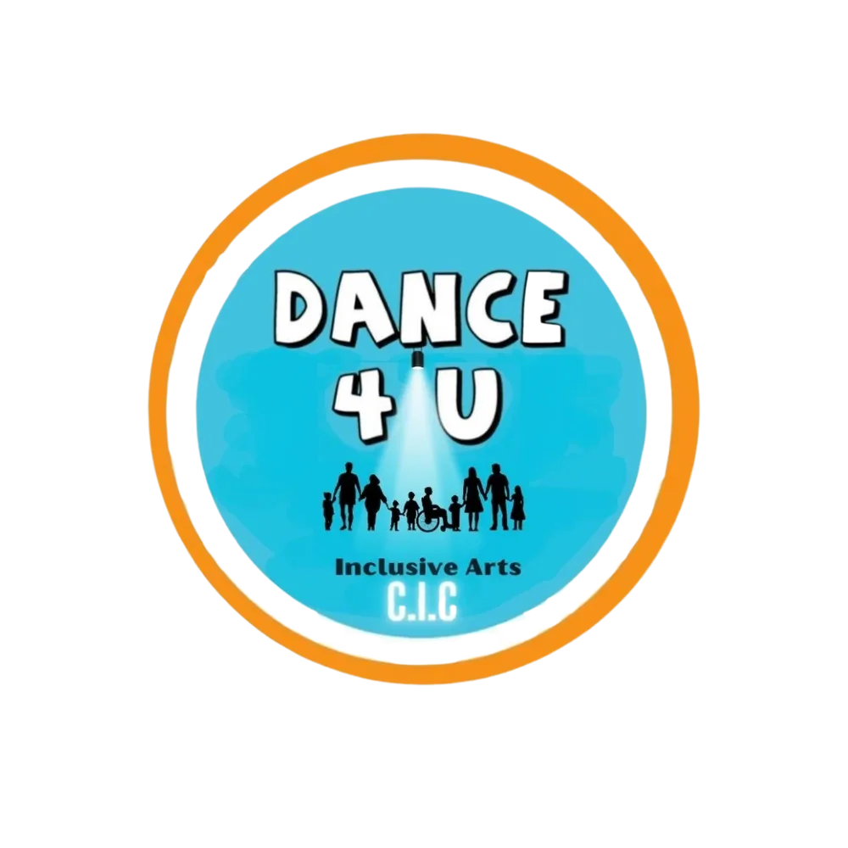
DANCE4U
INCLUSIVE ARTS CIC
PRIVACY POLICY

Organisation | Dance4U Inclusive Arts CIC
Effective Date | September 2026
Review Date | September 2027
Registered Office | 21 Oakwood Rd, Boldmere, Birmingham, B73 5EH
Privacy Contact | emily@dance4u.info
Website | www.dance4uinclusivearts.com

Contents
1. Purpose of this policy
2. Data Controller
3. Personal information we may collect
4. Information relating to children and young people
5. Safeguarding information
6. Photographs, videos and media
7. Online classes and digital delivery
8. Staff, volunteers and freelance practitioners
9. Why we use personal information
10. Our lawful bases for processing
11. Special category information
12. Sharing personal information
13. Funded programmes and monitoring
14. How we keep information secure
15. How long we keep information
16. Marketing communications
17. Website and cookies
18. Your data protection rights
19. Requests relating to personal information
20. Data breaches
21. Complaints
22. Changes to this policy
23. How we collect personal information
24. Lawful basis by type of activity
25. Special category data and higher-risk processing
26. International transfers and cloud service providers
27. Automated decision-making and profiling
28. When and how we provide privacy information
29. Privacy information for children and people with additional communication needs
30. Your right to object
31. Data processors and service providers
32. Approval

1. Purpose of this policy
Dance4U Inclusive Arts CIC is committed to protecting the privacy, dignity and personal information of everyone who engages with our organisation.
Our mission is to provide accessible dance and movement opportunities for disabled children, young people and adults, building confidence, improving wellbeing and creating meaningful social connection through movement.
This Privacy Policy explains how we collect, use, store, share and protect personal information relating to:
• Participants
• Children and young people
• Parents and carers
• Volunteers
• Staff and freelance practitioners
• Directors
• Partner organisations
• Referrers
• Funders
• Website visitors
• Individuals making enquiries about our services
Dance4U Inclusive Arts CIC aims to comply with applicable UK data protection legislation, including the UK General Data Protection Regulation (UK GDPR) and the Data Protection Act 2018.
2. Data Controller
Dance4U Inclusive Arts CIC is the Data Controller for personal information collected in connection with our programmes and activities.
For privacy enquiries, requests or concerns, please contact:
Dance4U Inclusive Arts CIC
Email: emily@dance4u.info
Website: www.dance4uinclusivearts.com
Registered address: 21 Oakwood Rd, Boldmere, Birmingham, B73 5EH
3. Personal information we may collect
The information we collect will depend on the individual's relationship with Dance4U Inclusive Arts CIC.
This may include:
Participant information
• Full name
• Date of birth
• Age
• Gender, where relevant
• Parent or guardian details
• Address
• Email address
• Telephone number
• Emergency contact information
• Attendance records
• Programme registration details
• Communication preferences
Accessibility and additional needs
To make our programmes safe and accessible, we may need to collect information relating to:
• Disability
• Additional needs
• Learning needs
• Communication needs
• Medical conditions
• Allergies
• Medication
• Mobility requirements
• Sensory requirements
• Emotional or behavioural support needs
• Relevant risk information
• Reasonable adjustments required to participate
Some of this information is considered special category personal data and receives additional protection under data protection legislation.
We will only collect information that is reasonably necessary to support a participant safely and appropriately.
4. Information relating to children and young people
Many of our services involve children and young people.
We take additional care when processing children's personal information.
Where appropriate, information will be provided by a parent, carer or legal guardian.
We may collect information relating to:
• Participation
• Attendance
• Emergency contacts
• Additional needs
• Safeguarding
• Medical requirements
• Photographic consent
• Programme outcomes
• Feedback
• Progress within sessions
Where appropriate, children and young people will also be informed in an accessible and age-appropriate way about how information about them is used.
5. Safeguarding information
Dance4U Inclusive Arts CIC has a responsibility to safeguard children, young people and vulnerable adults participating in our services.
We may therefore record information relating to:
• Safeguarding concerns
• Disclosures
• Incidents
• Injuries
• Welfare concerns
• Referrals
• Communication with safeguarding agencies
• Relevant risk assessments
Safeguarding information will be treated as confidential and access will be restricted to individuals who need the information to fulfil their safeguarding responsibilities.
There may be circumstances in which we are required to share information without consent where this is necessary to protect an individual from harm or meet a legal or safeguarding obligation.
6. Photographs, videos and media
Dance4U Inclusive Arts CIC may take photographs or videos during activities, events, performances or workshops.
These may be used for purposes such as:
• Promoting our services
• Social media
• Website content
• Funding reports
• Impact reports
• Newsletters
• Promotional materials
• Programme evaluation
Where appropriate, consent will be obtained before identifiable photographs or videos are used for promotional purposes.
Parents and carers may decline consent for their child to appear in promotional material.
Participants or parents/carers may contact us if they wish to withdraw consent for future use of photographs or videos.
Withdrawal of consent will apply to future use where reasonably possible, although it may not always be possible to remove material that has already been printed, distributed or lawfully published.
7. Online classes and digital delivery
Some Dance4U Inclusive Arts CIC programmes may be delivered online.
Where online platforms are used, participants may be required to provide information such as:
• Name
• Email address
• Login information
• Video or audio participation
• Attendance information
Participants will be informed where sessions are being recorded.
Online sessions will not ordinarily be recorded unless there is a clear reason for doing so and appropriate consent or another lawful basis is in place.
8. Staff, volunteers and freelance practitioners
We may process personal information relating to staff, directors, volunteers and contractors, including:
• Contact information
• Employment or volunteering records
• Qualifications
• Training records
• References
• DBS information
• Safeguarding checks
• Right-to-work information
• Insurance information
• Bank details
• Payment records
• Emergency contacts
• Performance or supervision information
Sensitive recruitment and safeguarding information will only be accessible to authorised individuals.
9. Why we use personal information
Dance4U Inclusive Arts CIC may use personal data to:
• Register participants
• Deliver programmes and sessions
• Provide appropriate accessibility support
• Communicate with participants and families
• Keep participants safe
• Manage emergencies
• Record attendance
• Administer funded programmes
• Demonstrate programme outcomes
• Evaluate our services
• Process payments
• Manage volunteers and staff
• Comply with safeguarding obligations
• Maintain financial and governance records
• Respond to enquiries
• Promote our organisation where consent has been provided
• Meet funder reporting requirements
• Meet legal and regulatory obligations
We will not use personal information for purposes that are incompatible with the reason it was originally collected unless there is an appropriate lawful basis.
10. Our lawful bases for processing
Under UK data protection legislation, we must have a lawful basis for processing personal information.
Depending upon the circumstances, we may rely on:
Consent
Where an individual has freely agreed to us processing their information for a specific purpose.
This may apply, for example, to certain marketing communications or use of photographs.
Contract
Where processing is necessary to provide a service someone has requested or entered into an agreement for.
Legal obligation
Where processing is necessary for Dance4U Inclusive Arts CIC to comply with the law.
Legitimate interests
Where processing is necessary for the legitimate operation of the organisation and does not override the rights and freedoms of the individual.
Vital interests
Where processing is necessary to protect someone's life or physical safety.
11. Special category information
Information relating to health, disability or certain other sensitive matters may constitute special category data.
Because Dance4U Inclusive Arts CIC specifically supports disabled participants, this information may sometimes be necessary to ensure that our services are safe, accessible and appropriate.
Where special category data is processed, we will ensure that an appropriate lawful condition is available under data protection legislation.
We will minimise the amount of sensitive information collected and restrict access appropriately.
12. Sharing personal information
We do not sell personal information.
Information may be shared where necessary with appropriate organisations or individuals, including:
• Staff
• Approved freelance practitioners
• Volunteers
• Directors
• Programme partners
• Schools
• Community organisations
• Funders
• Local authorities
• Safeguarding agencies
• Emergency services
• Professional advisers
• IT or administrative service providers
Only the information reasonably necessary for the relevant purpose will be shared.
Where possible, information provided to funders will be anonymised or aggregated.
We will not routinely provide identifiable participant information to a funder unless there is a legitimate reason and lawful basis for doing so.
13. Funded programmes and monitoring
Dance4U Inclusive Arts CIC receives grant funding to provide accessible dance and movement opportunities.
Funders may require us to report information such as:
• Number of participants
• Age ranges
• Attendance
• Programme outcomes
• Participant feedback
• Case studies
• Demographic information
• Impact evidence
Where possible, this information will be provided in an anonymous or aggregated format.
Where an identifiable case study, photograph or quotation is requested, appropriate consent will normally be obtained.
14. How we keep information secure
Dance4U Inclusive Arts CIC takes reasonable organisational and technical steps to protect personal data against:
• Loss
• Theft
• Unauthorised access
• Accidental disclosure
• Alteration
• Destruction
• Misuse
Measures may include:
• Password-protected systems
• Access restrictions
• Secure cloud storage
• Secure email accounts
• Limiting sensitive information to appropriate personnel
• Data protection awareness
• Safeguarding procedures
• Secure disposal of documents
• Confidentiality expectations for staff and volunteers
No system can guarantee complete security, but we take reasonable steps proportionate to the sensitivity of the information we hold.
15. How long we keep information
Personal information will not be kept for longer than reasonably necessary.
Retention periods will depend upon the type of information involved.
As a general guide:
Type of informationIndicative retention
General enquiries | Up to 2 years
Participant registration records | Duration of programme plus appropriate administrative period
Attendance and programme monitoring | Normally up to 6 years where required for funding/audit
Financial records | Normally 6 years
Funding records | In accordance with funder requirements, normally 6 years or as specified
Staff/contractor records | In accordance with employment, tax and legal requirements
Photographic consent records | For as long as associated material is used
Safeguarding records | Retained in accordance with safeguarding and legal guidance
Some records may need to be retained for longer where there is a legal, safeguarding, contractual, insurance or funding requirement.
16. Marketing communications
We may contact individuals about relevant Dance4U Inclusive Arts CIC activities where:
• They have requested information
• There is another appropriate lawful basis
• They have consented to receiving marketing communications
People can unsubscribe from marketing communications at any time.
Administrative or safeguarding communications relating to an existing programme are not considered marketing and may still be sent where necessary.
17. Website and cookies
Our website may use cookies or similar technology to:
• Operate website functionality
• Understand how visitors use the website
• Improve user experience
• Monitor website performance
Where required, visitors will be given choices regarding non-essential cookies.
Third-party websites linked from our website will operate under their own privacy policies.
18. Your data protection rights
Depending upon the circumstances, individuals may have the right to:
• Ask what information we hold about them
• Request a copy of their personal information
• Ask us to correct inaccurate information
• Request deletion of information in certain circumstances
• Restrict how information is used
• Object to certain processing
• Withdraw consent where processing relies on consent
• Request transfer of certain information
• Raise concerns about how their information has been handled
Not every right applies in every circumstance.
For example, we may need to retain certain information to comply with safeguarding, legal, financial or regulatory obligations.
Important: The rights available in a particular situation depend on the lawful basis and circumstances of the processing. Not every right applies in every case.
19. Requests relating to personal information
Requests relating to personal information should be sent to:
Dance4U Inclusive Arts CIC
Email: emily@dance4u.info
We may ask for information to confirm the identity of the person making the request before disclosing personal data.
20. Data breaches
A personal data breach may include:
• Loss of confidential information
• Information being sent to the wrong recipient
• Unauthorised access
• Theft of records
• Accidental disclosure
• Cybersecurity incidents
Suspected data breaches should be reported immediately to the Director responsible for data protection.
Dance4U Inclusive Arts CIC will assess the incident and take appropriate action.
Where legally required, we will notify the Information Commissioner's Office (ICO) and affected individuals.
21. Complaints
We encourage individuals to contact Dance4U Inclusive Arts CIC first if they have concerns about how their personal information has been handled.
Individuals also have the right to raise concerns with the:
Information Commissioner's Office (ICO)
The ICO is the UK's independent authority responsible for data protection.
22. Changes to this policy
This policy will be reviewed at least annually or sooner where:
• Legislation changes
• Our services change
• New technologies are introduced
• Funding requirements change
• A significant data protection issue arises
The most current version will replace previous versions.
23. How we collect personal information
We collect personal information directly from individuals and, where appropriate, from parents, carers, legal guardians, staff, volunteers, referrers, schools, partner organisations, commissioners or other professionals involved in supporting a participant.
Information may be collected through:
• registration, referral and consent forms;
• email, telephone, website enquiries and other communications;
• attendance records and session notes;
• safeguarding, incident and risk-assessment records;
• funded programme monitoring and evaluation forms;
• staff, volunteer and contractor recruitment processes;
• online platforms used to deliver or administer activities.
Where personal information is obtained from someone other than the individual, Dance4U will provide appropriate privacy information within the timescales required by data protection law, unless an exemption applies.
24. Lawful basis by type of activity
Dance4U identifies an appropriate lawful basis before using personal information. The basis may vary according to the activity and circumstances. The table below gives examples of the bases that may commonly apply.
Processing activity | Possible UK GDPR lawful basis | Notes
Registration and delivery of requested services | Contract and/or legitimate interests | Used to administer participation and provide the service requested.
Responding to enquiries | Legitimate interests and/or steps before entering a contract | Used to respond to requests and communicate about services.
Safeguarding and welfare | Legal obligation, vital interests and/or legitimate interests | The exact basis depends on the circumstances and applicable safeguarding duties.
Accessibility and health-related support | An Article 6 lawful basis plus an appropriate Article 9 condition where special category data is used | Dance4U documents the relevant special-category condition and only processes what is necessary.
Staff, volunteer and contractor administration | Contract, legal obligation and/or legitimate interests | Includes recruitment, payment, training, supervision and safeguarding checks.
Funding, monitoring and evaluation | Legitimate interests, contract and/or legal obligation | Identifiable information is minimised; anonymous or aggregated reporting is preferred.
Promotional photographs, videos and optional marketing | Consent where appropriate | Consent can be withdrawn for future use, subject to material already lawfully published.
Dance4U keeps its lawful-basis decisions under review. Where legitimate interests are relied upon, we consider the purpose, necessity and impact on the individual before processing.
25. Special category data and higher-risk processing
Because Dance4U provides inclusive services, we may process health, disability and other special category information. This data receives additional protection.
• We identify both an Article 6 lawful basis and, where required, an Article 9 condition before processing special category data.
• We collect only information that is necessary for the stated purpose and restrict access to authorised people.
• We keep a record of the categories of special category data used and the reason it is required.
• Where required by law, Dance4U will maintain an appropriate policy document describing safeguards, retention and deletion arrangements.
• Where processing is likely to result in a high risk to individuals, Dance4U will consider and complete a Data Protection Impact Assessment (DPIA) before the processing begins.
26. International transfers and cloud service providers
Some technology, communications or cloud service providers used by Dance4U may store or process information outside the United Kingdom. Where personal information is transferred internationally, Dance4U will take reasonable steps to ensure that an appropriate lawful transfer mechanism and safeguards are in place.
• We will consider whether the destination benefits from a UK adequacy decision.
• Where required, we may rely on approved contractual safeguards or another lawful transfer mechanism.
• We will only share the information reasonably necessary for the service being provided.
• Individuals may contact Dance4U for further information about relevant international-transfer safeguards.
27. Automated decision-making and profiling
Dance4U does not ordinarily use solely automated decision-making or profiling that produces legal effects or similarly significant effects on participants. If this changes, we will update this Privacy Policy and provide the information and safeguards required by data protection law.
28. When and how we provide privacy information
Dance4U aims to provide privacy information in a concise, clear and accessible way. Where we collect personal information directly, privacy information will be made available at or around the time the information is collected.
• Where information is obtained from another source, privacy information will normally be provided within a reasonable period and no later than one month, unless an exemption applies.
• If we use the information to communicate with an individual, privacy information will normally be provided by the first communication where required.
• If we plan to disclose the information to another recipient, privacy information will normally be provided by the time of that first disclosure where required.
• Publishing this policy on our website does not replace the need to make people aware of it and provide an easy way to access it.
29. Privacy information for children and people with additional communication needs
Dance4U recognises that privacy information must be understandable to the people it relates to. Children, young people and participants with learning or communication needs will be supported to understand how their information is used.
• Privacy information may be provided in age-appropriate, plain-English or Easy Read formats.
• Different versions may be used depending on individual learning, communication, sensory or accessibility needs.
• Visual or picture-based information, simplified step-by-step explanations, larger text, AAC-compatible information, signing or interpreter support may be used where appropriate.
• Where online services are used with children, privacy explanations should be clear, prominent and provided at appropriate points in the participant journey.
• Parents or carers may receive privacy information where appropriate, but this does not remove the importance of communicating directly with the child or young person in a way they can understand.
30. Your right to object
You have the right to object to certain uses of your personal information, including some processing based on legitimate interests and direct marketing.
If you object, Dance4U will consider your request in accordance with applicable data protection law. You can contact us at emily@dance4u.info. Direct marketing objections will be respected and actioned as required.
31. Data processors and service providers
Dance4U may use trusted third-party organisations to provide services on our behalf, for example hosting, cloud storage, email, booking, payment, communications, online delivery or administrative support. Where a provider processes personal information on our behalf, we will take reasonable steps to ensure appropriate contractual and data-protection safeguards are in place.
32. Approval
This Privacy Policy has been approved by the Directors of Dance4U Inclusive Arts CIC.
Emily Marie Bollard
Director
Sade Veleta Leanne Bloise
Director
Amy May Wood
Director

Effective: September 2026
Review: September 2027

