 | PRICE | QUANTITY
MAIN COURSE
Brisket of Beef | 23.99/lb.
Half Roast Chicken | $8.99/ea.
APPETIZERS/SIDES
Chopped Chicken Liver | $16.99/lb.
Egg Salad | $14.99/lb.
Albacore Tuna Salad | $16.99/lb.
Whitefish Salad | $21.99/lb.
Chopped Herring | $19.99/lb.
Smoked Whitefish (sold Half or Whole only) | $21.99/lb
Tzimmes | $13.99/qt.
Kasha Varnishkes | $12.99
Nova Lox | $33.99/lb.
Gefilte Fish | $12.99/ea.
Horseradish | $11.99/lb.
Noodle Kugal Pan (serves 12) | $40. 00
Potato Kugal Pan (serves 12) | $35.00
Noodle Kugal Small Pan (serves 2-3) | $12.99
Potato Kugal Small Pan (serves 2-3) | $12.99
 | PRICE | QUANTITY
SOUP
Chicken Broth | $7.00/qt
Matzo Ball | $2.50/ea.
Kreplach | $2.50/ea.
DESSERT/BREAD
Rugulach assorted flavors | $14.99/lb.
Mandel Bread – chocolate/ cranberry and almond | $14.99/lb.
Round Plain Challa (2 pound) | $12.99
Round Raisin Challa (2 pound) | $13.99

Rosh Hashana Hours: Monday, 09/06/21, 8:00 am – 7:00 pm Tuesday, 09/07/21, 8:00 am – 7:00 pm

Yom Kippur Hours: Wednesday, 09/15/21, 8:00 am – 7:00 pm Thursday, 09/16/21, 8:00 am – 7:00 pm (Tray Pick Up’s Available from 1:00 pm – 7:00 pm)
Name: | Pick-Up Date
Phone # | Pick-Up Time
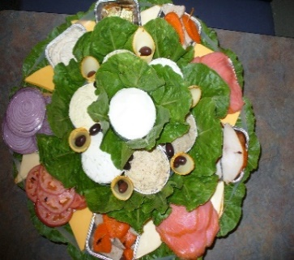
Thank you for the Opportunity of Serving You!

FISH TRAY INCLUDES: Nova Lox, Baked Salmon, Gefilte Fish, Chopped Herring, Cream Cheese, Tuna Salad, Whitefish Salad, Egg Salad, Bagels, Rye Bread
Goldman’s Deli phone: 480-367-9477 www.goldmansdeliarizona.com We have Trays Available for Yom Kippur: Fish Tray, Breakfast Tray, Salad Tray, Meat Tray

We have Trays Available for Yom Kippur: Fish Tray, Breakfast Tray, Salad Tray, Meat Tray

