|  |  |  |
| --- | --- | --- |
|  | PRICE | QUANTITY |
| **MAIN ENTREE** | | |
| Brisket of Beef | $25.99/lb. |  |
| Brisket (Extra Lean) | $27.99/lb. |  |
| Half Roast Chicken | $8.99/ea. |  |
| **APPETIZERS/SIDES** | | |
| Chopped Chicken Liver | $18.99/lb. |  |
| Egg Salad | $16.99/lb. |  |
| Albacore Tuna Salad | $18.99/lb. |  |
| Whitefish Salad | $23.99/lb. |  |
| Smoked Whitefish (sold Half or Whole only) | $23.99/lb |  |
| Tzimmes | $15.99/qt. |  |
| Kasha Varnishkes | $14.99 |  |
| Nova Lox | $35.99/lb. |  |
| Gefilte Fish (no horseradish) | $13.99/ea. |  |
| Horseradish | $12.99/lb. |  |
| Noodle Kugal Pan (serves 12) | $49.99 |  |
| Noodle Kugal Small Pan (serves 2-3) | $14.99 |  |

|  |  |  |
| --- | --- | --- |
|  | PRICE | QUANTITY |
| **SOUP** | | |
| Chicken Broth | $8.00/qt |  |
| Chicken Broth with Veggies | $8.99/qt |  |
| Matzo Ball | $3.00/ea. |  |
| Kreplach | $3.00/ea. |  |
| **DESSERT/BREAD** | | |
| Rugulach assorted flavors | $16.99/lb. |  |
| Mandel Bread – chocolate/ cranberry and almond | $16.99/lb. |  |
| Honey Cake (homemade) | $8.99 |  |
| Round Plain Challa (1 pound) | $8.49 |  |
| Round Plain Challa (2 pound) | $14.99 |  |
| Round Raisin Challa (2 pound) | $15.99 |  |

**Rosh Hashana Hours:** Saturday, 09/24/22, 8:00 am – 3:00 pm Sunday, 09/25/22, 8:00 am – 3:00 pm Monday, 09/26/22, 8:00 am – 7:00 pm

|  |  |
| --- | --- |
| Name: | Pick-Up Date |
| Phone # | Pick-Up Time |

**Yom Kippur Hours:** Tuesday, 10/04/22, 8:00 am – 7:00 pm Wednesday, 10/05/22, 8:00 am – 7:00 pm Tray Pick Up’s Available from 1:00 pm – 7:00 pm “Ask about our Famous Fish Tray!”

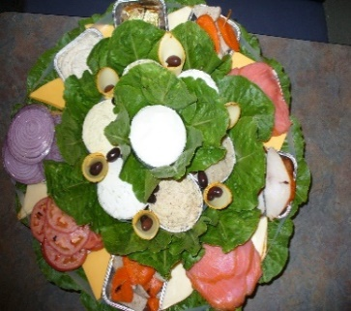

**Thank you for the Opportunity of Serving You!**

**Goldman’s Deli phone: 480-367-9477 www.goldmansdeliarizona.com We have Trays Available for Yom Kippur: Fish Tray, Breakfast Lox Tray, Salad Tray, Meat Tray**

**We have Trays Available for Yom Kippur:** **Fish Tray, Breakfast Tray, Salad Tray, Meat Tray**

**FISH TRAY INCLUDES:** **Nova Lox, Baked Salmon, Gefilte Fish, Tuna Salad, Whitefish Salad, Egg Salad, Cream Cheese, Sliced Cheese, Garnish, Bagels, and Rye Bread**