Joy In Learning

Child Care Centers



Parent Handbook

Glen Burnie

Marley Park

Whispering Woods

Updated: February 2025



Joy In Learning Child Care Centers

**Dear Parents,**

We are pleased to have you as part of the Joy in Learning community. Each of Joy in Learning’s three locations have been part of the Anne Arundel County community for three plus decades. Since opening the first location in 1984, many parents, children, and their families have passed through our doors. It is our hope that being a part of our community will be a rich and fulfilling experience for your child and your family.

  Joy in Learning is committed to offering the best quality childcare for children ages 18 months to 10 years of age. The children participate in creative and challenging learning programs in a clean, safe, inclusive, and nurturing environment.

  The purpose of this handbook is to provide you with an understanding of important policies that will help your child on a daily basis. We are so pleased you have chosen to be a part of our family and hope to enrich your child’s life and impact a joy in learning for the child’s time with us.

Thank You,

Leah and Benjamin Shiffman

Leah and Benjamin Shiffman

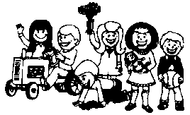

**Table of Contents**

| **Section** | **Page number** |
| --- | --- |
| **Mission Statement** | **4** |
| **Purpose & Objectives** | **4** |
| **JIL Diversity and Inclusion Policy** | **5** |
| **JIL General Information and Policies:** | **5** |
| **Registration** | **5** |
| **Registration Fees** | **5** |
| **Personal Items** | **6** |
| **Clothing** | **7** |
| **Hours of Operation** | **7** |
| **Arrival and Departure Procedures** | **7** |
| **Center Closings** | **8** |
| **Late Pick Up Policy** | **9** |
| **Behavior Management** | **10** |
| **Biting** | **10** |
| **Child Custody/Court Matters** | **11** |
| **Inclusion** | **12** |
| **Smoking** | **12** |
| **Fire Drills** | **12** |
| **Field Trips** | **13** |
| **Video/Audio Surveillance** | **13** |
| **Withdrawals** | **13** |
| **Meals** | **14** |
| **Tuition Payments** | **15** |
| **Discounts** | **17** |
| **Illnesses/Health Policy** | **17** |
| **Medications** | **19** |
| **Injuries** | **19** |
|  |  |
| **Before/After School Care** | **20** |
|  |  |
| **Frequently Asked Questions** | **21** |
|  |  |
| **Withdrawal Notice** | **24** |
|  |  |

**Mission Statement**

To give all children the opportunity to discover the joy inherent in all learning through discovery, observation, and shared experiences.

**Purpose and Objectives**

It is the purpose of the Joy In Learning Child Care Centers to enhance the total growth and development of each child through general and specific techniques of enrichment designed to:

1. Promote physical growth and development (running, climbing, balancing, using manipulatives)
2. Aid emotional development (regulation, expression, stress management, self-sufficiency, acceptance, empathy)
3. Enhance social competence (consideration for others, cooperation, social awareness, relating to others, resolving conflict)
4. Provide opportunities for cognitive learning (concepts, vocabulary, number sense, problem solving)

The objectives of the Joy In Learning Child Care Centers are to:

1. Demonstrate through example, opportunity, and conversation the **Joy** inherent **In** all **Learning**.
2. Provide an atmosphere of respect and caring for young children and each other. Our ultimate goal is to enhance the child’s self-esteem, while facilitating each child’s potential for optimal personal development.
3. Schedule a balanced day of activity, rest, nourishment, and creative involvement.
4. Supply materials and equipment conducive to learning about self, family, community, environment, math, science, music, art, literature, and architecture.

At Joy In Learning Child Care Centers, we believe that our centers will serve as a basic support for the family. Our role is to enhance the parent’s relationship with their child through a program rich in tolerance, encouragement, and acceptance.

**Joy in Learning Diversity and Inclusion Policy**

All families and children are welcome at Joy in Learning. Diversity in our family, student, and staff populations are critical to building a welcoming and safe environment for everyone.

Joy in Learning offers an inclusive program. All children, including those with and without disabilities, developmental differences, or learning differences have access to and participate in the same routines, play, and learning experiences.

Children learn, develop, and grow best in an environment that values all people and celebrates the natural diversity and differences in the world in which we live.

**General Information**



**Registration Packet**

At registration, a packet of information is provided to you. This packet should contain all medical and center forms that must be completed and submitted to the Director before your child’s first day. The following forms are included:

1. Immunization

2. Health Inventory (physical)

3. Emergency Card (2 copies)

4. Tuition Agreement Form

5. Parents Guide

6. Welcome Letter from the Business Office

7. Video/Audio Authorization

**Registration Fees**

Upon registering your child with Joy In Learning Child Care Centers, a one time, non-refundable registration fee per child is required. For children between the ages of 18 weeks and 10 years old, the registration fee is $100. After the registration fee has been paid, spaces cannot be held for more than two weeks.

**Other Fees**

Activity Fee: This fee is billed and collected twice each year: September and February. This non-refundable fee provides your child (depending on classroom) with annual center fieldtrips, events, and classroom activities.

Copy Fees:

* Child Records: $5.00 flat fee, Prep time: 48 hours
* Court/Attorney records (i.e. sign in/out sheets, roll books, etc.) $20 flat fee plus $.10 per copy. Written notice/court documents required. Prep time: Up to 1 week

**Child’s Personal Items Provided by Parents**

1. A complete change of clothes (clothes should be suited for the appropriate season)

2. A sheet, blanket, and bag for storage **(paper/plastic bags are not acceptable)**. The Center is not responsible for cleaning items. Parents are to take these items home on their last day of the week and return these items on their first day back.

3. A lunch container

4. Diapers and wipes (if applicable)

*The Center is not responsible for items your child/children bring to the Center. Toy guns, swords, or play weapons of any type are prohibited.*

**Clothing**

It is recommended that children wear play clothes and tennis shoes to Joy In Learning. Daily activities include both active and messy play. Open toed sandals or shoes are discouraged. However, if they are worn, they must be secured properly around the ankles (e.g. Crocs). For safety reasons, flip flops are not allowed. Children need to feel comfortable enough to enjoy themselves without worrying about the condition of their clothes. Please remember to dress them appropriately for the season and outside play (i.e. hats and mittens in the winter, free flowing light garments in the summer). ***Note: All items should be labeled with the child’s name.***

**Arrival & Departure Procedures**



**Hours of Operation**

Hours of operation are Monday through Friday 6:30 a.m. to 6:00 p.m. **A late pick up fee will be charged if picking up your child after the Center’s closing time.** (See Late Pick Up Policy)

**Arrivals and Departures**

It is requested that parents whose child or children will be absent, or arriving after 9:00 am, to please notify the Center via phone call, text, email or through the approved Day Care App. A parent, guardian, or authorized adult is required to escort the child/children in and out of the classroom. No child will be allowed to enter or leave without adult supervision, regardless of the child’s age.

**Sign-In/Sign-Out Procedures**

Parents are required to sign-in and sign-out their children in each classroom. This applies to parents of multiple children. Each child must be signed in and out separately.

**Center Closings**

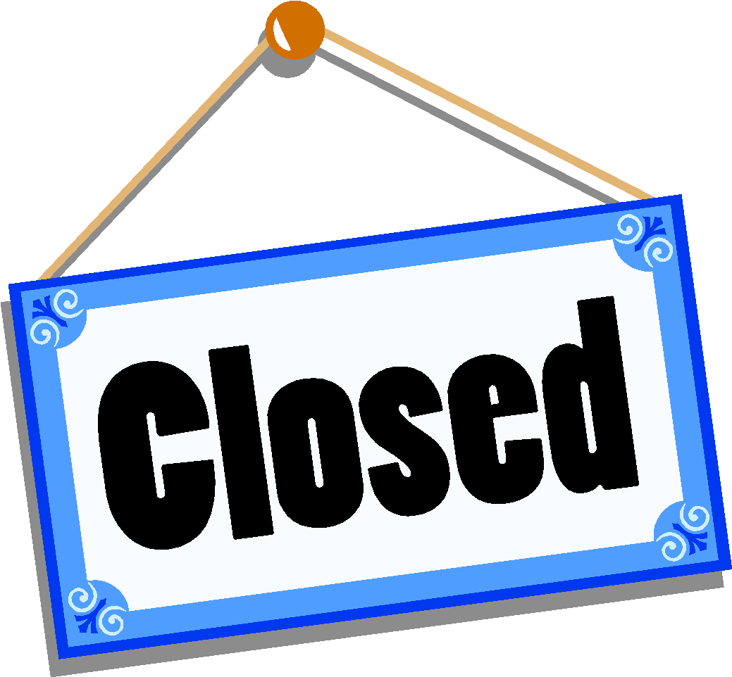

**Emergency**

Joy In Learning reserves the right to close its Centers when it is deemed necessary. A decision to close will be based on the best interests of the children, parents, and staff. Parents are still liable for full tuition. The Center does not follow the county school system in regards to closings. Parents and staff can check the Joy In Learning Facebook page and/or their email for center closings and delays. Announcements may differ according to Center locations.

In the event that inclement weather and/or natural/manmade disaster becomes known after the Center is already open and a decision is made to close early, parents will be notified by phone, as well as email not less than three hours before the early closing time. Parents picking their child/children up after the announced early closing time will be charged a Late Pick Up Fee.

**Holidays:**

* *New Year’s Day
* Memorial Day
* Juneteenth
* *Independence Day & day after
* Labor Day
* Halloween (close at 4:30pm)
* Thanksgiving Day & the day after
* **Christmas Holidays
* New Years Eve (close at 4:30pm)

* When this holiday falls on a Saturday or Sunday, the Center will be closed either the Friday before or the Monday following the holiday.

** Christmas Holidays consist of December 24, 25, and 26th. Since these days vary each year the actual holiday closings will be announced yearly.

**Parents are still responsible for the full tuition when the center is closed for holidays.**

**Professional Training Days:**

Joy In Learning will be closed one day for First Aid/CPR and/or staff training during the month of October. The specific date will be announced in August of each calendar year. Parents are still responsible for the full tuition during Professional Training Days.

**Late Pick Up Policy**

In the event you arrive to pick-up your child after the center’s closing time, a late pick up fee will be assessed for each 15 minute increment that you are late. We understand things happen and situations arise, however, staff members are officially off the time clock when the center closes. For safety reasons, company policy requires two staff members to remain with any child/children, after the Center closes.

Any family picking their child/children up past closing hours (6:00 p.m.) will be charged a $20.00 fee for each 15 minutes their child/children are in the Center. Please keep in mind that any family still in the building after 6:00 p.m. will be charged a late pick up fee.

Any family with seven late pick ups may be subject to dismissal. Records will be kept for a 1 year period (January - December) at which time new records will be kept.

All late pick up fees must be paid in full with (or before) your next tuition payment date or your child will not be allowed to return to the Center.

Late Pick Up Fees

6:00 p.m. – 6:14 p.m. = $20.00

6:15 p.m. – 6:29 p.m. = $40.00

6:30 p.m. – 6:44 p.m. = $60.00

6:45 p.m. – 6:59 p.m. = $80.00

Etc.

***Failure to abide by the JIL policies may result in dismissal from the Center and forfeiture of all fees*.**

**Behavior Management Procedures and Positive Behavioral Interventions and Supports (PBIS)**

Joy in Learning staff uses positive behavioral supports and strategies with children that include providing choices and using redirection. Offering choices to children is a proactive behavioral support strategy that gives children a sense of empowerment and control in their environment. At the same time, choices foster children’s development of responsibility and independence. Children need choices throughout the day: meals and snacks, where to play, where to sit, and what materials to use are just a few opportunities for children to make choices for themselves.

Additionally, redirection will be used as a positive behavioral support technique where the adult changes the child’s focus or direction from a negative behavior or experience to a positive one. It may involve one of four different types of redirection: verbal, physical, verbal with a visual cue, and redirection of attention to a positive model.

These methods will be applied to all children but may look different depending on the variables in each situation. These include age, developmental level of the child, discipline history and others.

**Corporal punishment, humiliation, embarrassment will not be used as forms of discipline at any point for any reason.**

**Biting**

Biting is a behavior that sometimes occurs in a child care setting; Joy In Learning considers it a serious matter. We address this behavior by: 1) The bite victim is cared for and the bite is cleaned with soap and water; ice is applied. 2) An accident report is written for both children and both parents are notified. As in the case with all incidents between children, names are not disclosed. 3) A log kept of the biter, and the parent(s) are notified.

**Dismissal Policy**

Should the decision be made that the child and the Center are not compatible, the parent may be given up to, but not in excess of, a two week period in order to make other child care arrangements. **This does not apply to non-payment dismissals.**

At any time when the center feels a child requires one-on-one care, a decision will be made if our center is the right fit or not. Joy in Learning will not be responsible for hiring and paying a one-on-one for a child. This must be done by an outside entity.

**Child Custody/Court Procedures**

**Confidentiality of Student Records**

Your child/children records are open only to your child’s teacher, the Director, the Owner, and authorized employees of Maryland’s State Licensing Agency.

**Authorized Release of Child**

The Center will only release a child to a parent, legal guardian, or an individual authorized by the parent and/or legal guardian listed on the emergency information card. Staff members reserve the right to ask for two (2) forms of identification from any person trying to pick up a child from the Center. If an individual is listed on the emergency card, and produces proper identification, the child may be released from the center without a confirmation call to the parent.

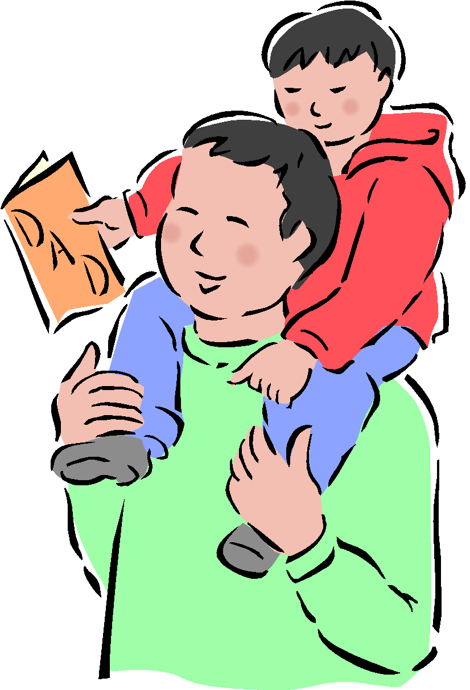

The Center does not make it a practice to accept authorized pick up changes over the phone, except in emergencies. Under these circumstances, a return confirmation call from a staff person to the parent may be necessary.

As a parent, you must submit in writing the new authorized person’s information (name, address, telephone number) to be added to the list. In cases in which an authorized pick up person is to be deleted, please contact the Center Director.

**Custodial and Non-Custodial Parents**

Unless a specified custody agreement, signed by a judge and on file in the center, has been submitted the non-custodial parents will have the right to information about their child/children. This means that non-custodial parents will be informed of all school activities, classroom concerns, and information about their child. This practice is beneficial to children in order to help them feel that both parents are taking an active role in their childcare experience.

**Testifying in Court**



If you request an employee of Joy In Learning to appear in court or testify for the purpose of a child custody hearing, a service charge of $150.00 per 4 hours will be required. The charge is per staff member and must be paid in full at least 10 days prior to each court date.

**Other Info**

**Inclusion Policy:** Joy in Learning supports all children with developmental disabilities and special health care needs. If your child has an IEP/ISFP, we ask that you share the documents with our teachers so that we can support the goals of your child. We also welcome all services providers in our center to assist in the growth of your child.

**Smoking Policy**

Joy In Learning is a SMOKE – FREE property. Smoking is not permitted anywhere on the premises. This includes e-cigarettes.

**Fire Drills**



Fire Drills are held at least once a month. Fire Drill logs are posted in each classroom along with evacuation plans.

**Field Trips**



All Joy In Learning Centers will have the opportunity to attend field trips. Due to company policy on child/adult ratios, trips may be subject to parent participation. The child/adult ratios are: two year olds: 2 to 1; three and four year olds: 4 to 1. The Grizzly ratio is 10 to 1. Should any classroom not be able to meet child/adult ratios, that class may cancel the trip.

**Video/Audio Surveillance**

Video and audio surveillance has been installed at all Joy In Learning locations. These camera systems were installed for several reasons:

* To provide enhanced security for our facilities and premises,
* To monitor our premises in the event we need to make weather related decisions or closures,
* To monitor the classroom activities.

Please keep in mind that conversations may be recorded. Video and audio surveillance is not available for use by families via the internet.

**Withdrawals**

In the event your child withdraws from Joy In Learning, we ask that parents please give the Center Director a two (2) week written notice. Any family wishing to return will be required to re-register (if spaces are available) and will be responsible for all enrollment fees. A child is considered withdrawn if the child is absent for four (4) or more consecutive days, and the center has not been contacted. To re-enroll, all registration fees will need to be paid again.

Upon leaving the center, Access Control Fob (ACF) must be returned immediately. Should the ACF(s) not be returned prior to your last week of care, a replacement fee of $20 per ACF will be charged to the family's account and may result in a pay to stay notice.

**Meals**



Meals/snacks are a part of the daily schedule at each center. Eating times are posted on the Parent Information Board in each classroom. Please keep in mind that classrooms need to adhere to these times, under normal circumstances. If your child is not present when the meal/snack is scheduled, it is the parent’s responsibility to see that the child/children are fed.

**Breakfast**

Breakfast is an optional service offered at Joy In Learning. Breakfast consists of cereal served with milk or juice. The times vary according to location, please check with the Center Director for exact times. The cost for breakfast is $1.00 for each day and a monthly tracking system is kept on each child. Children will be served breakfast if they request it and the parent will be billed at the end of each month. Parents, who do not wish their child to participate in the breakfast program, are asked to put your request in writing.

The Center will accept ready-to-eat breakfast food (bagels, muffins, donuts, etc…) sent in by the parent (if it is sent during breakfast times). However, if any Joy In Learning condiments, food, drink, or tableware is used in order to complete the breakfast, the breakfast fee of $1.00 will be applied.

**Lunch**

The parent provides lunch each day. The Center will provide milk with lunch. All Centers are equipped with microwave ovens. Parents are welcome to send in food that is pre-cooked and needs only to be reheated (**no longer than 1 minute**). Food must be in microwave safe containers. Food containers must be labeled with the child’s name. Parents should let the staff member who greets them in the morning know that their child has a hot lunch. Staff are not responsible for washing any lunch containers. If a child has no lunch for the day and parent contact is unsuccessful, a lunch will be provided to your child at the cost of $10.00.

**Snacks**

Snacks will be provided twice a day by the Center. The snack menu is approved by the Maryland State Department of Education Office of Child Care. The snack menu will be posted on the Parent Information Boards in each classroom. The Center reserves the right to change the daily snack, in which case, the change will be posted on the parent board.

Children are permitted to share a **store bought snack** (cupcakes, cake, ice cream, etc) as a special snack for birthdays. Please check with the Center Director to coordinate this snack and find out if there are any food allergies in the classroom.

**Tuition Payments**

**Joy In Learning Child Care’s Business Office Number: 410-760-3809**

All tuition payments are due the first day (typically Monday) of the week. Parents are required to sign up and pay through [Bright Wheel](https://mybrightwheel.com/). Exceptions must be approved by the owners and will be done on a case by case basis.

For families wishing to pay bi-weekly or monthly, please contact the Business Office.

Billing statements will be distributed by Wednesday of each week. Tuition payments are billed the week prior to attending the Center. This payment will cover child care for the following week. Families have until 9:00 am Monday of the current week to pay for that week. After 9:00 am on Monday, all payments are subject to a $20.00 late fee. A family’s tuition account is considered in arrears if payment is not received by the close of business on Monday.

If your child/children, for any reason, miss a day(s), you are still liable for the full tuition for that week. Vacation and sick discounts are available.

Keep in mind, if the center is closed on a Monday, tuition payments are due on the next business day the center is open. If a family’s tuition is in arrears, that family will receive a Pay-to-Stay Notice and your child/children will not be allowed to return to the Center until your account is paid in full and current or you contact the Business Office.

A family may get a Pay-To-Stay Notice for one or more of the following reasons:

1. Families that are in arrears with their tuition payment.
2. Families that are in arrears with their breakfast or full day’s payment.
3. Families who have not paid for the following by the due date:

Activity Fees

Summer Grizzly Activity Fee

Late Pick Up Fee

**Discounts**

**Vacations**

When the Center is notified at least two weeks in advance, the Center will reduce each full week (2, 3, or 5 day enrollment) for vacation by 20% when the tuition is paid in advance. The vacation discount will be applied when payment is received in advance for the discounted week. Vacation forms, available from the staff, should be filled out by the parent and returned to a staff member. **Your tuition account must be in good standing to receive the vacation rate.**

**Illnesses**

If a child misses four or more consecutive days due to the same illness, tuition for that week will be reduced by 20% if a doctor’s note is presented.



**ILLNESS**

**Health Procedures**

A sick child **SHOULD NOT** be brought to the Center. Health regulations prohibit the admittance of any child into the Center who exhibits one or more illnesses. The following are the most common, but not limited to:

* Communicable diseases (chicken pox, roseola, mumps, etc.)
* Lice
* Conjunctivitis (discharge from eyes or ears)
* Rash
* Runny nose with colored discharge (dark yellow/green)
* Vomiting/stomach ache/Diarrhea
* Fever of 100°F, or higher
* Covid19

Please keep in mind that Joy In Learning staff are not medical doctors, nurses, or physician’s assistants. JIL staff are encouraged to err on the side of caution and communicate with parents when making a decision about an illness or injury.

Joy In Learning cannot leave a child unattended inside. We cannot honor requests that children stay inside during outside time. If your child cannot go outside, then it is best that the child stays at home.

**Communicable Diseases**

It is Joy In Learning’s intention that all communicable disease cases be handled on an individual basis, with an emphasis placed on the total care and safety of the entire center. The parent/guardian of the ill child will be notified immediately. THE CHILD MAY NOT RETURN TO THE CENTER UNTIL SUCH TIME AS A DOCTOR’S RELEASE FORM ALLOWS THE CHILD TO RETURN TO THE CENTER. If it is found to be necessary, other families and the County Health Department will be notified of the communicable disease.

**Lice**

We maintain a policy of No Lice, No Nits. No Lice, No Nits means that, if one “louse” or one “nit” (egg) is found on a child’s body or hair areas, they must be picked up from the Center immediately. Upon returning to the Center, a staff member must check the child for the absence of nits and/or lice. **Please allow yourself enough time for the staff to examine your child**. This policy is recommended by the Health Department and is the best way to reduce the spread of Lice.

**Rashes**

If a rash or type of irritation is noticed and seems suspicious in nature, the parent will be contacted immediately. It will then be determined if the child will need to be picked up by the parent and if medical treatment will be required before returning to the Center.

**Runny Nose (with colored discharge)**

Each case will be handled individually. A parent will be contacted if the symptoms persist and/or other symptoms accompany the runny nose (i.e. coughing, fever, nausea, vomiting, stomach ache). Depending on the symptoms, the Center may ask that your child be picked up.

**Conjunctivitis**

No child will be admitted to the Center if they have or are suspected of having conjunctivitis (pink eye). If a child shows symptoms of the illness while at the Center the parent(s) will be contacted and asked to pick up their child from the center. Although symptoms of allergies or colds can be mistaken for conjunctivitis, it is the Center’s responsibility to treat all illnesses with caution. Conjunctivitis must be treated by a physician and a doctor’s note must be given to the Center upon the child’s return.

**Fever**

In the event of a fever, a parent/guardian will be notified if the child’s temperature is 99°F or higher. If the fever reaches 100°F or higher, the parent will be asked to make arrangements for the child to be picked up from the Center within one hour. Our Center policy is that a child must be fever free for at least 24 hours before returning to the Center. Sometimes an illness is still contagious after the symptoms disappear because the medication is masking them. Persistent fever will require a written notice from the child’s doctor stating that your child is no longer contagious, and should be presented upon your child’s return to the Center.

**Diarrhea**

After a second occurrence the parent will be contacted and asked to pick up their child from the Center. The parent may be contacted earlier than the second time if other symptoms accompany the diarrhea or the child no longer has appropriate clothing to wear. In the event a child returns to the center the following day, and has one more occurrence of diarrhea, the parents will be called to pick up the child.

**Medications**

Joy In Learning Staff may only administer medication to a child with a written statement from the doctor, addressed to Joy In Learning. This includes aspirin, over-the-counter cough syrups, prescription medications, etc. THERE WILL BE NO EXCEPTIONS. Also, a Child Care Medication Form must be filled out and signed by the parent. *When a child is on medication, all first doses of medication must be given to the child by the parent.*

**Injuries**

It is required that parents/guardians contact the Center within 24 hours of an accident in which a child/children sustained an injury at Joy In Learning that needed medical treatment. If an accident or mishap does occur, that requires professional medical treatment, an insurance claim form will be provided.

**Before/After School Care**

(Offered at Whispering Woods and Glen Burnie locations)

**Behavior**

It is expected that School Age children, while attending JIL., display their best manners, be respectful to others, and be courteous to their peers and the staff. Behaviors such as the use of profanity, obscenities (verbal or non-verbal), physical contact (kicking, pushing, etc.), misuse of classroom materials, etc…will not be tolerated and may result in the following:

* 1st incident - receive a written incident report and parent(s) will be notified.
* 2nd incident - receive a written incident report, parent(s) will be notified, and you may be asked to pick your child up at that time. If the incident occurs at the end of the day the child may be suspended for the next day.
* 3rd incident - A possible 2 day suspension and a mandatory Parent/Director Conference will be scheduled before the child may return to any Joy In Learning Center.

If a third incident occurs, the possibility of dismissal from the Center may be considered.

**Fighting**

Fighting will result in an automatic suspension from the Center. It is considered fighting when a staff member has to physically separate the children and/or an injury occurs. Joy In Learning will consider all incidents individually. Any behavioral concerns will be addressed in a fair and factual manner in order to determine a proper course of action.

**Full Days**

If your child attends Joy In Learning on days when the County Public Schools are closed, an additional fee will be charged for childcare. (See Rate Sheet)

**Late Openings/Early Dismissals**

If your child’s school has a 2 hour or less early dismissal/delayed opening school day, there will be no additional charge on that day. If the early dismissal/delayed opening is more than 2 hours, an additional fee for that day will be applied. Parents will be billed accordingly at the end of each month. (See Rate Sheet, Full Days)

**Summer Camp**

During the summer, Joy In Learning provides a structured summer program consisting of fun themes to meet the social, physical, emotional, and cognitive needs of each child. Activities involve technology, arts and crafts, fieldtrips, and water play. A detailed schedule of planned activities and events will be provided to all school age families participating in the summer program.

**Summer Camp Activity Fee**

Before the program begins, a non-refundable Activity Fee will be required. The price of the Activity Fee is determined and will be announced in early April. Prices are based upon field trips, activities, and transportation costs for these trips and activities. Field trips and activities are scheduled for all children enrolled. Parents are not able to pick or choose which trips or activities their child (children) will attend.

***QUESTIONS & ANSWERS***

***Some frequently asked questions about Joy In Learning…***

*Q. How long has Joy In Learning been in operation?*

A. Joy In Learning has been providing childcare services to children and their families since 1984.

**JIL Timeline**

* November 1983 - Incorporated
* January 1984 - Glen Burnie center opened, licensed capacity 18
* January 1985 - Glen Burnie center expanded, licensed capacity 38

**JIL Timeline (continued)**

* October 1985 - Acquired Marley Park center (formally Tiny Tots), licensed capacity 36
* July 1990 - Acquired Annapolis/Whispering Woods center (formally Mulberry Bush), licensed capacity 38
* September 1990 - Opened Security center, licensed capacity 40
* January 1992 - Sold Security center (now Child Care Academy)
* November 1993 – 10 year Anniversary
* November 1997 - Expanded Annapolis/Whispering Woods center, licensed capacity 66
* January 1998 – Expanded Glen Burnie center with School Age program, licensed capacity 60
* January 1998 - Opened Severna Park center, licensed capacity 40 August 1998 - Acquired Columbia center (formally Kindercare), licensed capacity 96
* March 1999 - Sold Severna Park center ( The Learning Years)
* November 2003 - 20 year Anniversary
* May 2007 – Columbia center is renovated to provide care for Infants/Toddlers, capacity 9
* August 2013 – Expanded Annapolis/Whispering Woods center, licensed capacity 82
* November 2013 – Joy In Learning celebrates 30 years
* January 2021-Sold Columbia (now Kiddie Mundo)
* January 2025 - Dennis Rohde (original owners) retires and sells business to Ben and Leah Shiffman

*Q. What is the current enrollment capacity at all your locations?*

A. Total capacity across three centers is 178 children.

* Glen Burnie Park - 60 children
* Marley Park - 36 children
* Whispering Woods - 82 children

*Q. May I come and look at your facilities?*

A. Yes, we have an open door policy. We are here to serve the community and we consider the time well spent in showing you around.

*Q. How can I reach the Business Office?*

A. The Business Office is located next to the Glen Burnie Center. Ms. Debbie is the Executive Director, monitoring MSDE regulations, licensing requirements, staff, and the curriculum. To reach the Business Office, please call (410)760-3809. Feel free to leave a message if we are unable to take your call, and we will get back to you as soon as possible.

Executive Director - Debbie Reed: [Debbie@joyinlearningJES.com](mailto:Debbie@joyinlearningJES.com)

For questions regarding your account contact…

Owner - Leah Shiffman: [Leah@joyinlearningJES.com](mailto:leah@joyinlearningJES.com)

Withdrawal Notice

We are always sorry to see a family leave. As we are always looking for ways to improve our programs, we are asking that you be so kind and complete this form for our information. We always ask that you give at least a two week notice, so that families on our waiting list can be notified. All fees and responsibilities for those two weeks are to be satisfied. Family’s records and tax statements will not be released until your account is paid in full.

My child/children _____________________________________________will be

withdrawing from the { Koala / Cubs / Bears / Grizzly} Classroom at the

{Annapolis / Glen Burnie / Marley Park} Center. His/Her last day will be

M Tu W Th F ____________________.

Reason for leaving: ______________________________________________________________________________________________________________________________________________________________________________________________________

Please rate on a scale from 1 – 10 about the following items. Since we strive to score all 10’s, please let us know in the Comments section if you are not 100% pleased:

1 = lowest 10 = highest

Location _______ Communication with Business Office _______

Safety _______ Communication with Director _______

Cleanliness _______ Communication with Teachers ________

Curriculum _______ Overall experience ________

Would you recommend our center to others? Yes No

Comments ___________________________________________________________________

____________________________________________________________________________

____________________________________________________________________________

Parent Signature _________________________________ Date ________________________