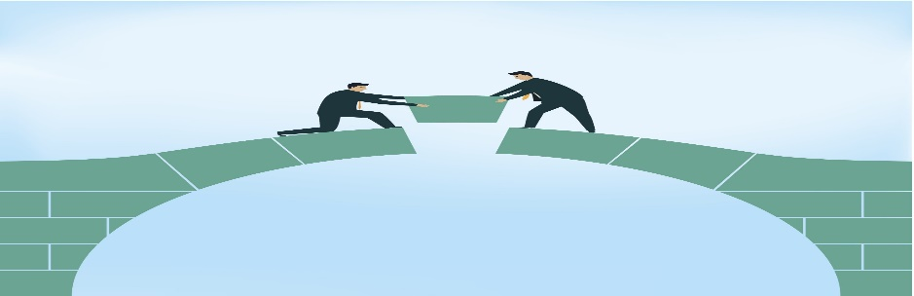 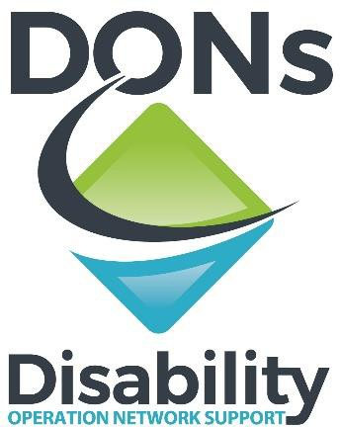

***The Bridge – Multidisciplinary team of Counsellors and General Therapy Assistants***

* *Disability Operation Network support (DON’s) will provide you with the support you need, through counselling with the added support of a therapy assistant.*
* *Therapy assistance entails a person centered/holistic approach which engages with both the participant and service providers to bridge the gap in accessing and engaging with mainstream services or allied health professionals.*
* *Increase your Knowledge and Skills to manage your capacity to overcoming obstacles in order to achieving your desired outcome of bridging the gap between providers and participants.*

*“*Bridging the Gap between the participant and their formal supports.”

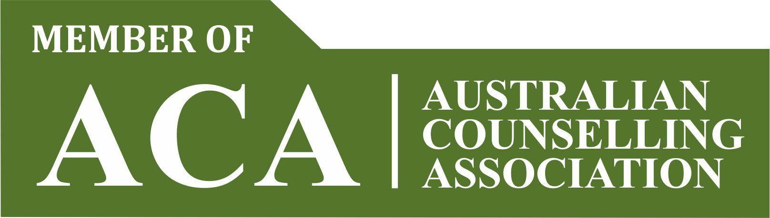

* **Develop Wellbeing, Recovery Plan including a Safety Plan: Which will include Emergency contacts, counselling helplines, NGO helplines. (If needed)**
* **Link you with Recovery Focused Support Groups or other mental health peers, mentors/ support workers.**
* **Communicate, Connect, Engage and Liaise with Non-Government and, Government services including NDIS services and department.**
* **The Bridge will also support you to engage and connect with other relevant specialised professionals such as; Allied health, Health, Mental health, Drug and alcohol, housing, DCJ including legal services. or services, including Support Coordinators and Psychosocial Recovery Coaches.**

Call us on 0404236505 to chat to our Multidisciplinary team or alternatively, email [thebridge@donsupport.com.au](mailto:thebridge@donsupport.com.au)