Newkirk Main Street  
 Board Agenda - January 21s', 2020  
Next Meeting: February 18'h, 2020 5pm

* Approve December Minutes: vote  
* Approve December Treasurer's Report: vote

New Business  
* Discuss, consider and possibly approve Design Grants  
 o Faith & Robert Capone 116 W. 7'h St.  
 ffl Paint & Fagade Grant §250.00 Estimated S5,000.00  
 u Upper Window Grant S500.00 Estimated Sl,200.00  
 Energy Grant S500.00 Estimated S4,000.00  
 Structural Grant S500.00 Estimated 95,000.00  
 * Grant approval total:51,750.00  
 * Estimated work total: S15,200.00  
 o NMS Contribution: 11.51%  
 o William & Stephanie Tucker 120 W 7'h St  
 *s* Has resubmitted grant applications with corrections made  
 Design committee will consider at their February meeting

Old Business  
* Discuss, consider, and possible vote on changing NMS fiscal year to July 1 through June 30  
 o Lisa is continuing to advise against this and feels strongly enough about it to resign  
* Discuss, consider and possible vote on proposed financial policy revised 1/15/2019  
* Discuss, consider, and possible vote on proposed 2020 budget  
* Discuss annual evaluation of program manager conducted 12/18/2019  
* New By-Laws, Mission & Vision Statements went into effect Jan 1, 2020  
* Main Street Now Conference will be held May 18 - 20fh in Dallas, TX  
 o 5189/night group room rate 5871.37 total  
 o 5169/night with loyalty club advance purchase (as of 1/15/2020), S1778.51 total  
 *s* Advance purchase S92.86 in savings  
 o Early bird registration closes February 3rd.  
* Office Report  
* Reinvestment Report  
* City Sales Tax  
* Volunteer Hours

Newkirk Main Street  
Minutes of Board Meeting December 16, 2019

In attendance: Sue Roy, lane Thomas, Richard Hinthorn (excused due to emergency), Dawn Brakey, Holly  
Cline, Jason Shanks, Maggi Hutchason. Staff present: Alyssa McCleery

Meeting called to order at 5:00 p.m. by President Sue Roy. Quorum was established.

* Discuss, consider and possible vote on changing NMS fiscal year to July I-June 30.  
 Consideration was given to changing the fiscal year in order to be consistent with other Main Street  
 communities, State Main Street, and the City. Action was tabled for additional information.  
* Discuss, consider and possible vote on mission and visions statement amendments.  
 At the recommendation of OMS, these statements need periodic review. Dawn Brakey provided the  
 definition of a vision statement as the guide for the desired future position of the organization. The  
 mission statement is the aims and objectives. With review and discussion of several proposals  
 provided in advance of the meeting, the following statements were adopted:  
 *Newkirk Main Street's vision to improve the quality of life by strengthening the historic core ofthe*  
 *community through concentrated efforts in Organization, Promotion, Design, and Economic Vitality.*  
 *Our Mission: Newkirk Main Street will continue to grow and develop* os *a result ofsupport from our*  
 *volunteers, local businesses, partnering organizations, and sponsors, who* o// *share a belief that a*  
 *strong downtown is* an *essential component to the integrity of our historical community.*  
 Motion made by Thomas, second by Brakey to accept the new Vision Statement. All Aye.  
 Motion made by Thomas, second by Cline to accept the new Mission Statement. All Aye.  
* Discuss, consider and possible vote on by-law amendments.  
 A first draft of the by-laws was reviewed at the November work session and the corrected copy was  
 distributed to the board prior to this meeting. Hutchason, representing the ad hoc by-laws committee,  
 reviewed the changes:  
 o Added tax exempt status  
 o Replaced "members" with "supporters" as recommended by Oklahoma Main Street, as  
 members implies exclusivity  
 o Amended Board of Directors section to include compliance with Open Meeting Act, board  
 orientation process, defined board duties, identified conflict of interest, added insurance  
 responsibilities  
 o Amended Board Officers section to included Treasurer as a board member, added Executive  
 Committee as responsible for sound fiscal and management policies and procedures,  
 o Added Finance responsibilities  
 o Added amendment procedures  
 Motion made by Hutchason, second by Shanks to approve the by-laws with the insertion of the new  
 vision statement and a correction of the fiscal year. All Aye.  
* Discuss, consider and possible vote on financial policy. Consensus was to table for further review.  
* Discuss, consider and possible vote on action plans. The committees have amended the plans in  
 compliance with OMS guidelines. Motion by Shanks, second by Cline to approve. All Aye.  
* Discuss, consider and possible vote on 2019 budget, as preparation for 2020 budget.  
 o Discussion included identifying all categories of income to balance the budget. Motion made  
 by Shanks, second by Brakey to approve the budget, contingent upon the recommended

modifications.

NMS Dec 2019 page two  
* Discuss, consider and possible vote on annual evaluation of program manager. Consensus was to  
 utilize a format that gathered information from the Chairperson and the staff before convening a  
 meeting to complete the evaluation before the holiday break.  
* Minutes of November 2019. Motion made by Cline, second by Shanks to approve. All Aye.  
* November Treasurer's Report. Consensus was to accept for audit.

New Business:

* Discuss, consider and vote on design grants  
 o William and Stephanie Tucker 120 W 7fh. Tabled for additional clarification of specific work done.  
 o Mario Venegas 108 N Main. Motion by Hutchason, second by Thomas to approve. All Aye.

Old Business:

o Main Street Now Conference May 18-20fh. Early bird registration closes Feb 3  
o Reports provided: Reinvestment Report, City Sales Tax, Office report, EV Committee report,  
 Promotion Committee report, Design Committee report

Due to staff hours exceeding the allowable hours year-to-date, the Main Street office will be closed  
December 23-January 1.



NEWKIRK IVI AIN STREET INC  
Statement of Assets, Liability, & Equity  
 December 31, 2019

Current Assets  
 CASH-GENERAL  
 CASH-SPECIAL PROJECTS  
 CASH-DESIGN GRANT  
 CD# 1450

Total Current Assets

Total Assets

ASSETS

$ 4,942.45  
 62,781.94  
 5,237.97  
 23 *943.30*

96 905.66

$ 96 905.66

NEWKIRK MAIN STREET INC  
Statement of Assets, Liability, & Equity  
 December 31, 2019

Current Liabilities  
Equity  
 CAPIT AL - NEWKIRK MAIN ST  
 112 W. 7th  
 DESIGN GRANTS ISSUED  
 Current Income (Loss)

Total Equity

LIABILITIES AND EQUITY

70,836.62  
 (421.89)  
(3,632.91)  
30 123.84

96 905.66

Total Liabilities & Equity

$ 96 905.66



NEWKIRK M AIN STREET INC  
 Statement of Revenue & Expense  
For the Period Ended December 31, 2019

Revenue  
 PLEDGE  
 CHARLIE ADAMS DAY  
 GRANTS  
 CHILDREN'S SHOP  
 DESIGN COMM{TTEE  
 DONATIONS  
 PROMOTIONAL COMMITTEE  
 LEADERSHIP CLASS  
 LOCAL BANQUET  
 RENT AL INCOME  
 BUSINESS WOMEN LUNCHEON  
 ST ATE BANQUET INCOME  
 INTEREST INCOME  
 BUILDING IMPROVEMENT DONATIO

Total Revenue

Operating Expenses  
 WAGES  
 UTILITIES

ADVERTISING  
SUPPLIES  
POST AGE  
TELEPHONE  
CLEANING  
INSURANCE  
WORKERS COMP INSURANCE  
REPAIRS & MAINTENENCE  
MAINTENENCE - COPIER  
PEST CONTROL  
MANAGER/VOLUNTEER TRAINING  
DUES/SUBSCRIPTIONS  
PRINTING  
LEGAL & ACCOUNTING  
PAYROLL TAXES  
ORGANIZATION COMMITTEE  
PROMOTION COMMITTEE - OTHER  
PROMOTION-CHARLIE ADAMS DAY  
JUNIOR MAIN STEET COMMITTEE  
ST ATE BANQUET  
HOLE IN THE WALL-LAWN CARE  
MISC EXPENSE

Total Operating Expenses

l Month Ended  
Dec. 31 2019

$ 4,310.00  
 0.00  
 0.00  
 5Ii .00  
 162.25  
 o.oo  
 0.00  
 0.00  
 0.00  
 0.00  
 0.00  
 0.00  
 131.40  
 2 200.00

7,314.65

1,180.00  
144.29  
 20.00  
 3.00  
110.00  
104.32  
 60.00  
 0.00  
 69.33  
 0.00  
161.30  
120.00  
 0.00  
 o.oo  
 0.00  
200.00  
 90.27  
264.17  
109.05  
 0.00  
 o.oo  
 0.00  
 0.00  
 21.37

2 657.10

Pct

58.92  
0.00  
0.00  
6.99  
2.22  
0.00  
0.00  
0.00  
0.00  
0.00  
0.00  
0.00  
i .80  
30.08

100.00

16.13  
i .97  
0.27  
0.04  
1 .50  
1.43  
0.82  
0.00  
0.95  
0.00  
2.2 i  
I .64  
0.00  
0.00  
0.00  
2.73  
i .23  
3.61  
I .49  
0.00  
0.00  
0.00  
0.00  
0.29

36.33

12 Months Ended  
Dec. 31 20 19

$ 18,585.00  
 16,074.28  
 4,700.00  
 5I1 .00  
 83 i .25  
 285.51  
 i ,079.90  
 2,100.00  
 I ,040.00  
 87.00  
 431.00  
 315.00  
 535.07  
 2 200.00

*48,775.O* I

14,160.00  
3,460.21  
 254.86  
 805.60  
 448.99  
1,180.00  
 690.00  
2,795. 14  
 280.67  
 345.75  
i,342.87  
 585.00  
3,825.64  
 428.60  
 19].74  
2,400.00  
1,!85.94  
I ,306.68  
 998.19  
i3,818.42  
 (5.20)  
 585.00  
 55.00  
 202.99

51 342.09

Pct

38.10  
32.96  
9.64  
1.05  
1.70  
0.59  
2.21  
4.31  
2.13  
0.18  
0.88  
0.65  
1.10  
4.5]

ioo.oo

29.03  
7.09  
0.52  
1.65  
0.92  
2.42  
i .4 ]  
5.73  
0.58  
0.71  
2.75  
 ] .20  
7.84  
0.88  
0.39  
4.92  
2.43  
2.68  
2.05  
28.33  
(0.01)  
1 .20  
0. 11  
0.42

105.26

Operating Income

4,657.55

63.67

(2,567.08)

(5.26)

AMPITHEATER DONATIONS  
 Total Other Income  
 Net Income (Loss)

I Month Ended  
Dec. 31 2019

2 *946.76*  
 2 946.76  
$ 7 604.31

Pct

12 Months Ended  
Dec. 31 2019

Pct

40.29 32 690.92 67.02  
40.29 32690.92 67.02  
103.96 $ 30 12 .84 61.76

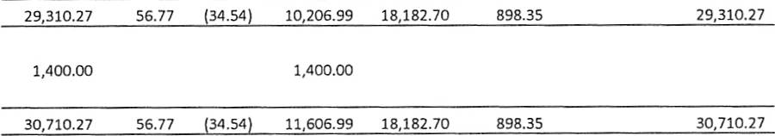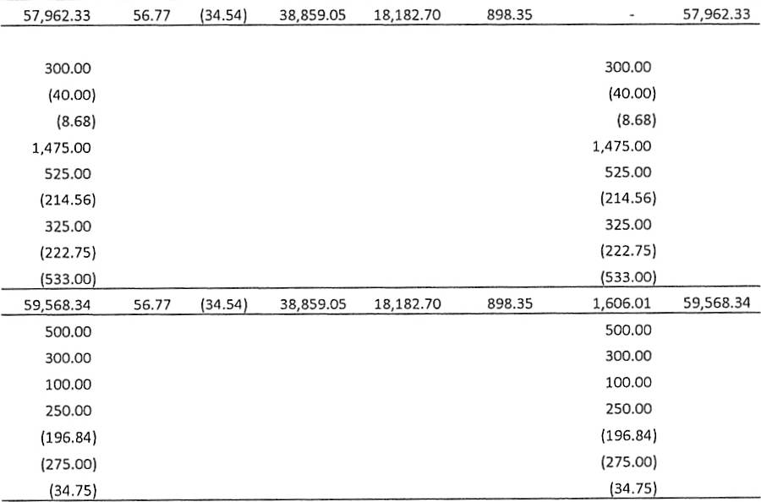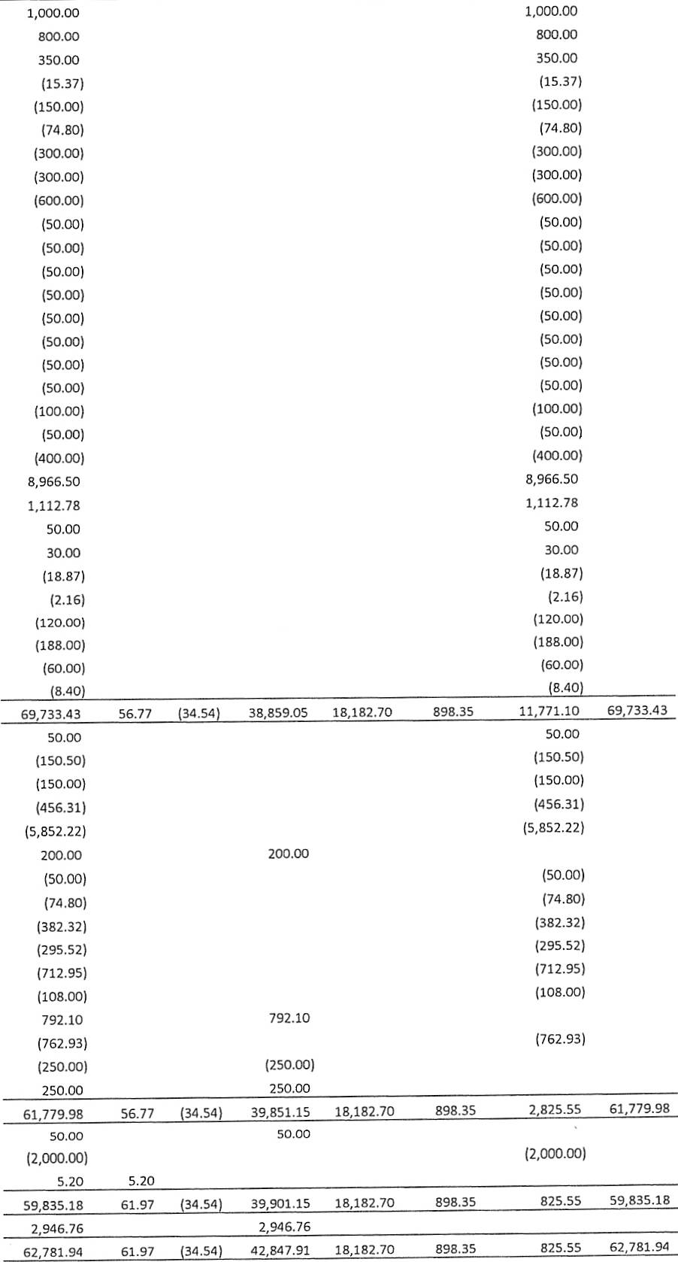

Nsw Itmn (tweet

Special Pio)ecii

led Hhrjley

toundxtion

Brlinte 01701/l'l

1/8/2019 Doc'i Food-Chnitmri Shop piiih

Bhlxnte 01/OR/l!I

)75/2019 NKComm Cheit-Amphithette+

aalaiiee o2QR7z(119

(30 25} (30 25i

5713{2Dlal Children'i Quttjet lundtiiiet

5/14/20)al Smijh Tum/S lnve-Amphitheztei

S/20/)019 Dougloi ind Sandy Cline-Amph

2,052 06

10,000 00

5/30/2019 Brewe+ThmilyT+uitAmph

Bzlrnte 06/30/201!1

7/9/2019 CA DIV Donhjioni

7/9/2019 New}ir} C of C CA Dty baojh

)79/2019 Alyiia reim GA dty O(l poxtet

7/22/)Olal CA Day Donrtioni

1Q3QO19 CA [)av [)onaliohi

7/23/)019 Alyiix reim. jiffy Shitli jihuji

77291201'l CA D!V Donhjioni

7/29/2019 Alyiia ieim Vinyl for CA D!V t-ihiili

)/2!1/2019 Aihley kontneilhbor an CA D{V ti+utji

Bzlrnte 07/31/)Ol'l

B/15/2019 CADtyDonrtion-(quity  
8715/201!I CA Dhy Donajioni  
8/20/2019 CA Diy DOn!tlOn!  
8/)7/201g CA Div Donajioni  
87))/)019 Alyiia reim CA Diy tuppliei  
R727QG1A Cheitikee Stnp Compxny-Tttnl ieiital  
8729/)019 Alyiia reim CA IVtt Poiteti

15,000 00

rs.ooo oa

%lhnte 08131/2D19

9/9/2019 Mi}eKingi  
9/9/2019 Bltt}welllaumtlTribune  
9/!1/2019 lhrry Newiom  
9/9/201!I Dhle & Gxyle Fitenhhuer  
g/972o)9 Bill Wetiel  
9/9/2019 lrVinz Spotted Behr Clhr}  
9j9t2Gl9 Carol Henioii  
V9/201!1 Tim Henio  
91972019 Kim ShaTei Shink  
9/9/2019 Htnnxh Ctoi+  
9/9/2019 Bob podgeii  
9/9/2019 Bnxn Hetmrnion  
9/g/2019 Cndy 8ogle  
9/10/201!1 Wayne White  
9/11/2019 Dawn Milli  
9/16/)019 CA Day proteedr  
9/16/2019 CADayptoceedi  
9724/)019 Bnhn Heimrniondonzted itoryjelling time  
9Q4/2019 CA [)hy-T ShiiltHutehhton  
*9114120}9* lunte Shinn  
g/z4720tg Alyiit Winner MtCleery

Balznte 09/30/2019

10/1/2019 CA D{V Donrjion  
10/1/)019 Mtin 5jteej Bxkety  
10/1/2019 Ctoii Around to+geTom Nelion  
IOQ/)019 Chry't Septic ILC  
10/1/)019 Dot'i Tood Sjorei InC  
ro/ij:ioig Deporit-KahleEMetpmei  
10/7/2019 Strgetorth ChTetmg & BBQ  
'io/772Dxg Blhtkwell toumrl Tribune  
ro/)7zotg Cowlgy Couner-Trhvler  
107)/)Olal Ponta Cijy Newt  
10/7/20tF Newki+} Heinld loumrl  
10/7/201!) Tehm Rhdio  
10/15/:!019 ttu leit  
10/17/2019 0TC Shlpi TIN Tar *CAD*  
10/22/20ig City of Aikinihi Ci+y-Movis Night- Ampi  
10/29/)019 Donzliiin to covet movie niHht-Ampifh

aalaiice 10{31/2019

1174/)019 AmpH:thetiet son!iiiin  
llllzQors CAo proceeds to Genetal ACCt  
11 /25/)01 *9* Anonvmoui Chih

3xlhnte 11/3oQO)9

12716/)01g

srlrnte 1)/31/)Ol'l

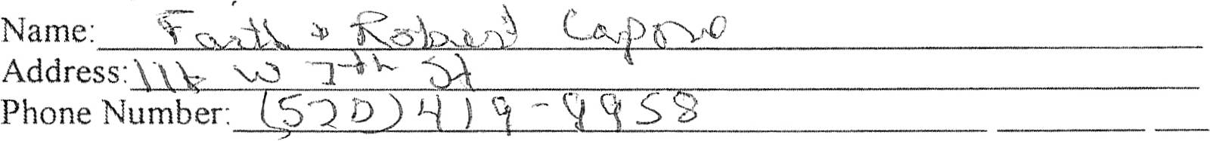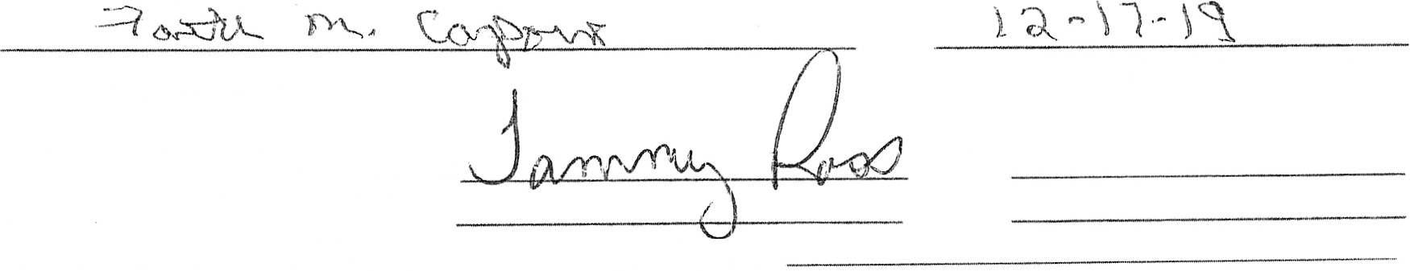

Newkirk Main Street Grant Application

Upper Window Grant - $500  
 Paint/Fagade Grant - $250  
 Structural Grant - $500

Back Door Grarit - $250  
Energy Grant - $500  
Guttering & Downspout Grai'it - match up to $200

Applicant must meet the following criteria:

; Commitment to complete work within 90 days of notification  
 Owner(s) and tenant(s) of building are agreeable to mork to be done  
*,Party* responsible for funding is in agreement with work to be done  
 >Project funding is in place  
 )e Applicant agrees to follow Design Committee recommendations

Documentation  
Building Owner:

Tenant'

Name: ---'--'  
Address:  
PI"ione Number:

Project Description

EEXstlismtlnatgedcOcnodsl.ttolOfneOnftibreulplrdoljnegct regarding this grant only(: = e)0. 66

Applicant Signature

Design Committee Approval  
Main Street Board Approval  
Required completion date for funding of grant:

Date of application

Date

Date

Revised :2-24-16

(O'lJ;-0

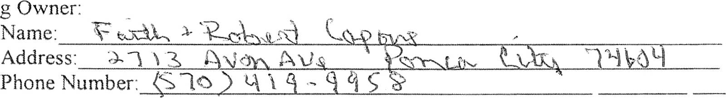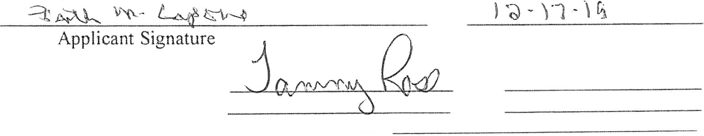

Newkirk Main Street Grant Appljcation

!Upper Window Grant - $500  
 Paint/Fagade Grant - $250  
 Structural Grant - $500

Back Door Grant - $250  
Energy Grant - $500  
Guttering & Downspout Grant - match up to $200

Applicant must meet the following criteria:

Commitment to complete work within 90 days of notification  
 Owner(s) and tenant(s) of building are agreeable to vork to be done  
2Party responsible for funding is in agreement with work to be done  
 Project funding is in place  
2Applicant agrees to follow Design Committee recommendations

Documentation

115 W l'

Tenant:

Name:

Address:

Phone Number:

Project Descriptioxi

Description of work planned for this grant only; fl -Ae -C -

EEXstlismtlna:gedcOcnodsl.ttloofneOntfirbe,%ldroljnegct reqThrding this gran,t only:

*S* 20<>. o o

Design Committee Approval  
Main Street Board Approva!  
Required compaetion date *ror* fundixig of grant:

Date of application

Date  
Date

Revised 2-24-16

,5-\SGi

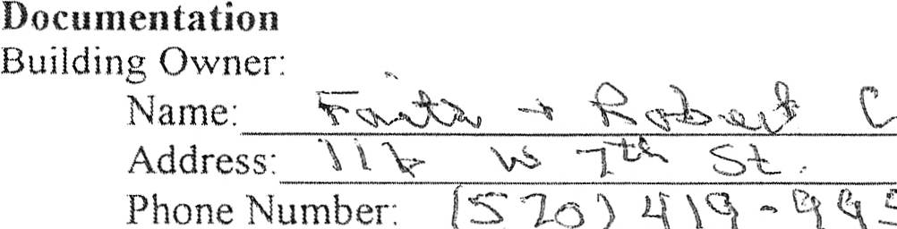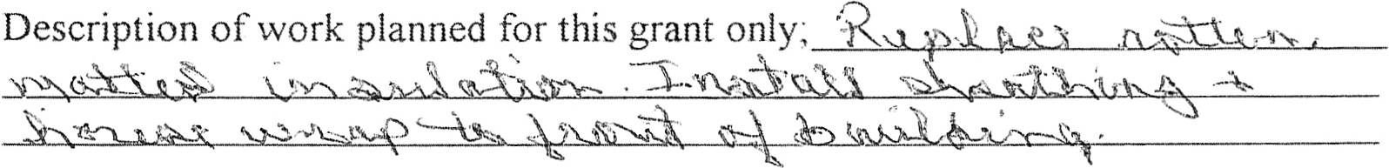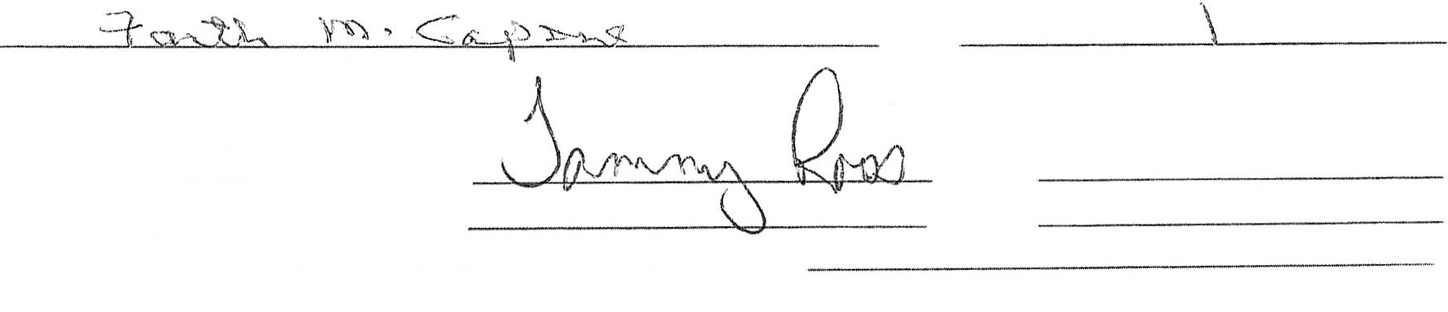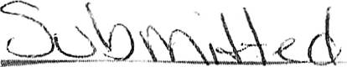

Newkirk Main Street Grant Application

Upper Window Grant - $500  
 Paint/Fagade Grant - $250  
 Structural Grant - $500  
 Back Door Grant - $250  
 Energy Grant - $500  
 Guttering & Downspout Grant - match up to $200

Applicant must meet the following criteria:

Q Cominitment tO coinplete work within 90 days ofnotitication  
*2j* Owner(s) and tenant(s) of building are agreeable to work to be doi'ie  
X Party responsible for funding is in agreement with *ork to be done  
 'g Project funding is in place  
X Applicant agrees to follow Design Committee recommendations

Th'V'%A

Tenant'

Name: "'  
Address:  
Phone Number:

Project Description

Estimated cost of entire project regarding this grant only' *4-f* =->oo - <) -s  
Existing condition of building:

Applicant Signature

Design Coi'nmittee Approval  
Main Street Board Approva!  
Required completion date for funding of grant:  
 Revised 2-24-16

Th k- }-l - ')  
 Date of application

Date

Date

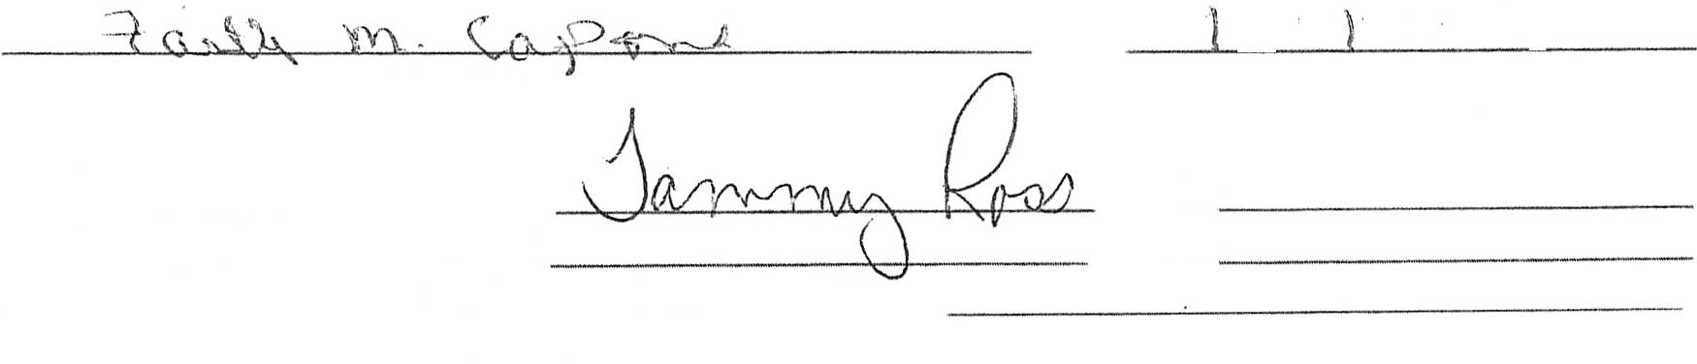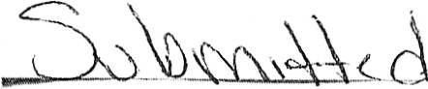

Newkirk Main Street Grant Application

Upper Window Grarxt - $500  
 Paint/Fagade Grant - $250  
 Structural Grant - $500

Back Door Grant - $250  
Energy Grant - $500  
Guttering & Downspout Grant - match up to $200

Applicant must *meet* the following criteria:

"yC' Commiti'nent to cornplete work within 90 days of riotification  
 O"ner(s) and tenant(s) of building are agreeable to work to be done  
 Party responsible for funding is in agreement with work to be done  
 Project funding is in place  
 Applicant agrees to follow Design Coinmittee recommendations

Docunientation  
Building Owner:  
 Name: F  
 Address: ") 'S %v  
 Phone Number:

Tenant:

Name:  
Address:  
Phone Number:

Project Description

Description of work planned for this grant only: 'Q h-xSi - A '2   
 .S-

Estimated cost of entire project regarding this grant only *"5* ..) 0 o . < ) ,  
Existing conditioi'i of building: - "

Applicant Signature

Design Coinmittee Approval  
Main Street Board Approval  
Required completion date for funding of grant:  
 Revised 2-24-16

g, - 1- % '7%  
Date of application

Date

Date

1.4: This cannot truly be accomplished until we have an accurate accounting of what belongs to

NMS and what is Newkirk Historical Society property.

4.6: IRS statute of limitations is 3 years; Lisa recommends to all of her clients to maintain all  
financial records for 7 years.

11.3: I use personal card for all travel and office expenses.

I have followed up with Equity Bank and they currently do not offer a business credit  
card. There is a "Charity Charge" credit card issued by Commerce Bank that is specifically for  
non-profits and is not based off a personal credit report.

Duties between accountant & treasurer will have to be determined.

Rev. 1/15/2019

1



Financial Policy Statement

Newkirk Main Street (NMS) is committed to responsible financial management. The entire  
organization, including the Board of Directors and staff, will work together, as financial  
stewards, to make certain that all financial matters of the organization are addressed with care,  
integrity, and in the best interests of NMS and the general public.

The policy and procedural guidelines contained in the handbook are designed to:

Protect the assets of NMS:  
Follow separation of duties and procedures to the extent practical:  
Ensure the maintenance of accurate records of NMS's financial activities;  
Provide a framework of operating standards; and  
Ensure compliance with federal, state, and local legal and reporting requirements.

The Executive Committee have the responsibility for administering these policies and ensuring  
compliance with procedures that have been approved by the Board of Directors. Exceptions to  
written policy may only be made with the prior approval of the Executive Committee or Board  
of Directors.

Changes or amendments may be made to these policies at any time with the approval of the  
majority of the Board of Directors and a complete review of the policies shall be conducted  
annually.

Every Director and Staff member is expected to be familiar with and operate within the  
parameters of these policies and guidelines.

Rev. 1/15/2019

2

NEWKIRK MAIN STREET FINANCIAL MANAGEMENT POLICIES

The Board and Staff of NMS will adhere to the following policies.

1. Assets - Safeguarding  
 1.1. The Treasurer, Program Director, and Board of Directors shall have primary  
 responsibility for ensuring that proper financial management procedures are  
 maintained and that the policies of the Board are carried out.  
 1.2. The Treasurer, Program Director, and Board of Directors shall provide fiscal oversight in  
 the safeguarding of the ASSets of the Organization and shall have primary  
 responsibilities for ensuring that all internal and external financial reports fairly present

its financial condition.

1.3. A proper filing system will be maintained for all financial records.  
1.4. Documents on all securities and fixed assets will be kept in a locked, fireproof file.  
 Inventory records will contain description, serial numbers, date of purchase or receipt,  
 valuation, and date of valuation.  
1.5. Appropriate insurance for all assets will be maintained.  
1.6. Treasurer will make monthly back-up of all financial records.

2. Annual Review  
 2.1. The Board of Directors recognize the value of an Audit, however, given the expense, an  
 Annual Review will be conducted by the Board of Directors at the end of the fiscal year.

3. Disbursements  
 3.1. All NMS checks will require signature from the Treasurer and one other signee as  
 approved by the Board of Directors  
 3.2. The Treasurer and signee(s) will sign checks for the organization consistent with the  
 budget  
 3.3. Any changes to authorized signatures shall be approved by the Board of directors  
 3.4. All disbursements shall be made by check and shall be accompanied by substantiating  
 documentation  
 3.5. The Treasurer will keep unused check supplies safeguarded under lock and key.  
 Individuals responsible for preparing checks will accurately record the numbers used on  
 a timely basis. The Treasurer will verify that check numbers are used in sequence and  
 questions any missing checks.  
 3.6. All voided checks must be defaced and retained either on the check stub or with  
 canceled checks.  
 3.7. No checks may be written to "cash" or "bearer" unless approved by the Treasurer or  
 President

Rev. 1/15/2019

3

3.8. Petty Cash - no ongoing petty cash account is authorized. Petty cash may be obtained  
 as needed for events. Petty cash shall always be kept secured.

4. Receipts  
 4.1. Receipts shall be kept on file with Treasurer.  
 4.2. All checks shall be endorsed "Deposit Only" immediately upon receipt.  
 4.3. All cash receipts shall be recorded on pre-numbered duplicate receipts.  
 4.4. A copy of the deposit slip from the bank shall be compared and attached to the  
 corresponding receipt copies and cash filing.  
 4.5. Deposits shall be made in a timely manner and at a minimum of once a week. All un-  
 deposited revenues will be safeguarded under lock and key.  
 4.6. All back up for deposits will be retained for a minimum of seven (7) years.  
 4.7. Any discrepancies on deposits will be reported to the Board of Directors immediately.

5. Bank Statement Reconciliation  
 5.1. The Treasurer will maintain a record of all bank transactions, listing all checks disbursed  
 and all receipts deposited.  
 5.2. All bank statement will be opened and reviewed in a timely manner. Bank  
 reconciliation and approval will occur within 30 days of the close of the month.  
 5.3. On a monthly basis, the Treasurer will reconcile the bank statements and notify the

Executive Board of any discrepancies.

6. Budgets  
 6.1. The Program Director, in cooperation with the Treasurer and Executive Board, will  
 prepare an annual operation budget, which will be approved by the Board of Directors  
 no later than the June Board Meeting. The budget will include an operating statement  
 of revenues and expenses and an annual program of work which includes committee  
 project listings.  
 6.2. The budget should be reviewed annually at a minimum

7. Chart of Accounts  
 7.1. The Treasurer will maintain a chart of accounts. The chart of accounts will be updated  
 yearly for changes and updates during budget preparation.

Rev. 1/15/2019

4

8. Financial Reporting

8.1. Budgets are adjusted by the Executive Board as necessary to reflect changing

conditions.

8.2. Non-standard journal entries shall be discussed with a CPA to ensure proper accounting

treatment.

8.3. The Treasurer will administer the preparation of financial reports to the Board of

Directors at each board meeting.

9. Indemnity

9.1. To the full extent that it shall have from time to time under applicable law and in the

manner from time to time prescribed or permitted by applicable law, NMS may

indemnify an past, present, or future Director, Officer, Employee, or Agent of against all

costs, expenses and liabilities, including attorneys' fees, actually and necessarily

incurred by or imposed upon them in connection with or resulting from their

involvement with NMS.

10. Investment

10.1. The Executive Committee will recommend to the Board of Directors, for approval, any

investments deemed necessary. NMS will follow the investment objectives listed

below, in order of importance:

10.1.1. Safety of Principal

10.1.2. Liquidity

10.1.3. Competitive Rate of Return

11. Expenses

11.1. An approved receipt or expense statement is required for all disbursements made to

reimburse staff and volunteers (including but not limited to the Board of Directors and

committee members). The receipt or expense statement shall be approved by the

Program Director and the Treasurer in the case where disbursement is requested by a

Board Member.

11.2. An approved receipt or expense statement shall be submitted to the Program Director

before being passed onto the Treasurer for payment.

11.3. Travel Expenses for the Program Director shall be incurred on the company credit

card, with all expenses requiring accompanying receipts. Travel expenses that may not

be reimbursed include the following:

* Airline club memberships.

Rev. 1/15/2019

5

@ Airline upgrades.  
* Business class for domestic flights or first class for all flights.  
* Childcare, babysitting, house-sitting, or pet-sitting/kennel charges.  
* Commuting between home and the primary work location.  
* Costs incurred by traveler's failure to cancel travel or hotel reservations in a  
 timely fashion.  
* Evening or formal wear expenses.  
* Haircuts and personal grooming.  
* Laundry and dry cleaning.  
* Passports, vaccinations and visas when not required as a specific and necessary  
 condition of the travel assignment.  
* Personal entertainment expenses, including in-flight movies, headsets, health  
 club facilities, hotel pay-per-view movies, in-theater movies, social activities and  
 related incidental costs.

* Travel accident insurance premiums or purchase of additional travel insurance.  
* Other expenses not directly related to the business travel.

11.4. The Program Director is to be reimbursed for mileage when he/she is driving their  
 personal vehicle in the course of doing business for NMS. The mileage rate is to be  
 consistent with the IRS rate allowance.  
11.5. Any out-of-town travel involving an overnight stay must have approval of the Board of  
 Directors.  
11.6. Invoices and bills shall be opened and reviewed by the Program Director before being  
 passed on the Treasurer for payment.  
11.7. Copies of all invoices paid in full will be filed with the Treasurer.-shall be maintained  
 for a minimum of seven 7 ears

12. Record Retention

12.1. All financial records shall be maintained for a minimum of seven (7) years; those  
 records listed below as follows:  
 Audited and un-audited financial statements  
 Tax Returns  
 Bank Statements  
 Canceled checks  
 Copies of paid bills  
 Records of receipts and what receipts are for  
 Long term contracts and leases  
 Board Minutes

Membership meeting minutes

Rev. 1/15/2019

6

13. Signature authorities - Contracts

13.1. The Program Director has the authority to sign contracts for services for events as long

as the financial implications of the contract are included in the organization's budget.

Recurring contracts can be approved by the Program Director if the contract financial

implications are approved as part of the annual budget. If the financial implications of

signing a contract are not included in the organizations budget, the Executive

Committee's approval is required before authority to sign the contract is granted.

14. Signature Authorities - Banking and Financing

14.1. Authority is granted for the following activities as described in the table below. The

organization's financial duties are distributed among multiple people to help ensure

protection from fraud and error. The distribution of duties aims for maximum

protection for the organization's assets while also considering efficiency of operations.

15. Taxes

15.1. The Treasurer shall file all necessary monthly and yearly reports in a timely manner.

16. Operating Reserve

16.1. The amount of the operating reserve will be calculated each year after approval of the

annual budget, reported to the Board of Directors. The operating reserve will be funded

with surplus unrestricted operating funds. The target minimum operation reserve fund

for the organization is three (3) months of average operating costs. The calculation of

average monthly operating costs includes all recurring predictable expenses such as

salaries and benefits, occupancy, office, travel, program, and ongoing professional

services.

Rev. 1/15/2019

7

|  |  |
| --- | --- |
| Activity | Authority |
| Opening additional accounts at current bank | Executive Committee |
| Line of Credit | Executive Committee with Board of Directors Approval |
| Check Signing | See Disbursement Policy |
| Authorized to negotiate & commit NMS to , financing arrangements | Board of Directors Approval |
| ' Entering a bank r-elationship - | Program Director with Board of directors' approval |
| Authorized to execute investments | Executive Committee with Board of Directors approval |

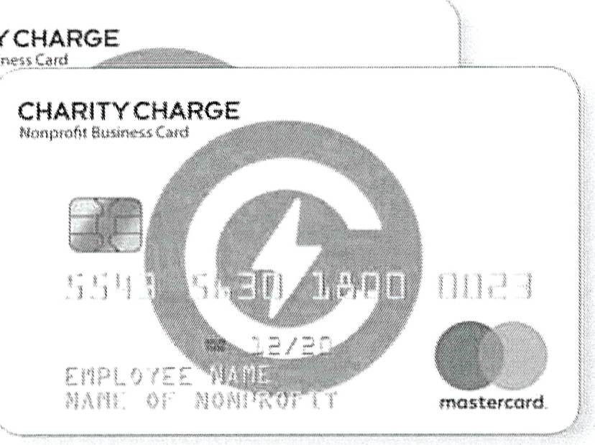

CHARITY CHARGE

The Qnly Credit Card Designed For Nonprofit Expenses  
Unique Benefits for Nonprofits - Backed by Commerce Bank

' l g ..s " al'

t

No Annual Fee

No Persorial Guarantor Required

Automatic Cash Back Rebates

Nonprofit cardholders also receive a dedicated account manager  
 and advariced onairie accouriting tools including:

!:2eal-time coritrol of employee card limits

Built-in eXpenSe reporting for ail cardholders at no cost

Custom

numerous

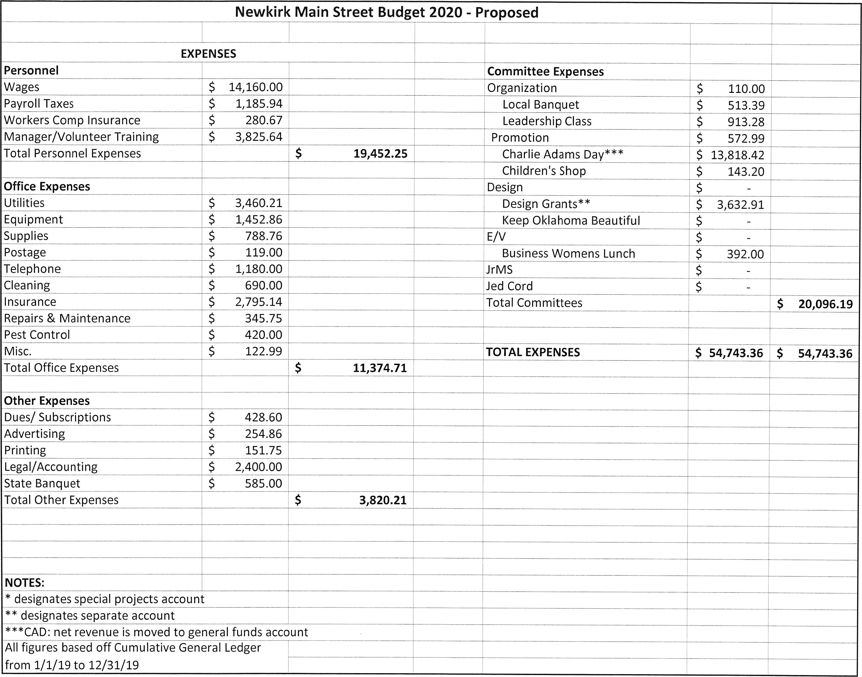

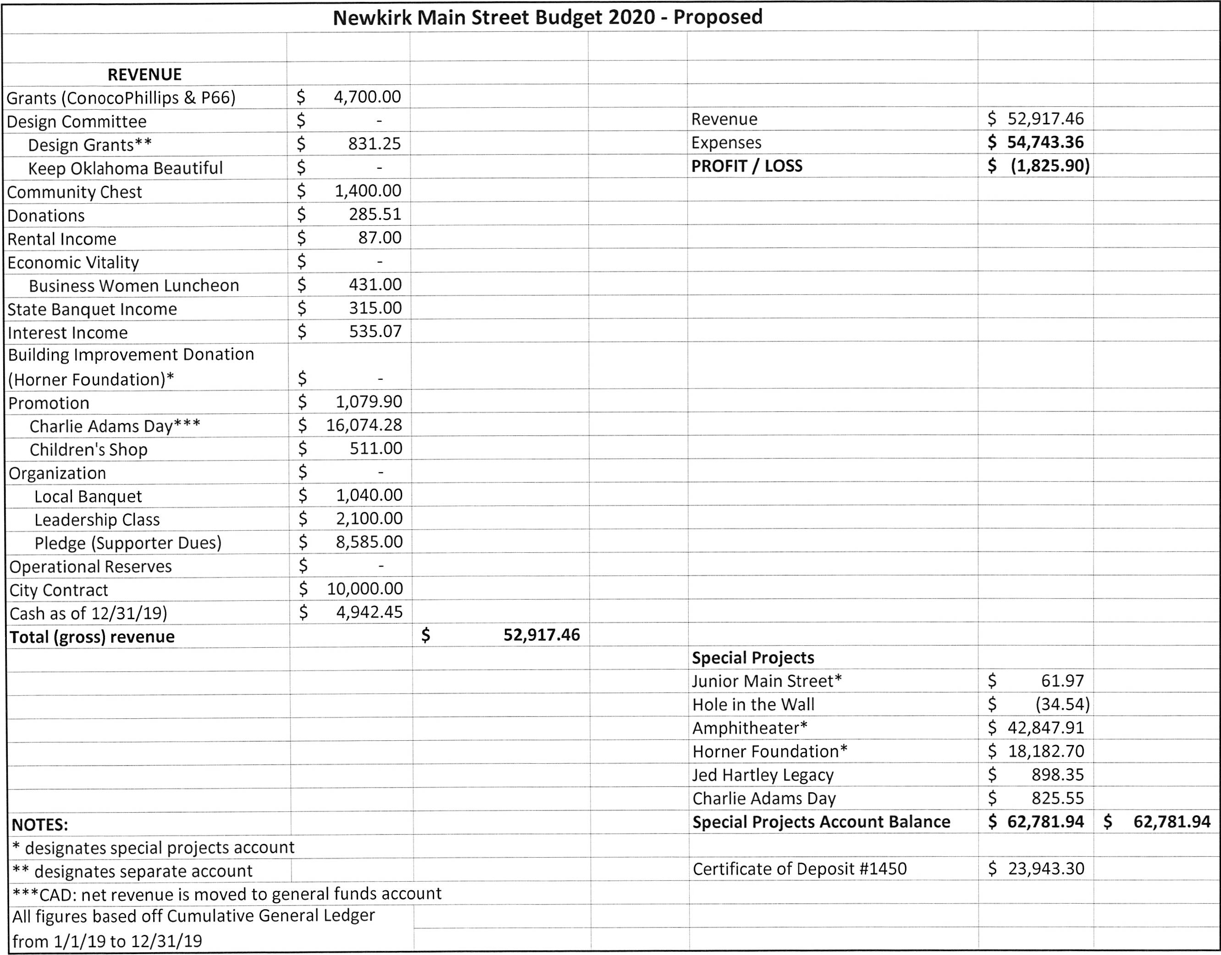



Newkirk Main Street Prograrri Manager Evaluation

Part 1: Evaluation is based on a scale from 1 to 5, with one being least desirable and five being most desirable.  
 l  
Ensure communication between committees is well established.  
-ASSiSt committee with implementation of work plans 4  
Manage all administrative aspects ofthe Main Street program 4  
 (purchasing, record keeping, reports to OMSC & NMSA)

Become familiar with all person and groups directly or indirectly  
 involved in the downtown commercial distrid.

ASSiSt the committees is developing the annual work plan.

Develop and conduct on-going public awareness and education  
 program designed to enhance appreciation of the downtown's  
 assets and foster an understanding of the Main Street programs'  
 goals and objectives

*3*

Use speaking engagements, media interviews, and personal appearances  
 To keep the program in the public eye.

3

Advise downtown merchants and Chamber of Commerce retail committees  
 on Main Street program activities and goals.

ASSiSt individual tenants or property owners with physical improvement projects

Encourage a cooperative climate between downtown interest and locat public officials.  
 Help build strong and productive working relationships with appropriate public  
 agencies at the local and state levels.

Develop and maintain data systems to track the process and progress of the local Main  
 Street program: economic monitoring, individual building files and sketches,  
 photographic documentation of physical changes, information on job creation  
 and retention.

3

Represent the community to important constituencies at the local state, and national  
 levels, Speak effectively on the program's directions and findings.

Maintain an organized office, presentable to visitors, keeping dependable open hours,  
 with files easily accessible to committee members.

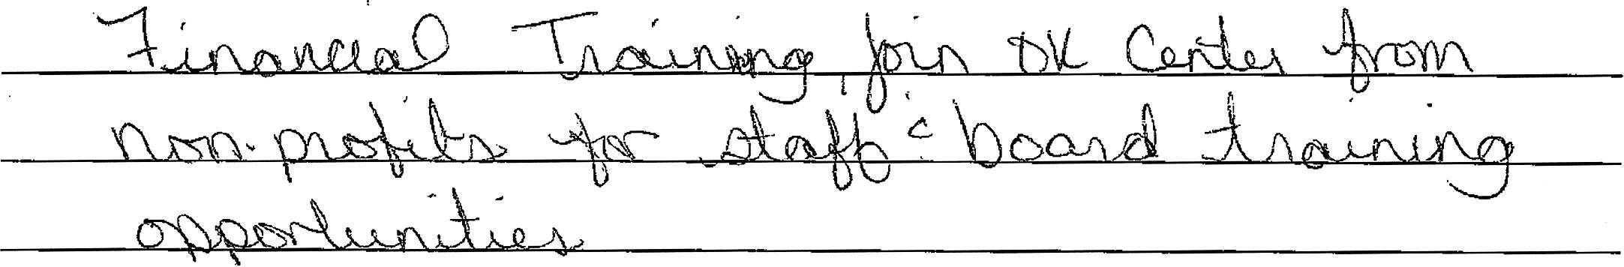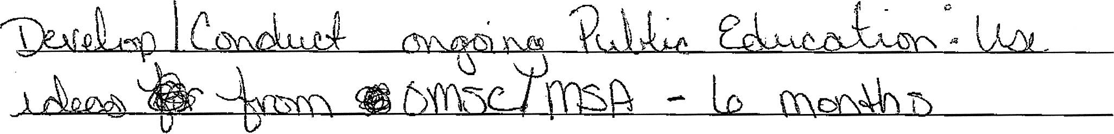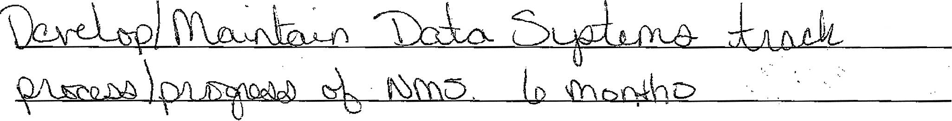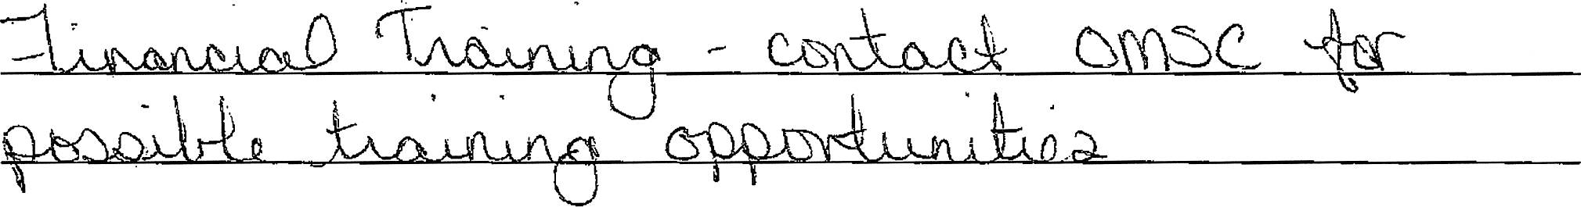

3. - What training or ski(Is development should be implemented that would fully develop employee's

potential?

PART 4: NEW GOALS

Listonetothreegoalstobeattainedbytheemployeebeforehis/hernextreview. Indicate  
preparation/training necessary to attain these goals and projected completion date. Goals must be realistic  
and reasonably accomplished as part of the employee's regular workload.

1.

2.

3.

APPRAISER: I have discussed all items reviewed in this form with the named employee.

Appraiser's Signature

Date

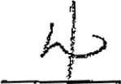

Newkirk Main Street Program Manager Eva!uation

Part 1: Evaluation is based on a scale from I to 5, with one being least desirable and five being most desirable.

Ensure communication between committees is well established.

ASSiSt committee with implementation of work plans

Manage all administrative aspects of the Main Street program  
 (purchasing, record keeping, reports to OMSC & NMSA)

Become familiar with all person and groups directly or indirectly  
 involved in the downtown commercial district. '

ASSiSt the committees is developing the annual work plan.

Develop and conduct on-going public awareness and education  
 program designed to enhance appreciation of the downtown's  
 aSSetS and fOSter an understanding Of the Main Street programs'  
 goals and objectives

LJse speaking engagements, media interviews, and personal appearances  
 To keep the program in the public eye.

Advise downtown merchants and Chamber of Commerce retail committees  
 on Main Street program activities and goa!s.

ASSiSt individual tenants or property owners with physical improvement projects

Encourage a cooperative climate between downtown interest and local public officials.  
 Help build strong and productive working relationships with appropriate public  
 agencies at the local and state levels.

Develop and maintain data systems to track the process and *progress* of the local Mairi  
 Street program: economic monitoring, individual building files and sketches,  
 photographic documentation of physical changes, information on job creation  
 and retention.

Represent the community to important constituencies at the local, state, and nationai  
 leve(s. Speak effectively on the program's directions and findings.

Maintain an organized office, presentable to visitors, keeping dependable open hours,  
 with files easily accessible to committee rriembers

%3

*)'Pll'*

7

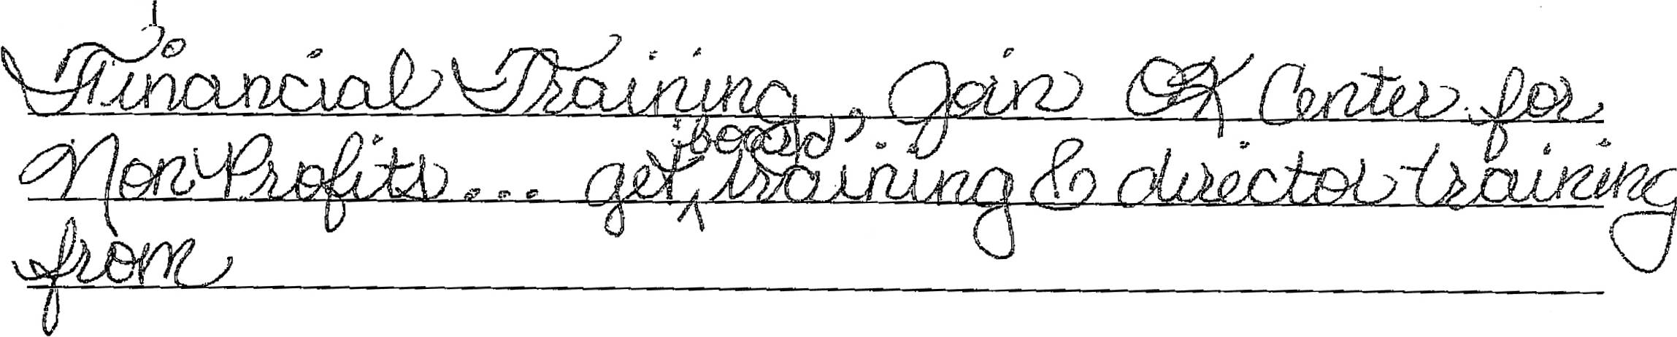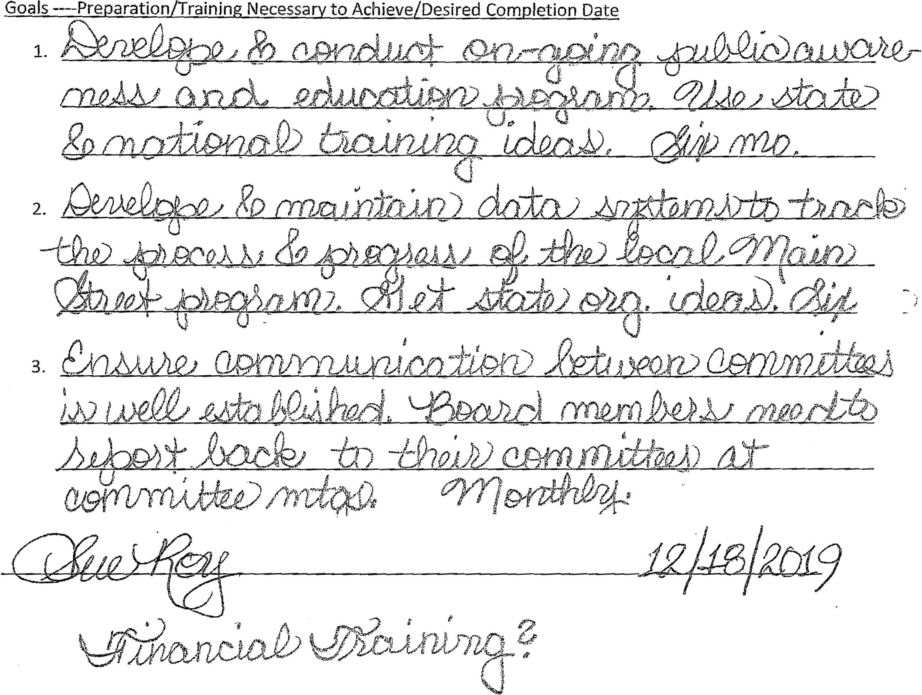

3. What training or skills deveiopment should 5e implemented that would fuliy deve(op employee's

potentia ?

PART 4: NEW GOALS

List one to three goals to be attained by the employee before his/her next review. Indicate  
preparation/training necessaty to attain these goa)s and projected completion date. Goals must be realistic  
and reasonabiy accomplished as part of the employee's regular workload.

*\ff....2;"q*  
APPRAISER: I have discussed al! items revi't'Wed in this form wkh the named,.etmployee.

Appraiser"sSignature Date

Office Report  
 Prepared by Alyssa McCleery  
December 12"h, 2019 - January 15'h, 2020

{* Prepared all committee agendas - Promotion Meeting was cancelled at II the day of the  
 meeting, no one attended E/V committee meeting  
/as Filed weekly reports with Lisa Kubik's office with exception of the week of December 23rd. I  
 prepared report and attempted to submit but Lisa's office was not open  
{* Filed the monthly reinvestment report with OMSC  
<* Designed & e-mailed the January events newsletter, a task that previously fell on the office  
 assistant  
 Attended all committee & city meetings apart from the December 23rd city meeting  
 Participated in the December lunch mob (Promotion event)  
 Assisted with Leadership Newkirk (Organization committee project)  
 Children's Christmas Shop (Promotion committee event)  
 o Workedwith4H/FFA(someareJrMSmembers)toassistwithwrappingthedayofthe  
 event  
 o Assisting with set-up for the actual event including all tasks that previously fell to the  
 office assistant  
<' Started to file 2019 Committee Agendas & Minutes  
 o Design & Org completed  
 o E/Vshouldbedonebytheendoftheweek  
/** Revamping the organization in the building design files. They were not all in the same order and  
 have found many duplicate documents or documents that do not pertain to the building.  
/** AlldocumentsfortheMainStreetAccreditationweresubmittedontimeandJeremyis  
 recommendingthat NMS be accredited in 2020.  
/** The time off for the holidays was very enjoyable and greatly appreciated. It was wonderful to  
 return at the New Year refreshed and ready to go again ! ! !

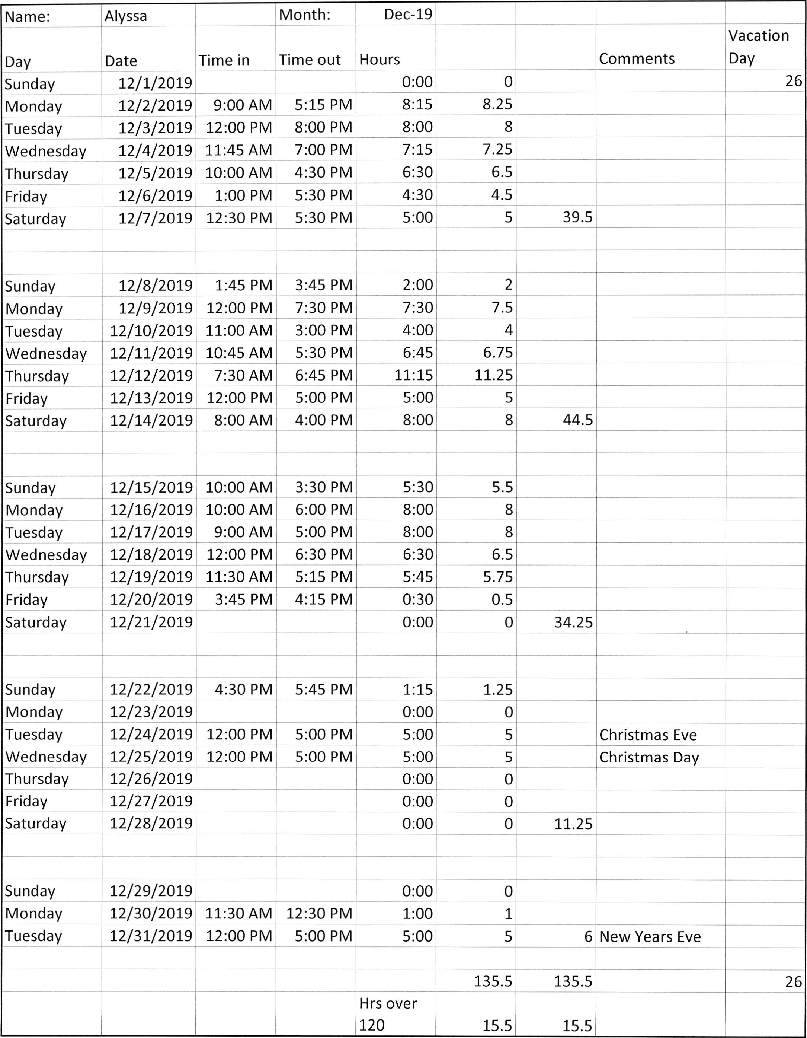

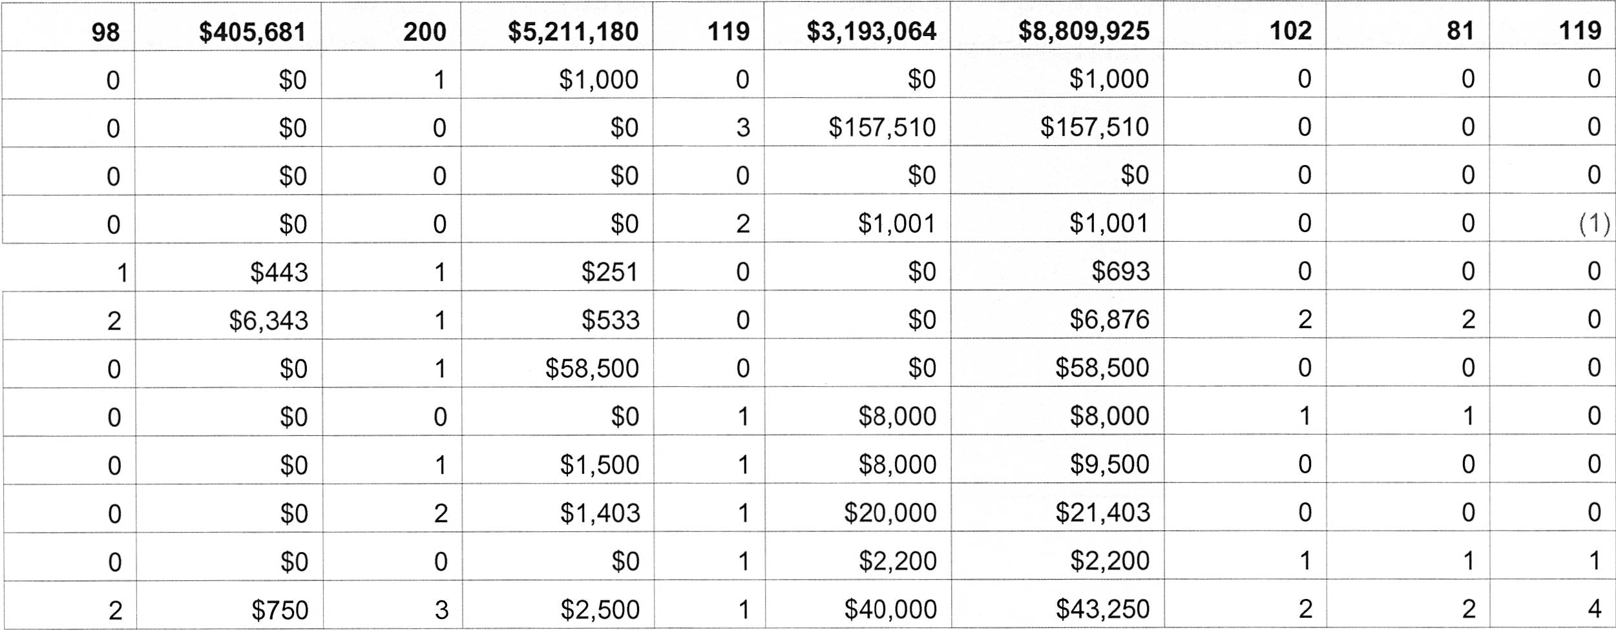

Town:  
Year Started:

Newkirk

"i992

Oklahoma Main Street Program  
Private Sector Reinvestment

EndofYear20l8

January  
February  
March  
April  
May  
June  
July  
August  
September  
October

November

December

Total for 2019

CumulativeTotal 103 413,216 210 5,276,867 129 3,429,775 $9,119,858 '108 87 123

3Qtr/19 (Jan/Feb/Mar)  
4Qtr/19 (Apr/May/Jun)  
1Qtr/20 (Jul/Aug/Sep)  
2Qtr/20 (Oct/Nov/Dec)

|  |  |  |  |  |  |  |
| --- | --- | --- | --- | --- | --- | --- |
| Facade Rehabilitations | - (jrFi-erBldg.Rehffi-t;' - Projects & New Constr. | Buildings Sold | Total Private Sector Reinvestment | Total Business Openings, Relocations, Expansions | N'et Gain in Business Openings, Relocations, Expansions | Net Gain in Jobs Created |
| ' No. of Dollar Projects Amount | ' No. of Dollar Projects Amount | No. of Dollar Bldgs. Amount |

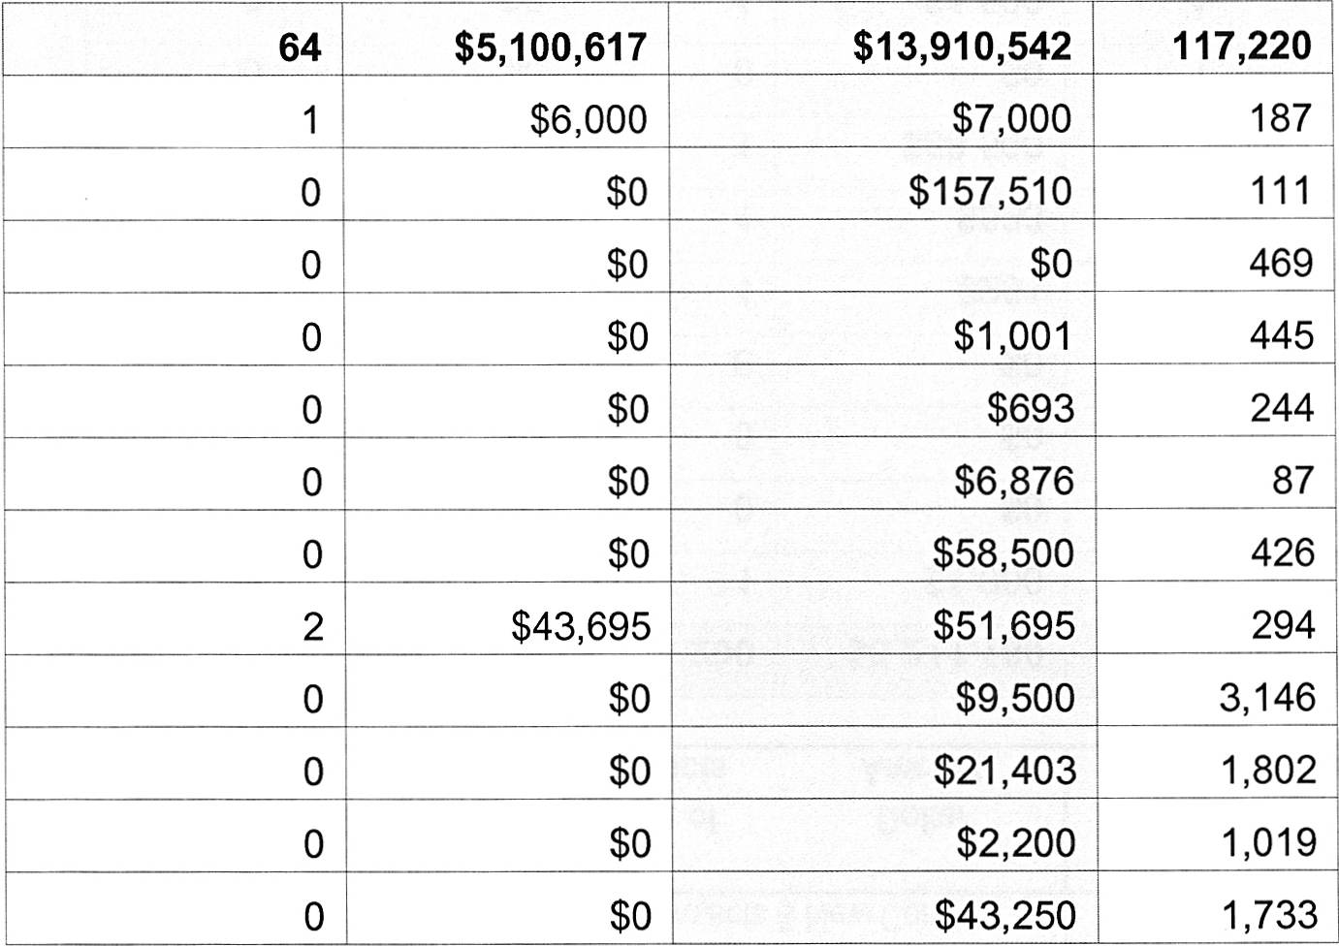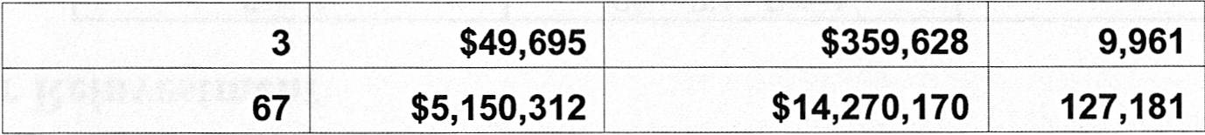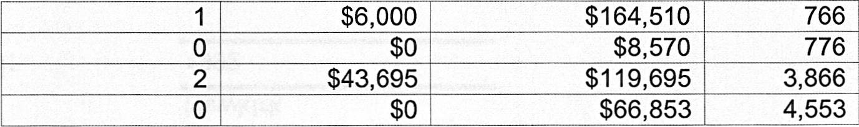

Town:  
Year Started:

Newkirk

1992

Oklahoma Main Street Program  
Investments in Public Improvements

EndofYear2018  
January  
February  
March  
April  
May  
June  
July  
August  
September  
October

November

December

Totalfor20l9

Cumulative Total

Capone's Investment LLC. Opened but no physical location as of yet. Ad

Charlie Adams Day & Leadership Orientation

116 W 7th purchased

112 W 7th purchased

Infinity LLC & CNB opened, Briggs Sold

3Qtr/19 (Jan/Feb/Mar)  
4Qtr/19 (Apr/May/Jun)  
1Qtr/20 (Jul/Aug/Sep)  
2Qtr/20 (Oct/Nov/Dec)

|  |  |  |  |  |
| --- | --- | --- | --- | --- |
| PUBLIC IMPROVEMENTS Number of Projects | ' PUBLIC IMPROVEMENTS Dollars Spent | TOTAL REINVESTMENT (Private Sector and Public Improvements) | Volunteer _Hours _ | I I REMARKS |

|  |  |  |  |  |  |  |  |  |  |  |  |  |  |  |  |  |  |  |  |  |  |  |
| --- | --- | --- | --- | --- | --- | --- | --- | --- | --- | --- | --- | --- | --- | --- | --- | --- | --- | --- | --- | --- | --- | --- |
| MONTHLY CITY SALES TAX COLLECTIONS 1991 TO 2010 | | | | | | | | | | | | | | | | | | | | | | |
| 1991 1992 | | | | | | | 1993 | | 1994 -$23,534.40 $r 9,365.59 |  | | | | | | | | | | | | |
| 1995 1996 1997 - 1998 | | | | | | | | | 1999 | | - 2000 | |
| JAN | $21 ,113.91 | | | $19,516.64 | | | $22_____,459.15 $20,482.64 | |
| $22, 195.69 $1 7,3_39.80 $20,227.58 | | $23,262.85 | | $26,816.33 | | | $22,035.62 | | $22,922.32 | | $26,58____7.99 $20,545.48 $22,287.95 | |
| FEB MARCH APRIL | $ 20,346.41 _$19,507.33 | | | _$22,375.78 $19,188.10 | | |
| $22,114.08 $25,307.58 | | $22,646.97 $21 ,465.62 | | | $19,562.92 $28,947.95 | | $19,273.32 $27,386.76 | |
| $19,985.70 | | , $22,422.56 |
| -$21 ,563.22 | | | $19,467.14 | | | $22,231 .38 | |
| $23,753.91 | $19,099.60 | | $20,47 4.90 | | $21 ,428.44 | | | $21 ,750.39 | | $25,118.87 | | | $23,37_3.69 $24,327.89 $23,990. 10 |
| MAY JUNE JULY | $20,850.55 N/A | | | _$23,272.93 $23,085.24 | | |
| 5i"i 9,931 .48 | | $21 ,585.23 | $55,907.68 | |
| $30,023.17 $28,429.90 | | $23,313.97 $24,289.33 | | | $25,320.88 $22,416.83 | | $21,936.10 $23,896.24 | | |
| $17,352.16 | | $21,656.4_5 $55,0-24.39 $24,610.81 $19,_838.28 | | |
| -. $20,779.00 | | | $21,516.81 | | | $23,370.74 | |
| $27,338.0al | | $22,586.67 | | | $22,945.87 | | $21 ,817.64 | | | $23,439.76 |
| AUG | $19,678.72 | | | $22,712.41 | | | $21_____,511.74 _$24,364.71 | |
| $21 ,448.72 $22,525.66 | | $21 ,007.43 | $24,593.85 | | $23,599.68 | | | $22,912.19 | | $25,766.88 | | | $24,854.59 |
| -SEPT $23,032.75 $22,667.38 OCT $21,318.05 $21,028.17 NOV $21,424.42 -$21,427.69 DEC $21,678.28 -$19,976.44 TOTAL $231,292.64 -$256,234.73 ff- 2002  szg,sos.ss | | | | | | |
| $18,754.05 | -$23,204.51 | | $26,458.30 | | | $23,37 4.89 | | $23,317.04 | | | $25,246. 13 $23,17_8.66 $24,96____7.02 $24,028.13 |
| $22,873.06 | | $23,23(3I91 | | $22,464.05 |
| $20,788.83 | | $22,772.84 | | | $ 22,642.47 | | $25,47 4.29 | | |
| $21 ,662.65 | | $22,177I65 | | $q 9,654.46 |
| $28,138.31 | | | $24,465.72 | | $25,352.09 | | $25,046.32 | | |
| $20,367.32 - | | $20,41 !5':05 | | $23,523.32 |
| $22,381.16 | | | $22,915.54 | | $23,175.34 | | $25,427. 16_ | | |
|  | |  | |  |
|  | | |  | |  | |
| $255,592.73 | | $266,732794 | | $315,036.33 |
| $296,057.15 | | | $282,759.41 | | $280,437.44 | | s:_s'z,asz.ga_3__zss,a | | | |
|  | |  | |  |  | | |
|  | | | 2010  $33,423.88 $30,495.57 $32,291.86 $29,935.29 $34,068.08 $30,900.06 $31,943.18 $32,130.55 $26,730.86 $3i703.24 $32,484.11 $33,378.22 $25,322.86 | | | | | | | |
| 2003 | | 2004 | | szg,m2 M20o6 $30,2_05.46 $28,934.04 $26,924.88 $26,002.10 $27,983.53 $26,457.80 $31,_138.79 $29,011.85 | | | |
| $24,7 47.69 | | $27,371 .38 | |
| FEB $27,409.05 MARCH $23,966.19 | | | | | . $26,103.01 | | $26,348.02 | | $25,181 .34 | |
| $24,849.94 | | $25,029.98 | | $28,448.19 $29,288.55 $25,718.68 | |
| APRIL | | $25, 101 .41 | | | $26,821 .61 | | $28_,360.96 $27,267.32 $25,134.95 | |
| MAY $26,261 .09 JUNE $24,873.54 JULY $25,764.70 AUG $27,525.48 | | | | | $24,650.68 _$25,229.02 $25,446.31 | |
| $31 ,g:32!.e.3 | | $32,802.74 | | $29,552.60 | | $26,756.03 | |
| $27,369.18 | | $31 ,037.67 | $31 ,015.40 | | | $28,242.34 | | $37,818.63 | | $32,329.17_ $33,27 4.64 $30,406.24 $31 ,gog.go | | $31 ,921 .75 I [2 66 > 95 | |
| $26,217.48 - | | $:_e,=+ezI"ig | | $25,613.05 |
| $25,881 .25 | | | $30,185.43 $34,337.87 $36,556.37 | | $28,660.92 $36,789.09 $37,206.20 | |
| $28,585.57 | | 25,440.41 | | $27,132.01 $30,794.36 $26,778.61 | | $30,729.57 $31,545.52 $30,351.51 $29,931.58 $28,_ffl.95 $31,619.60 | | | |
| SEPT | | $24,902.20 | | | $28,637.48 | | $28,675.70 | |
| OCT NOV DEC | | $26,183.11 $25,033.18 $24,941 .og | | | $27,370.40 $28,723.65 | | | _$32-,247.57 |
| $30,371 .72 | | | $32,646.73 | $35,763.32 | | $34,773.71 | |
| -$31 ,208.50 - | $28,429739 | | $30, 127.95 | $32_,884.90 $29,851 .40 | | | $32,053.70 $34,791 .09 | | | $35,819.58 $29,771 .97 | $29.107.50 $ 27,631 .03 | | $33,234.59 $32,643.40 | |
| $25,808.52 | | | $27,796.15 | $27,371 .38 | | $28,622.05 |
| TOTAL _$307,96132 $322,032.07 | | | | | | | |  |
| $328,47 4.73 | $330,350I26 | | $350,237. 14 |  |  | |  |  | |
| $357,421 .38 | | | $384,489.45 | | $400,751 .21 | | $352,076.71_ | | $344,260.75 |
|  | | | | | |  | |  |  | |  |  |
|  | |  | | |  | |  | |
|  | | |  | | |  | |  | | |
|  | | | | |  | |  | |  |
| I | | |  | |
|  | | |  | |  | |  | |

|  |  |  |  |  |  |  |  |  |  |  |  |  |  |  |
| --- | --- | --- | --- | --- | --- | --- | --- | --- | --- | --- | --- | --- | --- | --- |
| -- - - - MONTHLYC-ITYS-ALES-TAXC-OLLEC-TION-S - - - - -- 2011 to Current | | | | | | | | | | | | | | |
| 2011 2012 JAN $32,564.47 $35,192.87 FEB $28,568.07 $32,224.66 MARCH $28,527.00 $32,021.96 APRIL $31,148.06 $37,354.59 IMAY $32,690.60 $29,939.60 UUNE $35,709.22 $33,215.16 JULY $35,316.48 $37,306.48 iAUG $30,998.95 $43,514.55 | | | 2013 | 2014 | | 2015 | 2016 | | 2017 | 2018 | 2019 $35,923.46 $34,696.74 | | 2020 | |
| -$32,243.01 $29,875.62 $32,766.33 | | $26,716.56 $28,212.52 | $31 ,114.40 $29,569.40 |
| $37,384.44 _$35,867.94 $25,505.15 $40,159.27 | | | $38,395.96 $41 ,277.65 $52,846.19 |
| $30,695.44 | $31 ,289.31 | $31 ,366.47 | |  | |
| $44,678.41 | $37,407.95 | | $31 ,015.95 | $33,237.63 | $33,200.27 $34,080.06 $34,283.93 | | |  |
| $32,455.54 _$41,929.57 $35,653.92 $34,457.10 | $28,963.14 $29,612.93 | | $23,471.16 $32,975.14 | $30,039.28 $33,915.34 |
| $39,799.02 $38,739.95 $37,660.98 $32,639.56 $40,453.33 $32,991 .82 $34,918.80 $35,1_35.97 | | $31 ,502.67 $38,233.58 $33,863.43 $34,_082.24 $43,017.32 |
| $38,671.96 $35,151.46 | | $31 ,590.49 | $32,709.27 | $36,524.16 | | |  |
| $30,561 .34 | $35,398.69 | | $38,053.09 | |  |
| $41 ,118.92 | $34,667.91 | | $30,517.33 | $43,751 .35 | | $25,960.00 | |  |
| -SEPT ,OCT NOV DEC TOTAL |  | |  | |
| -$35,567.06 | $38,711 .34 | $32,605.33 | | $33,114.15 | $31 ,444.29 | | $34,025.73 | |  |
| -$33,97 4.54 | $35,47 4.34 | $20,337.99 | | $30,455.60 | $34,437.77 | | $36,110.25 | |  |
| -$34,544.83 | $35,830.16 |  | $38,791 .58 | $30,136.72 | $31 ,646.43 | | $34,447.43 | |  |
|  | |  |  |  | | $408,671.59 | | $0.00 |
| $384,470.42 |  |  | |  |  | |
| $391,095.21 | _@asg,as:z.=+o_ | $398,553.16 | |
| $454,547.35 | $419,183_.83 | | $428,392.85 | $472,829.10 | |

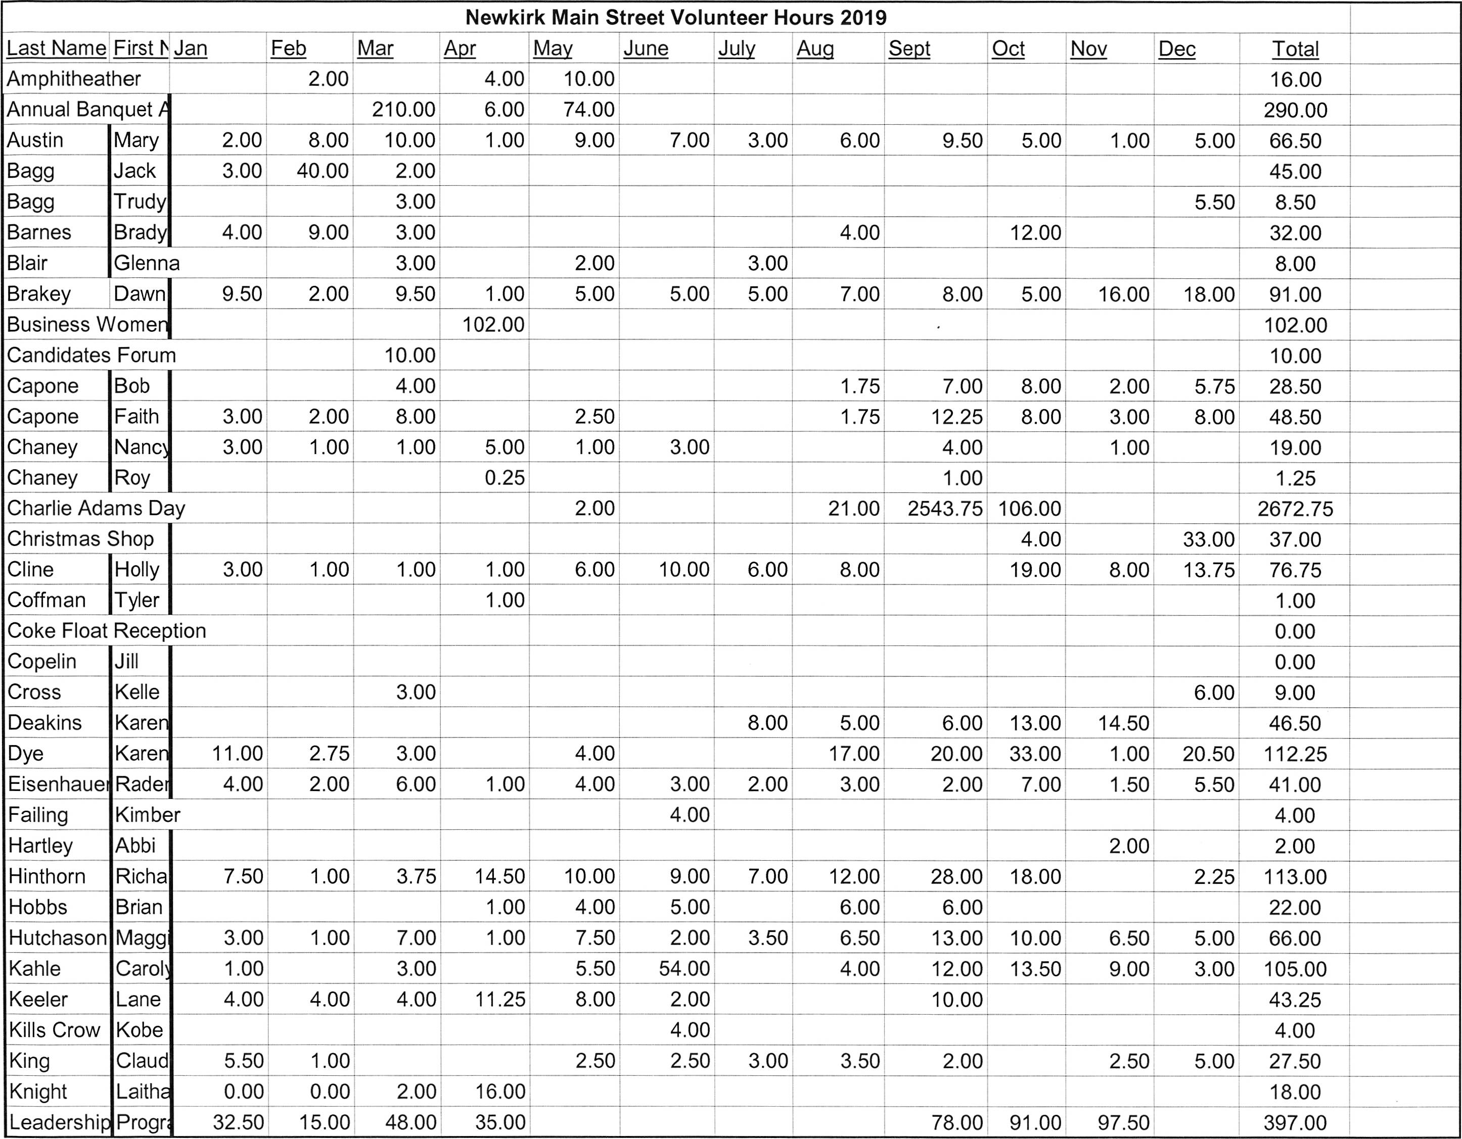

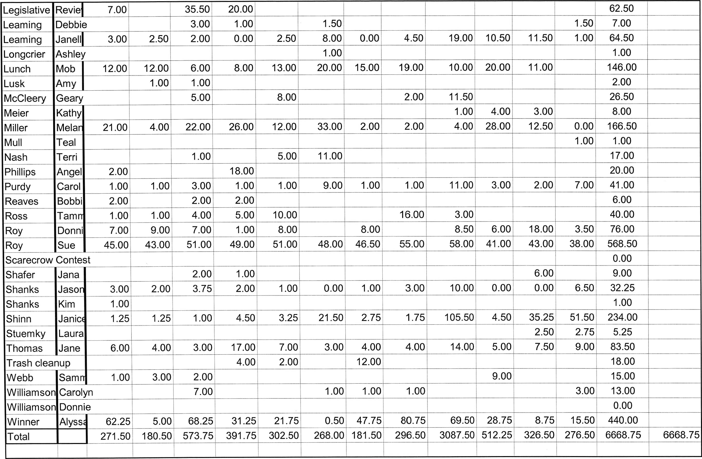

Organization Committee

December 2019

The Org committee met on December Ilth at noon. Those present were Holly Cline, Janell Leaming, Don  
Roy, and Mary Austin. Program Manager Alyssa McCleery was also present.

We looked at the meeting dates for 2020 and changed one of them. Alyssa has suggestions for new  
board members, and we delegated the calls to 3 people. We won't change until March, but it's good to

be ready.

We accepted the revised list of the action plans. We worked on this in November. We talked about the  
new way of signing up to work at the Children's Christmas Shop. We all liked the online program.

We discussed possible award nominations. Fundraising effort: Good Luck book. Public Awareness:  
Pathways Project. Volunteer development: 100 Residents; CAD. Main Street Hero: Hannah Cross.  
Premier Partner: Tammy Ross. Mary and Holly offered to help write the nominations.

The bulk of the meeting was spent signing letters and stuffing envelopes. Radena worked on them in  
advance for us, and we finished the rest of it. Some of us took boxes to work with us to seal and mail.  
The idea is to get the membership requests out as soon as possible but definitely in December.

The Main Street office will be closed from December 19 thru December 30'h.

Our next meeting will be January 8'h at noon.

Respectfully submitted,

Mary Austin

Organization Committee minutes 1-8-20

The Org Committee met Wednesday Jan 8'h at noon. Those present were Don  
Roy, Holly Cline, Janell Leaming, Radena Eisenhauer, and Mary Austin.  
Program Director, Alyssa McCleery was also present.

Alyssa gave us several pages of "catalyst strategies" and asked that when we  
had time to read it all to select the top 3 that fit Newkirk. She needs the info  
back by February I 2'h

We went over the work plan for the annual banquet. Alyssa will confirm  
reservation at the senior center. Radena will look for yellow tablecloths, and  
our decorations will be trucks, tools, hardhats, tape, etc., using the color  
scheme black and yellow. Alyssa will talk to Richard Hinthorn about his dad's  
refurbished toy trucks. The PowerPoint during the meal has not been very  
visible; we think we'll limit the slide show to the award nominations. Mary  
suggested that each of us invite one person to either help decorate/set up or  
clean up. We talked about bringing back the prize for people who paid their  
memberships before the banquet. No decision made on that.

Alyssa has confirmed Bob Capone would like to serve on the board. Holly will  
contact Ali Carpenter and Mary Ryan Smykil. Members going off are Jason  
Shanks, Brady Barnes, and Jane Thomas.

No progress has been made on the award nominations for the State, and  
they are due in OKC by January 31. Alyssa included info in the meeting  
packets in hopes we will get creative quickly.

The rest of the meeting was spent folding and stuffing the remaining letters  
for the membership drive. Results to date have not been impressive but  
there is still time.

Respectfully submitted,

Mary Austin

DESIGN MINUTES  
 January 8, 2020

The Design Committee met on January 8, 2020 at 4:30 at the Heritage Center. Members  
present were, Tammy Ross, Carolyn Kahle, Carolyn Williamson, Sue Roy, & Claudine  
King. Program Director Alyssa McCleery was also present.

Under new business, paint & fayade ($250), upper window ($500), energy ($500), and  
structural grants ($500) from Faith & Robert Capone were approved through a motion by  
Carolyn W with second by Claudine & approval by members. A motion by Carolyn K,  
seconded by Carolyn W, & passed by committee was made approving a letter declining  
grants by William & Stephanie Tucker (clarification was needed concerning addresses).

There was discussion of the local Main Street Annual Mtg., March 26'h (2020), beginning  
at 6 p m. Committee members were asked to provide 2-3 items (noting that baked goods  
sell well). Historical items related to Newkirk are hard to find but sell well. A press release  
requesting donations from the community was suggested.

Committee members have homework to read & select the top 3 Catalyst Strategies for  
Newkirk at the February Mtg. Members should also review the design grant application  
& process review. Suggestions are needed by members to update procedures.

Under old business consideration of OMSC award nominations received further review.  
They are due at OMSC office January 31, 2020. The Pathway Project including the book  
"Good Luck" (By Karen Dye) nominated for Best Placemaking Project. Carolyn's  
Antiques was nominated for Best Visual Merchandising. The Fall Family Fun Night was  
nominated for Main Street Crowning Achievement. Leadership Class 13 was also a

consideration.

Pictures with Santa was a success & there are plans to expand it next year.

The 33X50 of 100 Newkirk residents will be in the Community Room at the Newkirk  
Public Library for about a month. Sue needs to OK this with Marcina, the librarian.

The next meeting will be held at 4:30 pm on February 5, 2020 at the Heritage Center.

Respectfully submitted,  
Sue Roy



EIEI

MAINSTREET

NEWKIRK MAIN STREET VOLUNTEER HOURS

NAME

MONTH /YEAR

DET AIL  
Preparing for Board Meeting

Preparing reports for Board Meeting

Attending Board Meetings

Preparing reports for Committee Meetings

Committee Meetings

City Meetings

SPECIAL PROJECTS  
Newsletter

Charlie Adams Day

Children's Christmas Shop

Other

TOT AL HOURS