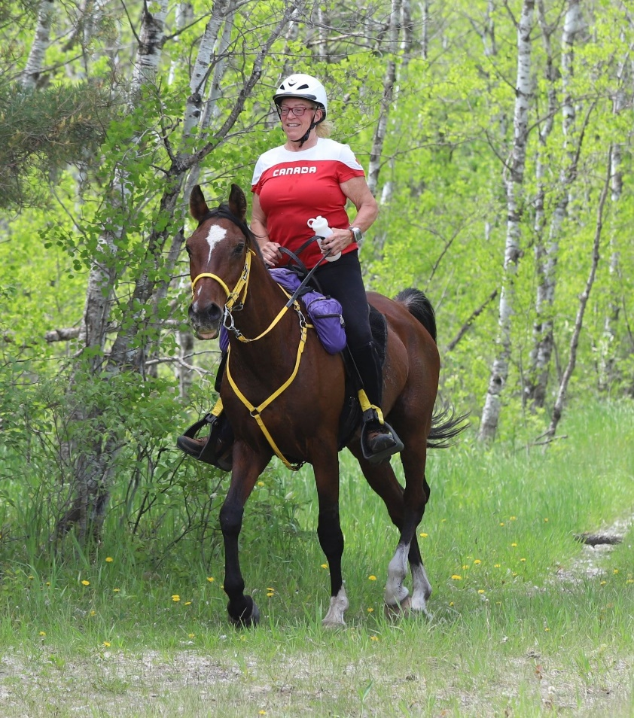

PERSONALITY

* Bold and very smart- he feels every thing you are thinking
* Leader and usually front of the pack
* Hundreds of Endurance miles
* Very intuitive and doesnt like to be bossed around

EXPERIENCE

* Arena, trail and hundreds of Endurance miles.
* Ranked 2nd in Canada 2018
* Walk trot lessons, Canter, learning to jump and some dressage
* English/Endurance or Bareback
* Rides Bitless in Arena, bitted bridle out of yard, can be very fast

BEST SUITED FOR THIS TYPE OF RIDER

* Bold. experienced intermediate, or advanced rider
* Good balance in seat
* Self assured rider that follows through with requests
* A leader to give self assured directions and requests

**CANSASS**

Age: 16

Breed: Arabian

Color: Bay

Height: 16

HORSE INFORMATION SHEET

[www.ridelikethewind.ca](http://www.ridelikethewind.ca)

HORSE INFORMATION SHEET

**GELDING**

SORA

[**©** TemplateLab.com](https://templatelab.com/)