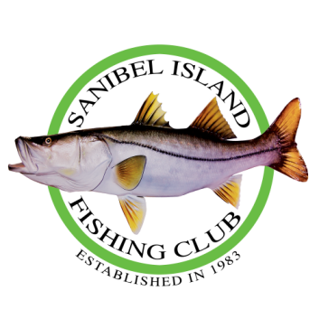
SAVE THE DATE
Our Annual Fish Fry will be held on March 15, 2025. The fish fry will be at the Community Center starting at 5:00. It will be a pot luck dinner with a cash bar so bring a dish to share. To avoid a shortage of fish similar to last year (red tide) we ask members to freeze any extra fish prior to that to donate to the fish fry. There is no charge for this event and we will be having a raffle again this year so bring your wallets.
We will be needing people to fry the fish. Any of you anglers that have skill in deep frying fish and would assist in this, please contact David Gurney at 651-248-3399

