Council Chambers at City Hall  602 College Ave.  St. Maries, Idaho | 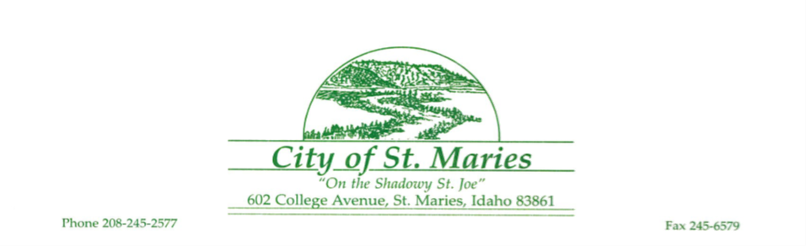 | May 07, 2025  at 5:00 p.m. Regular Meeting
PLANNING & ZONING MEETING MINUTES
- Call to Order.
The regular meeting of the St. Maries Planning Commission was called to order by Chairperson, Emmy Masterson at 5:00 p.m. on Thursday, May 7, 2025, in Council Chambers at City Hall, 602 College Avenue, St. Maries, Idaho.

- Roll Call.
PRESENT –
Chairperson, Emmy Masterson
Commissioners – Rhonda Stancil, Claudia Spooner, Mike Walters

- Approve April 2026 Minutes. – action item
Motion made to approve April 2025 Minutes.
Result: | Passed
Moved By: | Stancil
Seconded by: | Holmes
Voted Yes: | Stancil, Holmes, Spooner, Walters
Absent: | Commissioner Brian Cravens

- Public Hearing, Deliberation, and Decision: Code Amendments to revise definitions and provisions for yards and setbacks in various zoning districts, and repeal provisions for the City Impact Area.
Chairperson, Emmy Masterson, introduced the topic and explained the order and procedure of the public hearing. Rand Wichman, city planner, gave a staff introduction of the proposed code amendments to revise definitions and provisions for yards and setbacks in various zoning districts, and repeal provisions for the City Area of Impact. The public hearing was open at 5:04 p.m. There were no written comments. There was no testimony being in favor, neutral or in opposition. Commissioner Rhonda Stancil questioned whether there are any agriculture zones in the City at this time which Jacob Parsons, Building Official, stated there were not. The public hearing was closed at 5:07 p.m.

Motion made to recommend approval of code amendments in conformance with the approval requirements as outlines in the staff report, to the City Council.
Result: | Passed
Moved By: | Walters
Seconded by: | Stancil
Voted Yes: | Stancil, Holmes, Spooner, Walters
Absent: | Commissioner –Brian Commissioner

- Code Amendment Discussion.
The Commissioners discussed potential topics for the next round of code amendments with Jacob Parsons, Building Official. The Commissioners agreed to prioritize regulations regarding tiny homes and then address possible solutions for the City’s existing 25-foot lots.

- Adjourn.
The regular meeting was adjourned at 5:17 p.m.

I presided over this meeting and can confirm that the foregoing minutes, prepared by the City Clerk, were approved by the Planning Commission during their regular meeting held on June 8, 2025.

__________________________________ ___________________________________
Emmy Holmes, Chairperson Attest: Jaidyn Kinzer, City Clerk

