Speeches doesn’t come natural to everyone.  Here are some ideas:  Pocket-Sized Wedding Toast Guide | 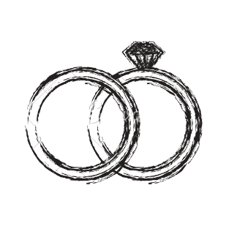
Questions to ask yourself and topics to consider.
Answer and elaborate below. Refer back to these in order to write out your speech on page two.
When did they tell you about their partner?
When did you know your friend was going to be one of your favorite people?
How long have you known the couple?
What do you love most about the couple as individuals, and as a couple?
When did you know they were for real?
Have they helped you through hard times?
How do you spend time with them?
What does their friendship mean to you?
What are five words that come to mind when you think about them?
Is there a classic story that sums them, or your friendship, up?
Where do you see yourselves and your friendship in ten years?

DO’s
- Make sure you introduce yourself and
your relation to the couple.
- Speak from the heart.
- Be thoughtful about your word choice.
- Thank the hosting family, or the people who did the most work to help pull together the wedding.
- Tell one or two stories that relate back to what you love about the couple.
- Make it mostly about the couple and less about your friendship.
- Remember to congratulate them.
- Stay politically correct. There are lots
of generations out there.

DON’T’s
- Make it a contest to prove how well you know them.
- Forget to write the actual toast into your speech. “Let’s raise our glasses to…” (audience will raise their glasses when you do).
- Speak for too long. Around five minutes is good to shoot for.
- Only tell inside jokes. Keep jokes broad, limited, and for everyone’s enjoyment.
- Feel like you have to be funny. Just be sincere.
- Be afraid to be serious and sentimental.
- Forget to end the toast on a positive and optimistic note.

Pocket-Sized
Wedding Toast Guide
Use this as a guide to build your speech. The most important thing is, even when planning ahead, that you’re thoughtful about what you choose to say. Stare at a picture of the couple while you think and write, and refer to your answers on the previous page to decide what you think is important to include.

Introduction:
Introduce yourself and your place in the wedding. Explain how you know your friend. Say a few words about your friend’s new spouse and how you feel about their union.

History:
Explain how you really, deeply feel about the couple. Explain what they bring to your life, and thank them for that.

Story:
Use this time to tell a story or two. Whatever feels most important to you. This is your time to share and make the crowd understand things about the couple they may not have known (good things or embarrassing things, but remember your audience).

Compliments/Thanks:
Thank the parents for raising your great friends. Thank the hosting family and everyone who greatly contributed to making the day happen. And, finally, congratulate and toast the couple.

Compliments & Thanks  Key Word or Phrase  Page 4 | Make your toast into a booklet:  The booklet pages are laid out in a specific order so the booklet reads correctly once folded. Make sure the top row is oriented upside-down before printing.  To edit top row:  - Click into the box and the text will automatically rotate.  - When done filling out, simply click outside of the box to rotate upside-down again. You need to do this so the text will read properly once folded. | Story  Key Word or Phrase  Page 3

Cheers | Pocket-sized  Wedding Toast  Melanie & Teddy  July 16th | Introduction  Key Word or Phrase  Page 1 | History  Key Word or Phrase  Page 2

Final folded product
If you follow the directions correctly, your final folded
booklet should look like the image below.
