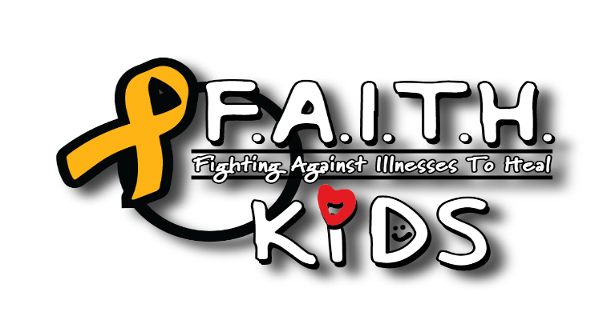
PHOTO RELEASE
By signing below, I hereby give permission to F.A.I.T.H.KIDS and its agents or employees, to use photographs taken of me or my minor child for use in any publication which may include printed or electronic media, or both. Furthermore, I give permission to F.A.I.T.H.KIDS to use my name or my minor child’s name in conjunction with said photographs. I understand that F.A.I.T.H.KIDS is under no obligation to use these photographs.
I hereby relinquish any right to inspect or approve the completed product or products which may include the finished photographs of me, advertising copy or any other printed or electronic matter that may be used in conjunction with them now or in the future, whether that use is known to me or unknown, and I waive any right to royalties or other compensation arising from or related to the use of the photograph.
I hearby agree to release, defend, and hold harmless F.A.I.T.H.KIDS and its agents or employees, including any firm publishing and/or distributing the finished product or products in whole or in part, whether on paper or via electronic media, from and against any claims, damages or liability arising from or related to the use of the photographs, including but not limited to any misuse, distortion, blurring, alteration, optical illusion or use in composite form, either intentionally or otherwise that may occur or be produced in taking, processing, reduction or production of the finished product, its publication or distribution. I certify that I am at least 18 years of age and am competent to contract in my own name. I have completely read this release before signing, and I fully understand the contents, meaning and impact of this release.

______________________________________________________________________________
Signature Printed Name Date
______________________________________________________________________________
Address City, State, Zip
______________________________________________________________________________
Phone Email
______________________________________________________________________________
Names of Minor Children
F.A.I.T.H.KIDS ~ P.O. Box 850102, Yukon, OK 73099 ~ 1(405) 532-3952

