WhistlePig Woodcraft
Beekeeping Woodenware



WhistlePigWoodcraft.com

John Cullom 443-398-0814 (call or text)

john@whistlepigwoodcraft.com

Woodshop address – 4585 Babylon Rd. Taneytown Md. 21787
Home address – 1606 Exeter Rd. Westminster Md. 21157
(Call or text before visiting)

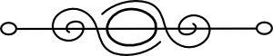

All prices plus tax. Credit card sales add 3%
All products are guaranteed. If you’re not satisfied, let me know & I’ll make it right.

Four Season Hive Setup
*Everything you need for a colony except bees & food*

Includes solid or screened bottom board with entrance reducer & plastic slide-in sheet, four boxes with frames & plastic foundation, inner cover, vent shim,
4 jar feeder with jars & lids, one feeder box to enclose the feeder,
candy board, quilt box, telescoping cover.
*(If you need a hive stand, an 8ft is $150, a 4ft is $80)*

Box options -
Four medium 8 frame boxes -$400
Four deep 8 frame boxes - $430
Two medium & two deep 8 frame boxes - $415
Four medium 10 frame boxes - $460
Four deep 10 frame boxes - $490
Two medium & two deep 10 frame boxes - $475

2/10/26
Five frame nuc setup - Includes screened bottom board, three boxes,
inner cover, migratory lid.
Medium boxes- $100 without frames, $160 with frames.
Deep boxes- $109 without frames, $172 with frames.

Frames – Medium with plastic foundation - $4 each, without - $2.00 each
Deep with plastic foundation - $4.25 each, without - $2.25 each

Escape board – 8 or 10 frame - $25

Screened or solid bottom boards-
(screened includes slide-in board & entrance reducer, solid includes entrance
reducer)
5 frame - $20 8 frame - $25 10 frame - $30
*Add $15 for a slanted landing board option

Inner covers-
5 frame - $15 8 frame - $20 10 frame - $20

Vent shims - 5 frame - $5 8 frame - $15 10 frame - $15

Telescoping covers-
5 frame - $22 8 frame - $35 10 frame - $38

Migratory covers- 5 frame - $15 8 frame - $20
10 frame - $25

Jar feeders with jars & lids (sits on top of inner cover)
1 hole - $11 2 hole - $20 4 hole - $35

Feeder box (encloses the jar feeder) - $25

2/10/26

Hive boxes-
Assembled Mediums -
5 frame - $20 8 frame - $25 10 frame - $30
Unassembled Mediums -
5 frame - $17 8 frame - $20 10 frame - $25
Assembled Deeps -
5 frame - $23 8 frame - $30 10 frame -$35
Unassembled Deeps -
5 frame - $20 8 frame - $25 10 frame -$30

Swarm traps- $45

Hive stands (pressure treated two by sixes & four by fours)
8 foot - $150 4 foot - $80

Candy Boards - $20 (includes 2x4 blocks for spacing in the sugar &
3/8inch shims for space above the frames)

Quilt Boxes - $20

Robbing Screen - $25

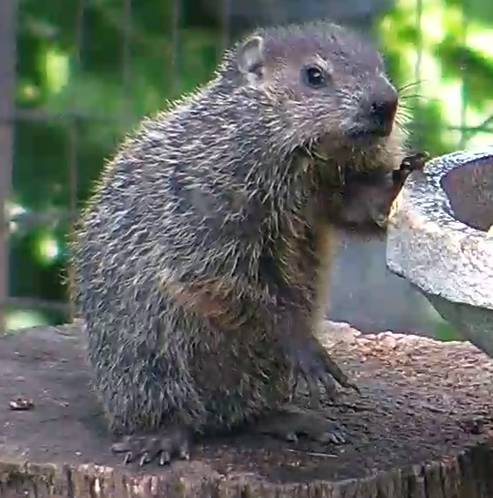 2/10/26
