WhistlePig Woodcraft
Beekeeping Woodenware

WhistlePigWoodcraft.com

John Cullom 443-398-0814

john@whistlepigwoodcraft.com

Woodshop address – 4585 Babylon Rd Taneytown Md. 21787

Home address – 1606 Exeter Rd Westminster Md. 21157
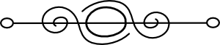

Hive setup - Includes screened bottom board, 4 boxes, inner cover,
vent shim, 4 jar feeder with perforated jar lids, telescoping lid.
Four medium 8 frame boxes - $192 without frames, $320 with frames.
Two medium & two deep 8 frame boxes - $200 without frames, $332 with
frames.
Four medium 10 frame boxes - $210 without frames, $370 with frames.
Two medium & two deep 10 frame boxes - $218 without frames,
$383 with frames.
Four deep 8 frame boxes - $211 without frames, $347 with frames.
Four deep 10 frame boxes - $226 without frames, $396 with frames.

Five frame nuc setup - Includes screened bottom board, three boxes,
inner cover, migratory lid.
Medium boxes- $96 without frames, $156 with frames.
Deep boxes- $105 without frames, $168 with frames.

Double nuc setup – Includes screened bottom board with front & rear
entrances, 10 frame medium box with removable divider, two 4 frame
medium nuc boxes, two nuc inner covers, two migratory lids.
$135 without frames, $199 with frames.

05/07/24
Frames – medium with foundation - $4 each
Deep with foundation - $4.25 each

Escape board – 8 or 10 frame - $20

Screened or solid bottom boards-
(screened includes slidein board & entrance reducer,
solid includes entrance reducer)
5 frame - $16 8 frame - $20 10 frame - $23

Inner covers-
5 frame - $10 8 frame - $20 10 frame - $20

Vent shims - 5 frame - $5 8 frame - $15 10 frame - $15

Telescoping covers-
5 frame - $22 8 frame - $35 10 frame - $38

Migratory covers- 5 frame - $10 8 frame - $12
10 frame - $15

Jar feeders with perforated jar lids (sits on top of inner cover)
1 hole - $6 2 hole - $9 4 hole - $14

Hive boxes-
Assembled Mediums -
5 frame - $20 8 frame - $22 10 frame - $25
Unassembled Mediums -
5 frame - $17 8 frame - $19 10 frame - $22
Assembled Deeps -
5 frame - $23 8 frame - $26 10 frame -$29
Unassembled Deeps -
5 frame - $20 8 frame - $23 10 frame -$26

Swarm traps- $45
05/07/24
Hive stands (pressure treated two by sixes & four by fours)
8 foot - $150 4 foot - $80

Horizontal hives - $400 (flat top) $500 (peaked top)
Available options (additional cost) – screened bottom,
carry handles, feeding trays, quilt trays

Peaked Lid – 8 or 10 frame -
Aluminum - $200 Copper - $300

Candy Boards - $15 (includes 2x4 blocks for spacing in the sugar)

Quilt Boxes - $10

OA Vape door - $7

Robbing Screen - $21

Oak display case – Fits medium honey frame - $150
Fits six 1 pound jars - $300

Ten frame assembly jig - $45

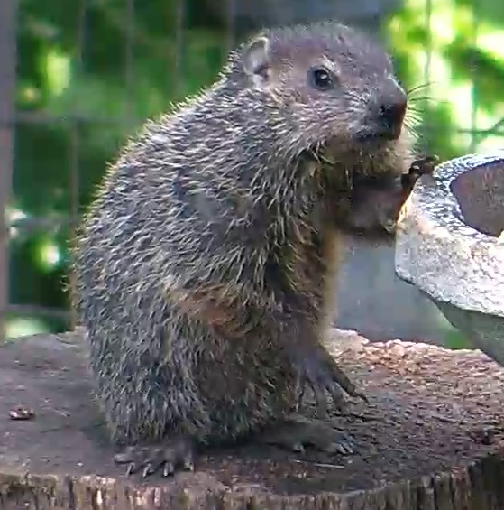

05/07/24
