**2023 Year in Review**

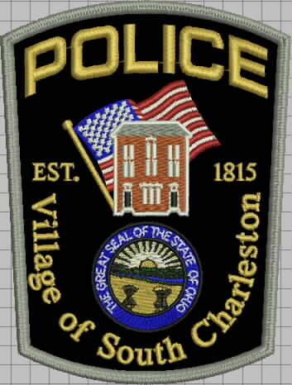

**2023 year in review**

**In the year 2023 the village police department handled 2132 calls of service. We averaged 5.8 calls a day 41 calls a week. We were down 113 calls from the year 2022, but we still average 6 calls more a week than we did in 2021. This is a significant increase due to the fact we did a lot of community policing during Covid and some of that has stopped now that certain things are getting back to normal. Below are some breakdowns of our calls of service. Sunday and Monday we handled a lower call volume than the rest of the week. Tuesday through Thursday were the highest call volume of the week, but they are fairly equal. In the village we have an officer on duty 24/7 365 days a year. There has only been a small-time frame since I have been Chief that we have not been able to accomplish that. Staffing numbers are low throughout policing and are staffing is starting to reflect that as well.**

**The chart below shows some of the calls we handled with comparisons over a 3-year span. Juvenile calls are up slightly from 2022. Whereas EMS stayed about the same over the past two years. We have been seeing a lot of outside problems migrate to the village, but the changes in society have caused that to occur.**

**Some of the calls for service we handled in 2023 are listed below. Of the 2132 calls we handled we had EMS 217**

**Suspicious Activity 73**

**911 Miss Dials 100**

**Peace Officers 51**

**Welfare Checks 39**

**DV/ Neighbor Disputes 68**

Traffic Stops 2023

**In the year 2023 The South Charleston Police Department Conducted 590 traffic stops. Those stops generated 321 citations with 269 warnings. There were 1.6 stops per day with 6 citations a week over the course of the year. Listed below are a break down of the citations issued throughout the year.**

**Speed 223**

**Suspension/Liscense 46**

**Traffic Control Device 26**

**Equipment 15**

**Registration Plates 37**

**Other 6**

**Marked Lanes 5**

**OVI 3**

**Wrongful Entrustment 4**

**Here is a 3-year analysis of traffic citations in the village. The stats in 2021 are low due to that being a COVID year. Certain traffic issues were suspended by the state, so some numbers are skewed. Depending who you listen to at state and federal level some of these issues were trending upward before Covid, while others say after. I know for the Village it seems that we have had traffic issues trending upward since Covid. Although we have not looked at traffic studies it appears that our traffic has increased in the Village and the disregard for driving safety is out there. Resources for Agriculture has also, grown in the community, so that has contributed to increased traffic as well.**

**The above Graff gives an overview of the officer and their day-to-day operations on traffic details and criminal arrest. Sgt Pugh, Ofc Marlett and Sgt Dunsmore are full-time employees. Ofc Marlett and Sgt Dunsmore are assigned to Southeastern Local School District in the roll of School Resource throughout the school year. During school down time, they work the road and keep up on their training and continuing education for their school responsibilities. Sgt Pugh is the second shift road officer. He took this position when Lt Repik semi-retired. The remaining personnel Ofc Diviak, Ofc Hull, Ofc Myers, Ofc Roberts, and Ofc Edgars are part-time employees. Sgt Pugh conducted the most traffic stops in 2023 with Ofc Diviak being second.**

**On the criminal side of things, the department was similar in stats. Sgt Pugh led with 8 criminal citations/ arrests, with Ofc Hull being second.**

**Their approximated work hours for the year were over 12,500 hours for the entire department. These hours include shift coverage, special duty/assignments, investigations, training and continuing education. The officers were required to have 24 hours of continuing education required by the state, while the SRO’s were required to have 40 hours of continuing education required by the state and then there was continuing education required for those with teaching and instructor certificates.**

**There were 177 traffic stops conducted on N Chillicothe St not related to the intersection of N Chillicothe St and Columbus Cincinnati, of which there were 73. On Columbus Cincinnati Rd from limit to limit there were 140 stops conducted. The remaining stops were handled on S Chillicothe and the plats. While we had over 50 stops on the side streets in the village. Traffic volume is not as high as Chillicothe St and Columbus Cincinnati Rd, but Church St and Jamestown Rd have some heavy speeding occur at different times of the day through out the year.**

**Crashes**

**Traffic crashes are on the rise again. During the past two years our traffic crashes were on the decline. This past year we handled or assisted on 31 crashes. There were 10 crashes on private property and 21 on public roadway. With the crashes that we handled there were 4 Hit Skip, 8 Failure to Control, 3 Failure to Yield and 1 ACDA. We also assisted OSP with 5 crashes in the township. We are dispatched to crashes in the township, when the county is busy or, due to unforeseen circumstance, or they are in town and need assistance, but normally we don’t handle that part of the roadway.**

**Reports**

In 2023 there were 577 reports taken. Of those reports 126 were criminal and those reports generated 31 arrests. The most significant arrest was an Agg Robbery that led to 4 people being indicted. There were 8 people arrested on warrants and another 6 from domestic violence. Crimes against Family and Theft and Fraud were the largest areas of crime in the village this past year. We had seen a slight uptick of drugs in the village last year and that ranged from meth and fentanyl to a small amount of cocaine. We have seen some issues with marijuana, but with the law changing to legalize it we are still waiting on clarification on how to handle certain parts of it. They are also trying to change certain areas of the law at the state house, so we will have to see what 2024 brings.

**Personnel**

**Staffing in the village declined towards the end of the year. We lost Officer Hudson to Madison County Sheriff’s Office. Officer Stark, who worked for our department along with Madison County Sheriff’s Department left policing all together. Officer Edgar took a full-time position with Logan County Sheriff’s Office and Officer Myers left unexpectedly.**

**The remaining staff consist as follows: full-time Sgt Pugh, who is the second shift road officer. School Resource Sgt Dunsmore and Ofc Marlett. Ofc Diviak is being moved to full-time to cover third shift in 2024. The remaining officers are part-time and cover shifts as needed. Their hours differ depending on their availability. Lt Repik is semi-retired, so he covers 2 days a week to several a month. Officer Hull usually covers 1 to 2 shifts a week. Officer Roberts and Rosales usually work 24 hrs a month. The village officers worked over 12500 hours in 2023. With training and shift responsibility they stay busy.**

**Training**

**We trained a lot throughout the year in 2023 that was no different from previous years. With the changes in policing, policy, and insurance we need to stay up to date. I also, look at village needs, so the citizens are taken care of to the best of our ability. The state requires that we do continuing training on a year basis. We have been required 24 hrs continuing training a year over the past couple. They are pushing for 40 hrs a year in the future. Policy now requires the department to do yearly training in several areas, so we stay on top of law changes and familiarity with the topics. Those range from use of force, Victim advocate laws and other areas of Crime against persons. The SRO are required 40 hours a year to keep up with their school responsibilities. Also, several of the officers got certified as EMR, so we can assist the squad. For those of you who haven’t noticed Cedarville has been covering the village at times. So, with officers being in the school and usually officers being the first on scene at night 5 of them became EMR to assist the village residents and Madison Twp EMS. We conduct active shooter training once a year and have started drivers training, which is now required by policy. Officers also do individual training on certain areas.**

**Equipment**

**The village cruisers are holding up well. None of them needed any major work. We have stretched tire life with better driving procedures and tire rotation on a regular basis. We use to get 6 to 8 months out of a set of tires. We now get about a year and a half. The Tahoe reached its life so it was put on GovDeals and sold. It was our oldest car in the fleet. The village is back to having 5 marked cruisers; 2 assigned to the schools and 3 assigned to street patrol.**

**We did get new body cameras at the end of 2023 resulting from a contract we have with our BWC company. Our cameras are from Provision, and when they were upgraded in 2019, we signed a contract that stated every 3 years they get upgraded. That will save us money and we are good until 2029, before we have to address the issue of BWC again. We did purchase 2 FLR, these are night scopes. We have had several issues the past couple years where we had to look for suspects and we were unequipped. London Police let us borrow some of their equipment a couple years ago, so we purchased what they used when they went on sale.**

**There was some additional first aid equipment purchased, when the guys became EMR. It was minimal in cost since some of it was donated**

**Community involvement**

**I try to keep the department involved in the community as much as possible. We partner with SCYA and sponsor the Easter Egg Hunt. We have sponsored a little league team over the past several years. We have participated in several parades throughout the county and South Solon. Officers participated in National Night out in Enon and Choctaw Lake. This past year we teamed up with the Heritage Society and sponsored that Halloween event in the Opera House.**

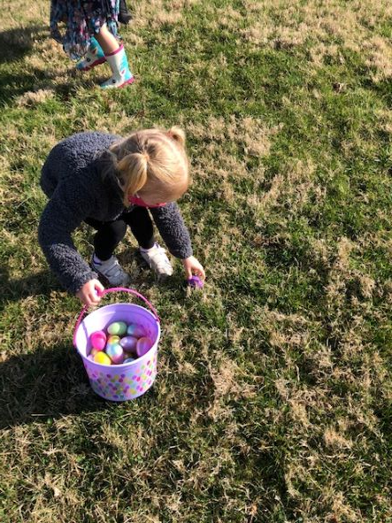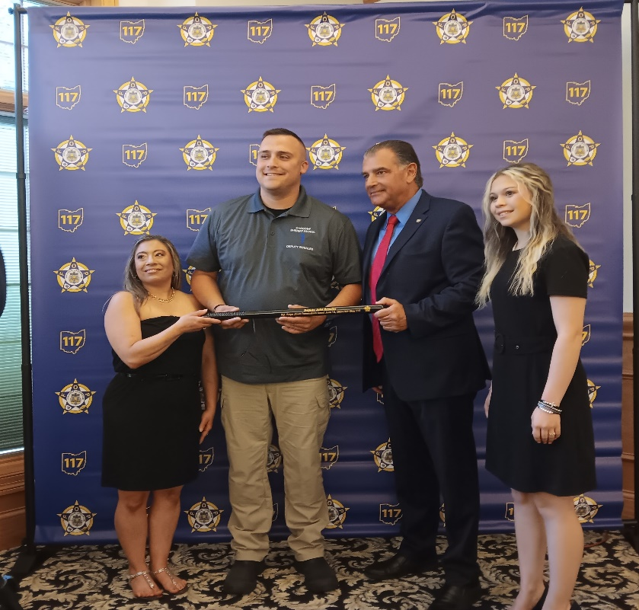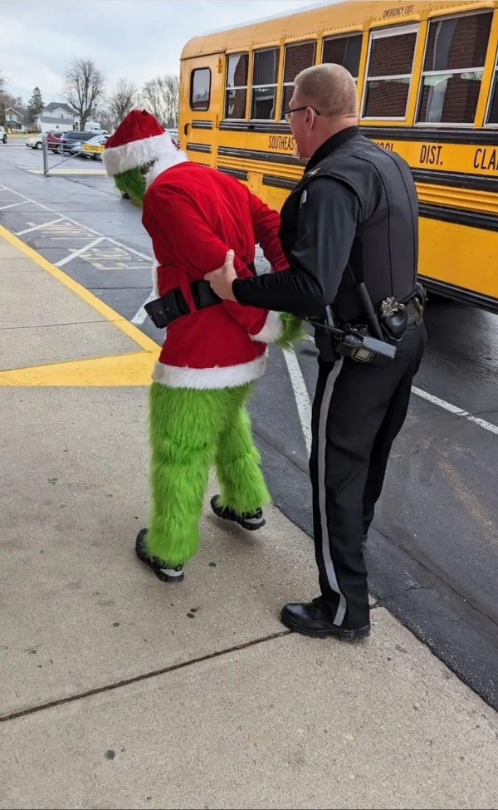

The top picture is Ofc Rosales receiving an award from the FOP. The bottom left is the Easer Egg Hunt. The picture on the lower right is Christmas fun Chief arresting the grinch after sealing a school bus