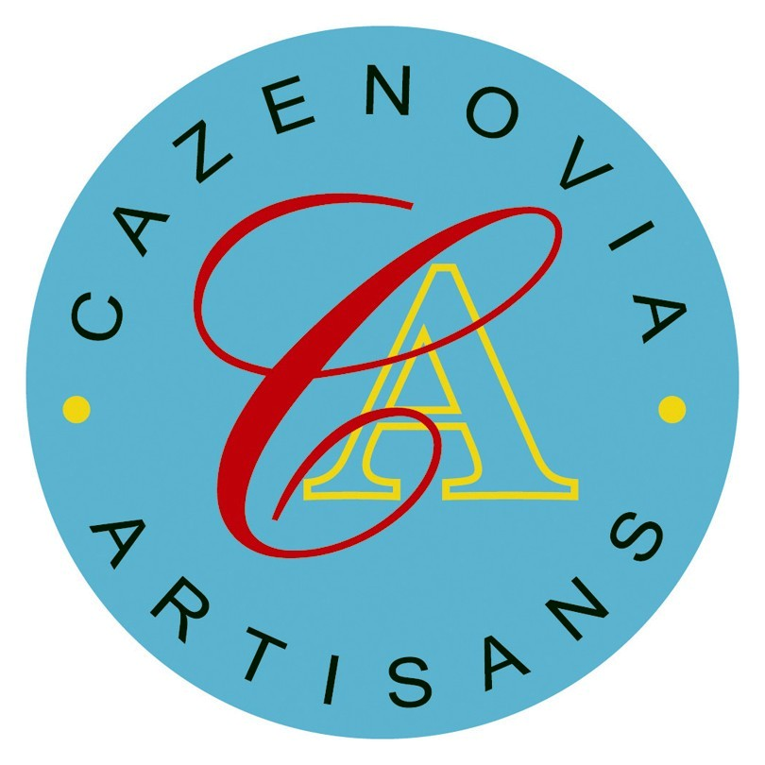Cazenovia Artisans

39 Albany Street

Cazenovia, NY 13035

315-655-2225

cazenoviaartisans.com

Membership Application and Information

PRINT VERSION

Thank you for considering becoming a member of Cazenovia Artisans!

Please read the information about membership and qualifications on our website before completing the application. You will also find a downloadable version of the application there.

**Date:** *______________*

**Name: _________________________________________________________________**

**Business name:**  *_________________________________________________________________*

**Address:**  *_________________________________________________________________*

**Email:**  *_________________________________________________________________*

**Phone:**  *_________________________________________________________________*

**Where can we find you on social media:**

*_________________________________________________________________*

**What is your art form (i e fiber art, glass, jewelry, painting etc)?**

*_____________________________________________________________________________________*

**Describe your product:**

*_____________________________________________________________________________________*

*_____________________________________________________________________________________*

*_____________________________________________________________________________________*

*_____________________________________________________________________________________*

*_____________________________________________________________________________________*

**How long have you been doing this work?**

*_____________________________________________________________________________________*

**Where/how are you currently selling your work?**

*_____________________________________________________________________________________*

*_____________________________________________________________________________________*

**Artist Statement:**

*_____________________________________________________________________________________*

*_____________________________________________________________________________________*

*_____________________________________________________________________________________*

*_____________________________________________________________________________________*

*_____________________________________________________________________________________*

*_____________________________________________________________________________________*

*_____________________________________________________________________________________*

*_____________________________________________________________________________________*

*_____________________________________________________________________________________*

*_____________________________________________________________________________________*

*_____________________________________________________________________________________*

*_____________________________________________________________________________________*

*_____________________________________________________________________________________*

*_____________________________________________________________________________________*

*_____________________________________________________________________________________*

IMAGES

Please submit your application together with five, high resolution, professional quality, images representative of the work you would like to sell at Cazenovia Artisans. Also submit one image where your work is displayed for sale.

Send to [info@cazenoviaartisans.com](mailto:info@cazenoviaartisans.com) .

1. *______________________________________________________________________________*

Dimensions: *________________________* Price: *_____________*

1. *______________________________________________________________________________*

Dimensions: *________________________* Price: *_____________*

1. *______________________________________________________________________________*

Dimensions: *________________________* Price: *_____________*

1. *______________________________________________________________________________*

Dimensions: *________________________* Price: *_____________*

1. ______________________________________________________________________________

Dimensions: *________________________* Price: *_____________*

1. Your artwork as it is displayed for sale.

I have read the information about becoming a member of Cazenovia Artisans on [www.cazenoviaartisans.com](http://www.cazenoviaartisans.com). The information is also available on page 4 and 5 of this document.

# Become A Member of Cazenovia Artisans

To be considered, you must live or work in Central New York. Your artwork should be original and be both designed and handmade by you. Since the Co-op is fully staffed and run by members, you must also be willing to spend some time each month staffing the gallery and interacting with visitors as well as taking an active part in other tasks included in running a gallery.

Membership application is available on our website, www.cazenoviaartisans.com.

# FAQ:s

**1. How do I become a member of Cazenovia Artisans?**  
Once your application has been reviewed, we have a two-step jury process. You will first present yourself and your work to the jury committee who decide whether to recommend you. If you are recommended, you will present your work at a monthly meeting of the entire membership who will vote on your candidacy.

**2. Is there a cost associated with being a member?**

All members pay a monthly assessment to cover operating expenses, currently $125.00.

**3. What is my take-home from sales made at the Co-op?**  
95% of the sale price goes to you, the Co-op takes 5%.

**4. How does the Co-op price my items?**  
All items are priced by the member creating the art.

**5. How am I paid?**  
You will receive a direct deposit into your bank account every month.

**6. How is sales tax handled?**  
The Co-op collects and pays all sales tax.

**7. Who runs Cazenovia Artisans?**  
The Co-op is entirely member run as an LLC. There is an elected board of managers that works together to set the agenda for monthly meetings, etc. All full members have an equal vote on decisions and are also co-owners of the business.

**8. Will I be a full member when I join?**  
Full membership is achieved when you have been an active member for a year. For the first six months you will be a Provisional member, followed by six months as an Associate member. Provisional and Associate members have limited voting rights and are unable to hold certain positions within the board and committees.

**10. Do I have to work in the shop?**  
Yes, members are expected to work around four, four-hour shifts per month. Each day is typically composed of two or more shifts. You are also expected to work on at least one committee and attend monthly meetings. It’s important all members do their fair share of work for the Co-op.

**11. What criteria do you look for in an applicant?**  
We consider both the art and the person when selecting members. Tell us what you will bring to the Co-op if you become a member.

Your work must be of professional quality. We also look for someone who can work well with the cooperative members, can sell others' work, has initiative, and will bring both personal and professional skills to the shop.

**12. How much space will I get? And do I need something to display my objects?**  
We have no hard fast rule about space. We try to be fair and respectful regarding space at the gallery. We also work closely with the merchandising committee when making decisions on how best to display the work. The Co-op has some displays for general use. Artisans are encouraged to create their own, as long as they consult with the merchandising committee first.