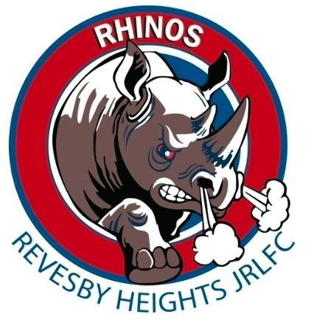Revesby Heights Rhinos Junior Rugby League Club 

Application Form – International Coaching Staff

(2026 Season)
Please return to paulandsonia87@gmail.com
- Coach
- Manager
- Yellow Shirt Trainer
- Blue Shirt Trainer

1. Personal Information
Full Name: ________________________________________________
Date of Birth: _____________________________________________
Address: ___________________________________________________

Phone Number: _____________________________________________
Email Address: _____________________________________________
NRL ID: ____________________________________________________
Working With Children Check (WWCC) Number: __________________
WWCC Expiry Date: __________________________________________
2. Coaching Qualifications
(List relevant coaching courses, certificates, and accreditations.)

3. Coaching Experience
(Outline your coaching background, including club names, age groups, years, and key achievements.)

4. Previous Coaching Positions Held
(Include volunteer or paid positions within rugby league or other sports.)

5. Age Group Applying For
(Please tick, If applying for more than one age group, please indicate preferences:
- Under 13
- Under 14
- Under 15
- Under 16
- Under 17
- Under 18
6. Additional Information (Include any skills, strengths, coaching philosophies, or relevant notes, Why you would like to be considered.)

Applicant Declaration
I hereby apply for an international coaching Staff position with the Revesby Heights Rhinos Junior Rugby League Club for the 2026 season. I confirm that all information provided in this application is true and correct to the best of my knowledge.
Signature: ____________________________________
Date: _________________________________________

Final Approval Statement
All applications are subject to review, and the Revesby Heights Rhinos Executive Committee will have final approval of all coaching appointments for the 2026 season.

