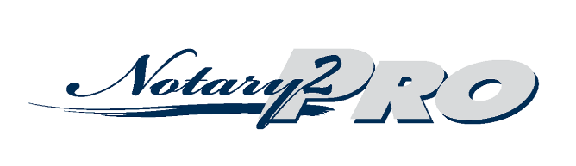

Carol Ray **|** notary2pro@gmail.com

Date

To Whom It May Concern:

My name is Carol Ray, and I am the Founder and Owner of Notary2Pro. Notary2Pro trains and certifies notaries how to do Loan Signings. I am a Retired Escrow Manager from California and was a Professional Notary Signing Agent for 14 years. In 2009 I developed Notary2Pro because I felt equipped to give Notaries Public the opportunity to obtain very detailed and comprehensive training. In 12 years N2P training has become a standard in the industry and we have over 10,000 successful students all over the country. Many companies are requiring notaries to have Notary2Pro training for the Certified Notary Signing Agents they hire.

I am writing this reference at the request of Lisa Contreras**.** I am happy to do this because I know how they have been trained and I have the utmost confidence that they will perform with the excellencewe demand of them prior to certifying them.

What N2P trains notaries on includes A to Z about document signings, details about various types of signings, and a variety of documents, working with Borrower’s, Seller’s and Buyer’s, personal grooming, dress codes, safety and much more!

We all know that performing Error Free signings is of the utmost importance. However, we are all human and do make occasional mistakes. My graduates have been taught that when they do have an error, they must graciously accept responsibility for the mistake and go fix it ASAP!

In conclusion, I would highly recommend Lisa Contreras will be an extremely positive addition to your organization. If you need any additional information, feel free to contact me at telephone or by email at notary2pro@gmail.com anytime.

Sincerely,

Carol Ray

Carol Ray

Owner, Notary2Pro.com