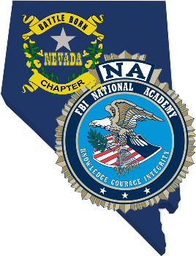
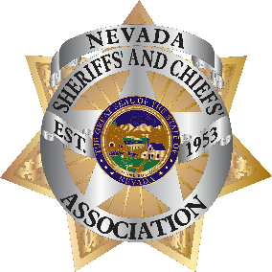
2022 Meetings &
Conference

NvSCA and FBINAA Annual Conference
Event Schedule

Monday November 14th
8:00 – 11:30 FBINAA Board Meeting – California Chapter – Napa C
8:00 – 11:30 NvSCA Membership Meeting – Napa A/B
11:30 – 12:30 Lunch
12:30 – 4:30 FBINAA – Section 1 and Nevada Chapter Meeting – Napa A/B
12:00 – 2:00 NvSCA CCW Subcommittee Meeting – Napa C
5:00 – Close Early Registration, Hospitality Suite (TBD)
5:00 – 10:00 Hospitality Suite – Suite number to be provided
(Times are subject to change as needed)

Tuesday November 15th – All in Napa A/B
7:00 – 5:00 Registration Desk open, Napa Hallway
8:00– 8:35 Presentation and Posting of Colors
Boulder City Police Department Honor Guard
Invocation
Sr. Chaplin Michael Thrower
Boulder City Police Department
Opening Remarks
Spencer L. Evans, Special Agent in Charge
Las Vegas Field Office
Announcements
Pamela DelPorto, NvSCA Executive Director
Charles Haycox, FBINAA Secretary/Treasurer
8:35 – 8:45 NCIC Inmate Communication
Platinum Plus Sponsor Presentation
8:45 – 8:55 Axon
Platinum Plus Sponsor Presentation
8:55 – 9:10 Break
9:10 – 10:15 Rick Taylor, Presentation on Command Presence
10:15 – 10:30 Break
10:30 – 10:40 Cradlepoint, Part of Ericcsson
Platinum Sponsor Presentation
10:30 – 11:50 Rick Taylor Command Presence (Continued)
11:50 - 12:00 Law Enforcement Against Drugs & Violence (LEAD)
Platinum Sponsor Presentation
Tuesday November 15th – All in Napa A/B (Continued)
12:00 – 1:00 Lunch
1:00 – 1:10 Open Text
Platinum Sponsor presentation
1:10 – 1:50 Dan Willis, Presentation on Bullet Proof Spirit
1:50 – 2:00 Break
2:00 – 3:00 Dan Willis, Bullet Proof Spirit (Continued)
3:00 – 3:15 Break
3:15 – 5:00 Greg Hanna, Presentation on The ABLE Project
5:30 – 10:00 Hospitality Suite

Wednesday November 16th – All in Napa A/B
7:00 – 8:00 Continental Breakfast (Sunrise Continental Breakfast)
8:00 – 8:10 Watch Systems, Offender Watch
Platinum Sponsor Presentation
8:10 - 9:30 Lt. Colonel Dave Grossman, Key Note Speaker, Presentation, Grossman on Truth
9:30 – 9:45 Break
9:45 – 12:00 Lt. Colonel Dave Grossman, Grossman on Truth
12:00 – 1:20 Exhibitor Appreciation Lunch and Raffle
1:20 – 1:30 OCV – The Sheriff/Police App
Platinum Sponsor Presentation
1:30 – 2:30 Jeff Halstead, Encrypted Communication
2:30 – 2:40 Break
2:40 – 3:30 Jeff Halstead, Encrypted Communication
Wednesday November 16th – All in Napa A/B (Continued)
3:30 – 4:00 NV POST Training document pickup, Registration Desk
6:00 – 7:00 Hosted Happy Hour
7:00 - 9:00 Banquet and Raffle
9:00 – 10:00 Hospitality Suite

Thursday November 17th – Napa A/B
8:00 -12:00 Nevada POST Commission Meeting

