FBINAA Nevada Chapter and the Nevada Sheriffs’ & Chiefs’ Association
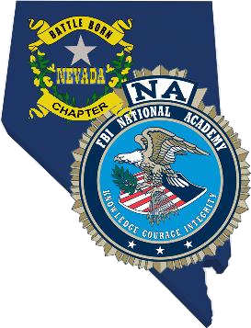
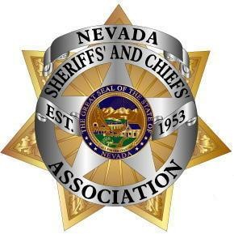
2021 ANNUAL TRAINING
CONFERENCE
November 14-16, 2022
SouthPoint Hotel
Las Vegas, Nevada

On behalf of the Nevada FBI National Academy Associates and the Nevada Sheriffs’ and Chiefs’ Association, we welcome you to the 2022 annual Training Conference.

We thank you for supporting our conference through your sponsorship, and hope your time here over the next few days is both enjoyable and worthwhile. We sincerely appreciate the value and contribution you provide to the conference and know much of our success is attributed to your support.

Also, as a sponsor, you and your representatives are invited visit our nightly hospitality room (room number will be provided). The hospitality room is your chance to network and create lasting partnerships with agency leaders so please make an effort to swing by at some point between 5 and 10 pm; we truly want to get to know you!

Additionally, please join us in the exhibit hall for our annual, hosted Exhibitor Appreciation Lunch and Raffle on Wednesday, November 16th at around 12:30. It is always a lively time and lots of fun. If you have something to raffle or are doing a business card drawing yourself, let us know and we can help out!

For your reference, enclosed is the draft conference schedule, the floor plan and some move-in/move-out information.

Thank You,

Chief Maquade Chesley, NV FBINAA
Director Pamela DelPorto, NvSCA

