Welcome Back to the South Point!

Dear Valued Guest,

On behalf of our owner, Michael Gaughan, we would like to thank you for staying with us here at the South Point Hotel, Casino, & Spa. We want you to know that your health and safety is our first priority here and we have taken steps in accordance to CDC guidelines to ensure that safety not only for our guests, but for our staff as well.

Employees will receive training on all aspects of this program including their department specific procedures. Emphasis will be placed on personal protective equipment, cleaning and disinfection, handwashing and social distancing.

07/02/20

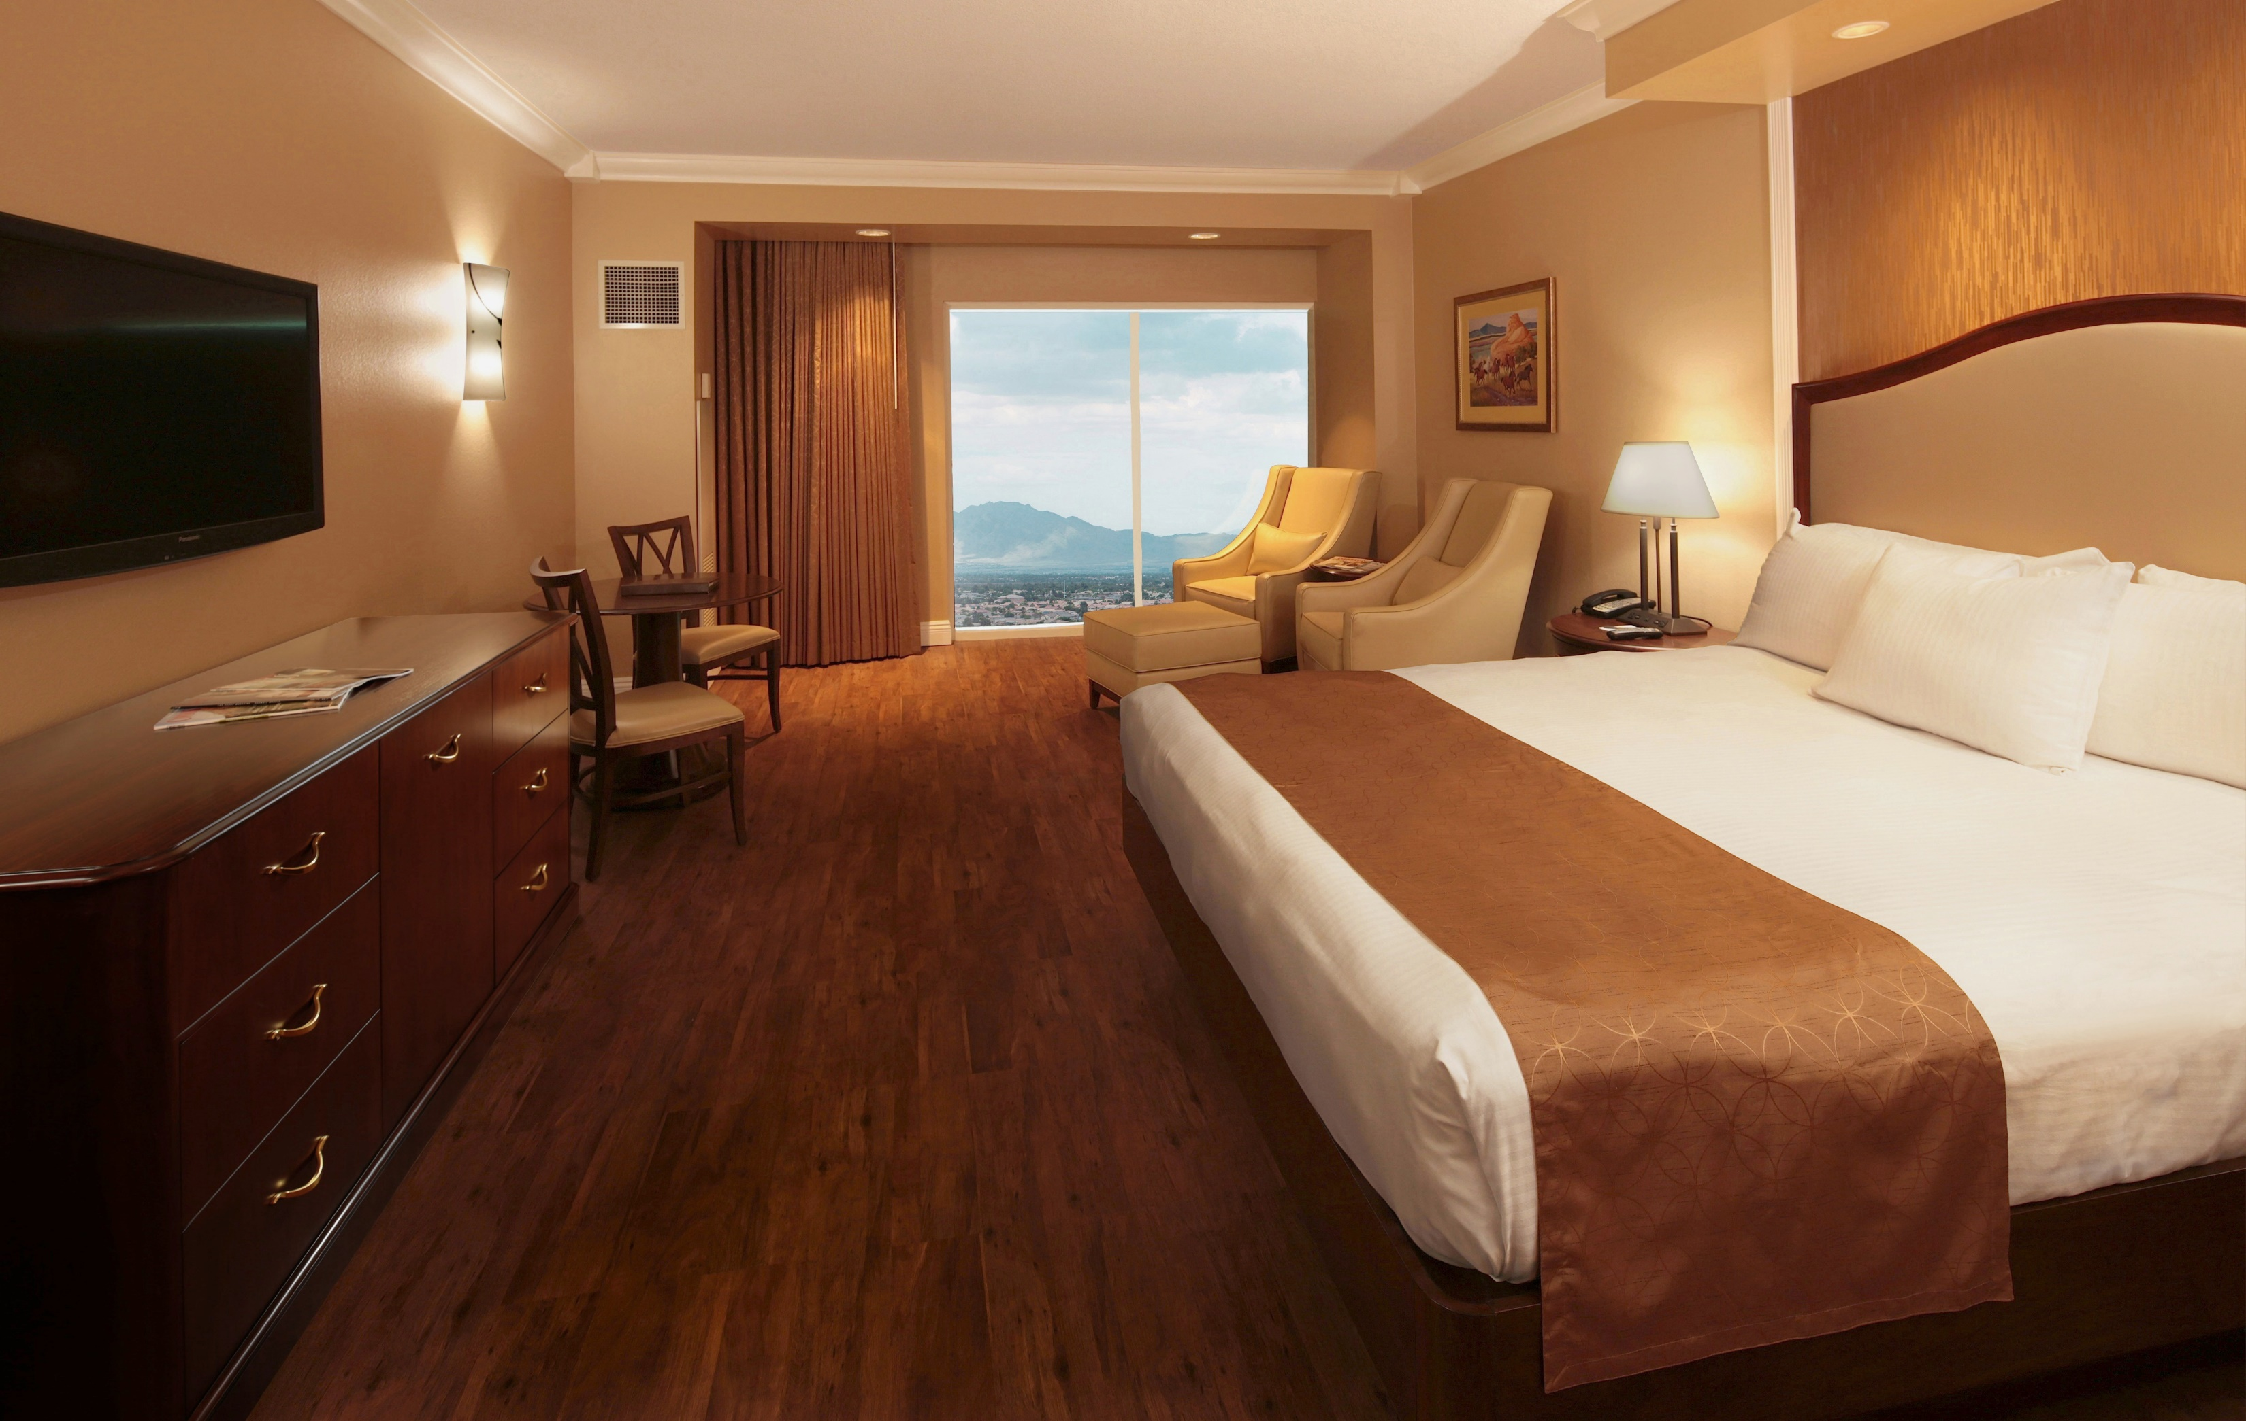

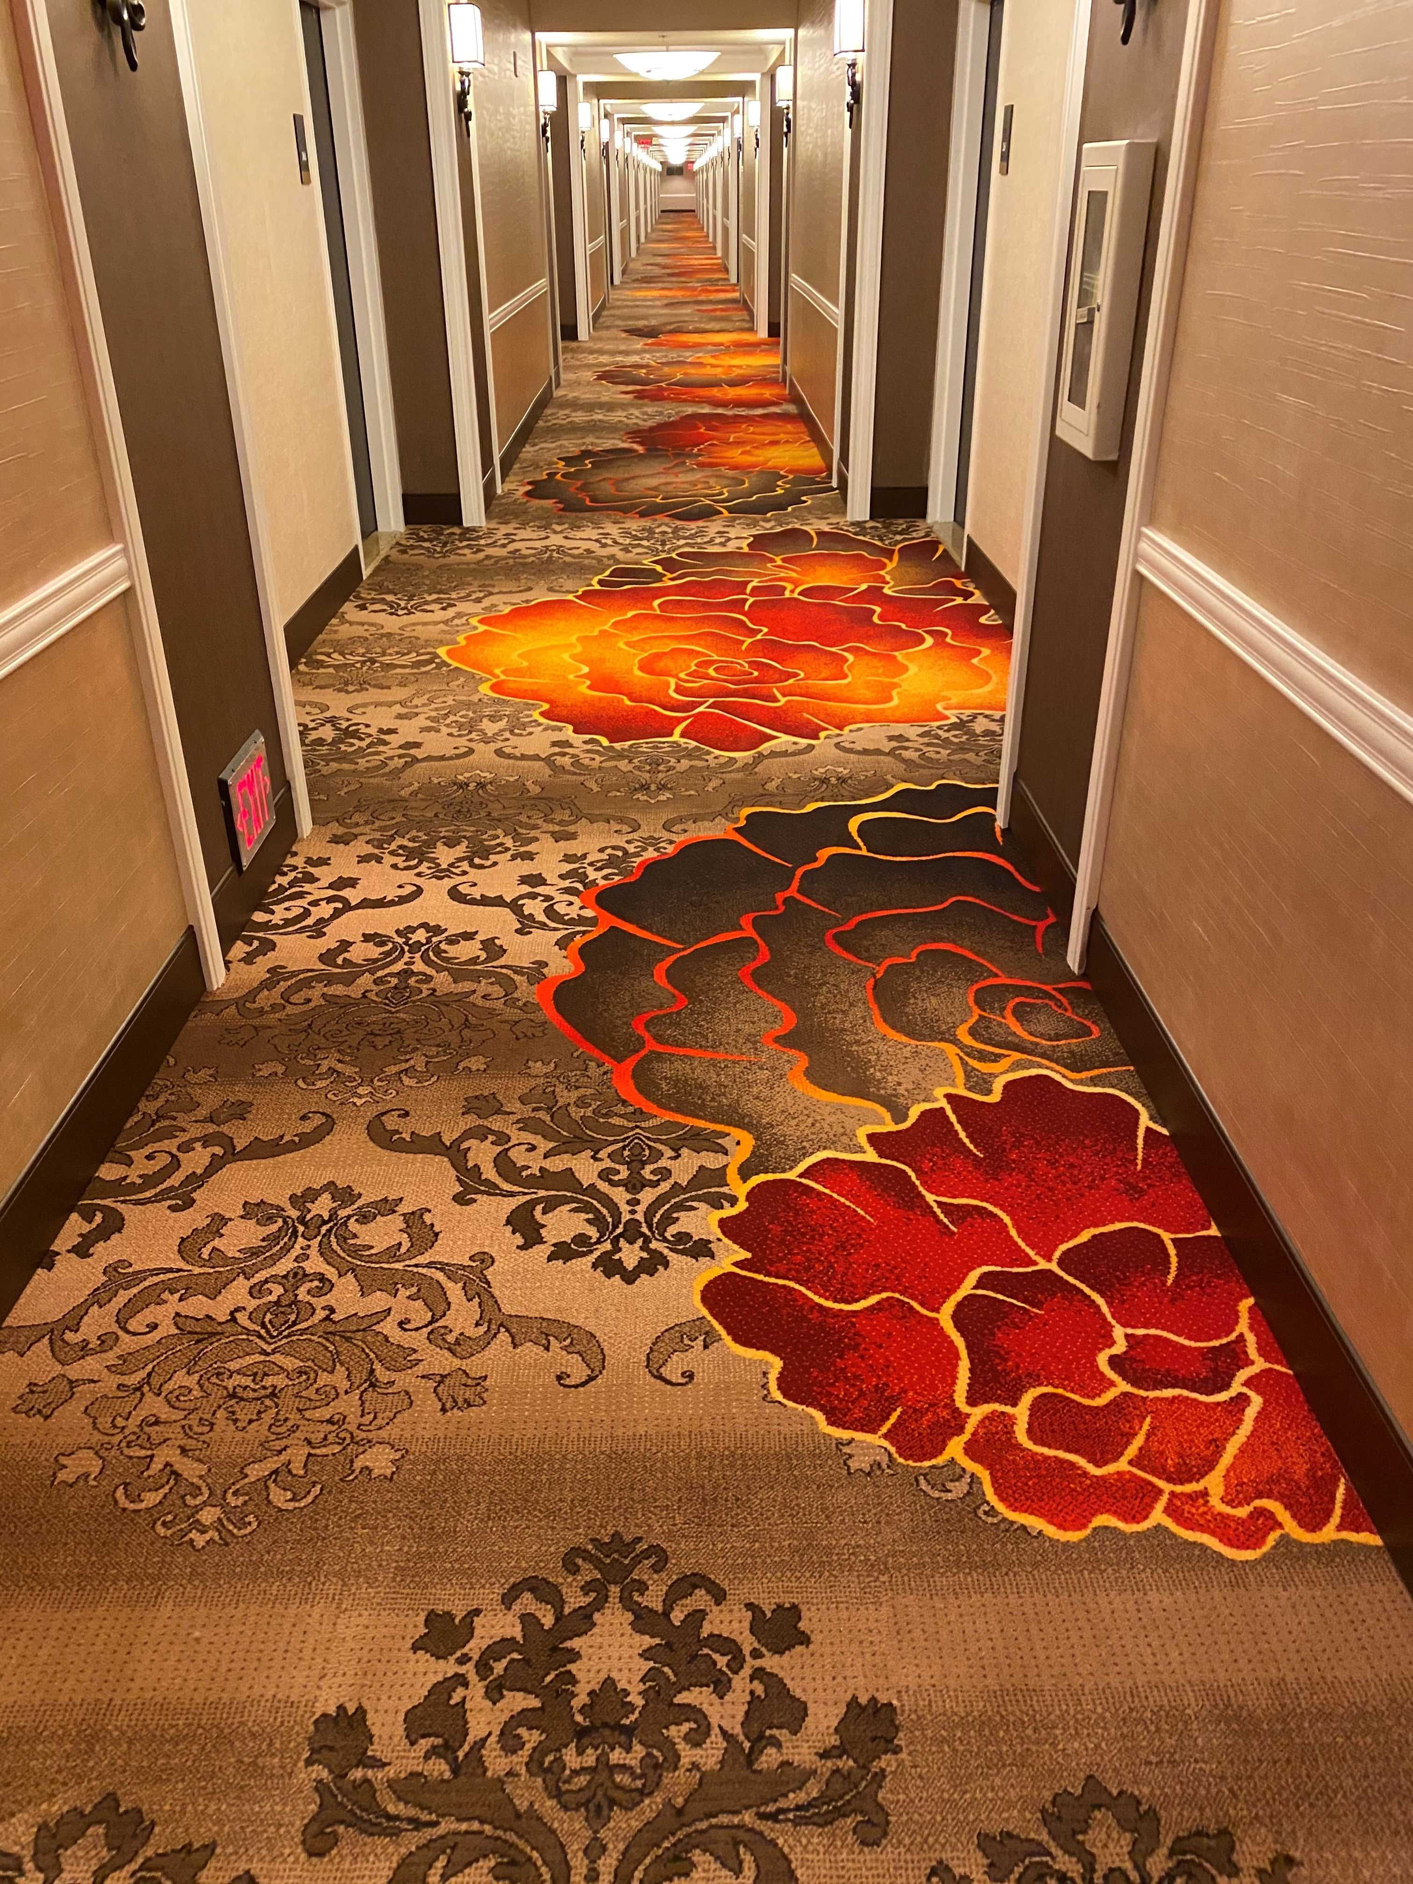

These guidelines include:
- Per the Nevada Governor’s Mandate, ALL Guests are REQUIRED to wear face a face covering while on property.
- Prior to your check in, your room has been completely disinfected.
- Every hotel guest that will be occupying the room must be present at check in and will go through a temperature check station, if the temperature is 100.4 or high we will then be mandated to follow CDC guidelines, up to and including transporting to the nearest medical care facility.
- During this time, we are not offering daily housekeeping service for guests that are staying more than one (1) night. If you need any extra amenities, please notify housekeeping at extension 77400 and they will be happy to assist and deliver these items.
- If you have trash that you’d like to be picked up, please place the trash outside of your door before 5:00pm.
- In the casino, we will have guests on every other slot machine and our table games will have a limited amount of people allowed at each game to ensure social distancing guidelines.
- No more than four (4) guests will be allowed in each elevator.
- The Bingo Hall and Family Bowling Center will be open, but will have a limited capacity.
- Cinemark Movie Theatres will be closed.
- Fitness Center hours – 5:00am to 8:00pm with limited capacity.
- Pool Hours – 8:00am to 10:00pm. Pool Bar will be open 11:00am to 6:30pm daily. Pool Deli will be open 11am to 5pm (Fri-Sun Only). The Jacuzzi will be closed as well.
- We also encourage our guests to self-check-out in the room via video check out.
A few of our restaurants will have different hours:
- Coronado Café – Open 24 Hours
- Garden Buffet
          - 7am to 9pm, Mon – Fri
          - 8am to 9pm, Sat - Sun
- Silverado Steak House – 5:00pm to 10:00pm, Daily
- Don Vito’s – 5:00pm to 10:00pm, Daily
- Steak N Shake
          - 12 Noon to 10:00pm, Sun – Thurs
          - 12 Noon to 1:00am, Fri – Sat
- Room Service will be available from 6:00am to 10:00pm
- Bowling Snack Bar
          - 8:00am to Midnight, Daily
- Kate’s Korner
          - 11:30 to 10:00pm, Sun
          - 11:00am to 10:00pm, Mon – Thurs
          - 11:00am to Midnight, Fri
          - 11:30am to Midnight, Sat
    - Del Mar Deli
          - 9:00am to 3:00pm, Mon – Thurs
          - 11:00am to 8:00pm, Friday
          - 10:00am to 8:00pm, Saturday
          - 10:00am to 7:00pm, Sunday
      - Seattle’s Best
          - 6:00am to 9:00pm, Daily

