Easy Read – Emergency and Disaster

 | We will work with you to create an emergency plan.
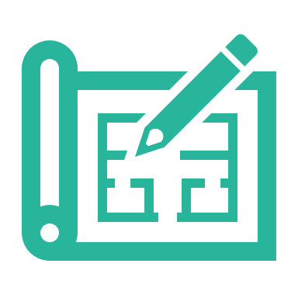 | Your emergency plan will reduce and get rid of any risks during an emergency or disaster.
 | An emergency is any sudden, urgent, unexpected event that may cause grave risk to your health, life or environment
 | A disaster can be prepared for and may cause loss of life, damage or hardship (such as fire and flood)
 | Your emergency plan ensures continuous support and manages your safety needs.
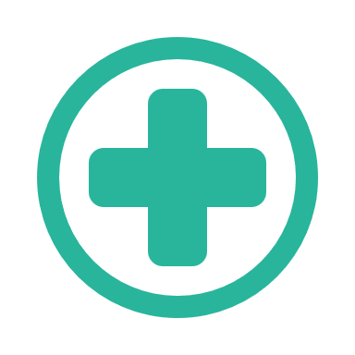 | Your emergency plan reviews what is critical to your safety, health and wellbeing
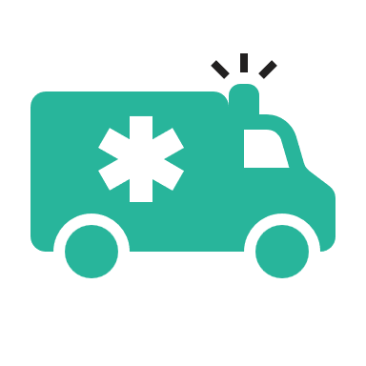 | Your emergency plan considers planning and responding to an emergency and disaster
 | Your emergency plan will look at potential changes, adapting and rapidly responding to ensure your support.
 | We will write the communication strategies to you and your network into the plan.
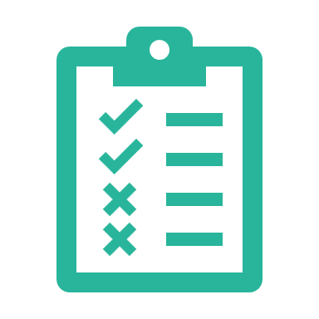 | We will test the emergency plan
 | You can give feedback on what worked and what needs change.
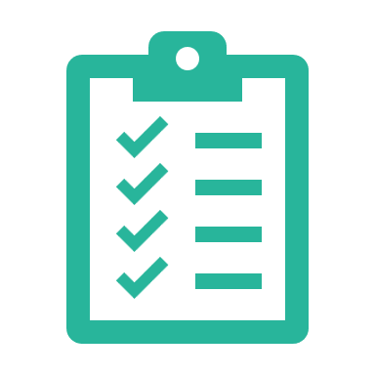 | Our management reviews all the information we gain from your test and the current situation.
 | Your staff will be trained and know your plan and how to help you.

