Easy Read – Appointments

 | You have an appointment to visit the doctor or hospital
 | It would help if you got dressed ready for your appointment
 | Staff will tell you the day before your appointment and put it on your calendar
 | Staff will remind you of the appointment time
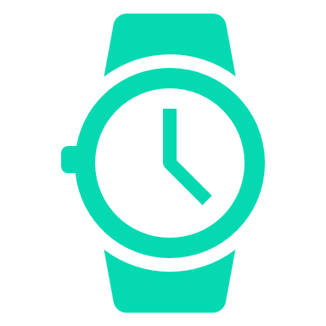 | Staff will inform you of the time you will leave for the appointment
 | Staff will help you gather your information if you want
 | You need to tell us if you want us to go to be part of your appointment

