Community Bike Drive

**Have a bike you don’t ride?**

**Donate it to a good cause!**

**Community Bike Works accepts any bike — any size, any condition — for our youth programs.**

**In Earn a Bike and Junior Earn a Bike, kids work with mentors to learn life lessons through bicycles.**

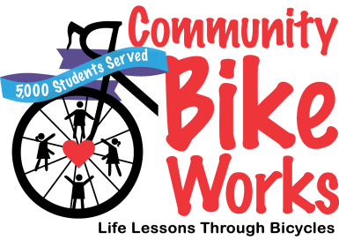

***Your logo here***

**COMMUNITY SPONSOR:**

**DATE & TIME:**

**LOCATION:**

*[SPECIAL INSTRUCTIONS/INCENTIVES]:*

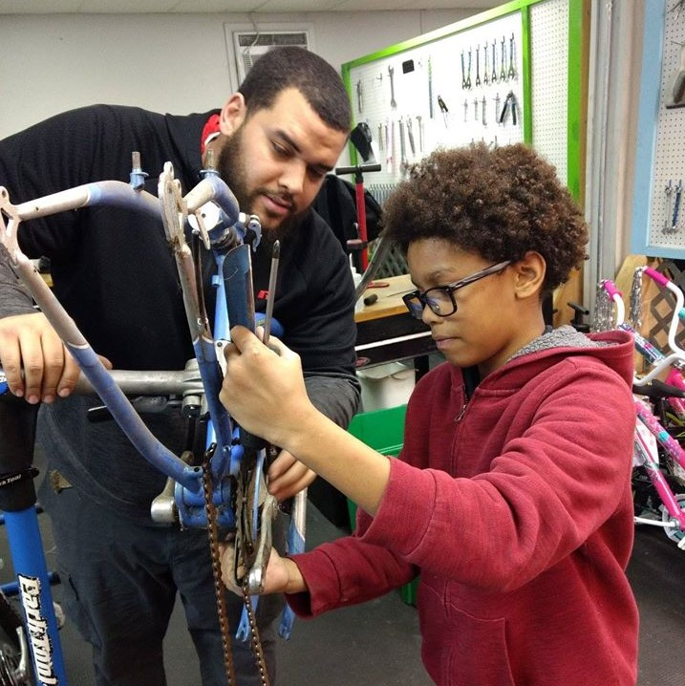

THANK YOU!

Bikes may also be brought to 235 N. Madison St, Allentown, from noon-5 pm, Mondays-Fridays



Community Bike Works | 235 N. Madison Street, Allentown PA 18102 | 610.434.1140 | communitybikeworks.org