235 North Madison Street | Allentown PA 18102
610-434-1140 | www.communitybikeworks.org

Board of Directors/Committee Application
Community Bike Works, a thriving youth development organization in the heart of Allentown, teaches life lessons through bicycles to the young people of Allentown and the Lehigh Valley who could benefit most. In our flagship Earn a Bike program, students are paired with adult mentors for 12 weeks of classes in bike mechanics and safety. While working on their bikes, students also learn communication, teamwork, perseverance, and other job skills. At the end of the course, students earn their refurbished bicycle and a new helmet!

In total, we engage 500 students each year in our bike mentoring programs, at our downtown Allentown bike shop, our East Allentown bike shop, and in schools in Allentown and Bethlehem. All students in Earn a Bike or Junior Earn a Bike are encouraged to participate in our supplemental programs, including after-school/summer Drop-in, Earn a Book, Youth Leadership, and a range of cycling programs. Students may also apply to serve as youth volunteers and, eventually, paid apprentices. Once engaged at Community Bike Works, students have access to all programs until they turn graduate from high school.

Community Bike Works seeks applicants for its board of directors and for membership on our board committees. It is an exciting time at Community Bike Works. YOU can help make our great programs even better!
Responsibilities | The board develops a vision for Community Bike Works and, along with the executive director, establishes and evaluates goals and policies to build that vision. Directors have fiduciary responsibility for Bike Works; they approve the budget, review financial records, and ensure adequate funds are raised. Directors serve as advocates for Bike Works in the community.

Meetings & Terms | The board meets six times a year on the second Monday of the month from 6 pm to 8 pm. Meetings are generally held January, March, May, June, September and November, and directors are expected to meet attendance requirements. Directors serve three-year terms with the opportunity for renewal based on a peer evaluation process.

Committees | Each board member is an active participant on at least one committee. Committees generally meet in the months that the full board does not. Committees include: Executive Committee/Board Development; Finance; Fund Development; Gala; Strategic Partnerships; Events, Outreach, & Marketing; Facilities. Ad hoc: Youth Scholarship.

Financial Commitment | Directors contribute a gift annually at a level that is generous and appropriate to their capability as donors, preferably at one of Community Bike Works’ leadership levels. Directors should be donors at the time they come on to the board. Directors also connect Community Bike Works to potential donors in their networks.

Annual Report | Community Bike Works’ most recent annual report is available at:
http://www.communitybikeworks.org/annual-reports.html

WHAT DOES COMMUNITY BIKE WORKS DO?
- We offer high-quality mentoring programs that use bicycles and books to connect youth with adult and peer mentors who can teach them skills that help them succeed.
- In order to help students reach their full potential, we offer additional resources and partner with organizations to help strengthen students’ families and the community.
- In all we do, we seek to give students and families a meaningful voice in our work. We strive to be an organization of racial and economic justice and equality, not charity.

STRATEGIC PRIORITIES: We aim to serve more students, more deeply, through high-quality mentoring programs.
- Ensure that the programs of Community Bike Works remain effective in delivering the mission of the organization and that our youth have the tools they need to succeed.
- Increase the number of students served, while seeking to serve those who could benefit most.
- Increase our engagement with participating youth and families, in order to provide them with opportunities for deeper connections to mentors and more avenues to success.
- Develop and maintain effective partnerships that allow Bike Works to serve our students and strengthen the community.
- Ensure that dedicated and capable staff, board and volunteers are in place.
- Strengthen and diversify our funding base.
- Implement administrative and facility improvements that increase Bike Works’ effectiveness and ability to serve as a safe place for students.

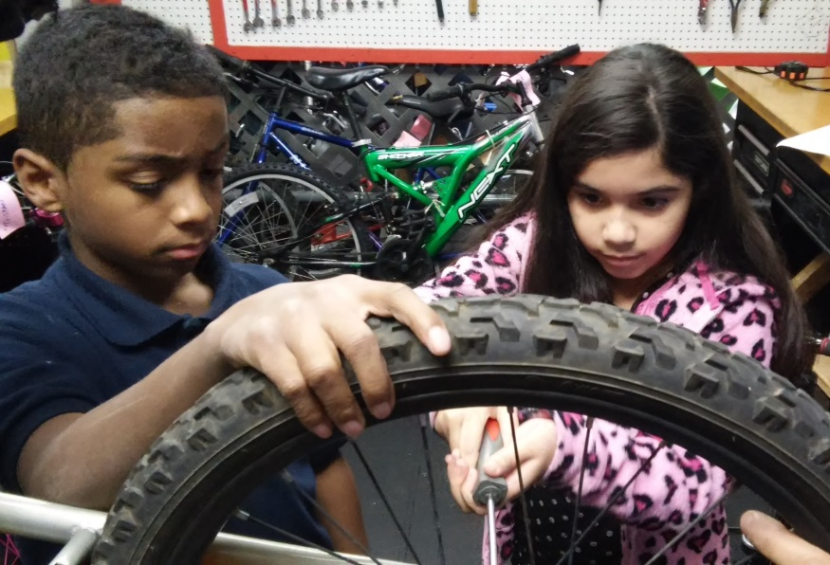
Community Bike Works is more
than learning how bikes work.
It’s learning how life works.
--Kyle, youth apprentice
235 North Madison Street | Allentown PA 18102
610-434-1140 | www.communitybikeworks.org

Application to the Board of Directors/Board Committees
Please submit to Kim Schaffer, Executive Director, kim@communitybikeworks.org

Name
Address
Employer Title
Phone (Home) (Cell) (Work)
Email

Preferred address: Work ( ) Home ( )
Preferred phone: Work ( ) Home ( ) Cell ( )

Are you generally available for meetings on the second Monday of the month from 6 pm to 8 pm? Yes ( ) No ( )

Please describe your interest in Community Bike Works and our mission.

Please describe the skills you would bring to the Community Bike Works board of directors.

Please list the boards and committees you serve on, or have served on, and any other relevant affiliations.
Organization Role/Title Dates of Service

Which board committee are you most interested in? Spin-a-Thon, Gala, Fund Development, Marketing, Facilities

Please provide any additional information.

