Great Lakes Stitchers Gathering

sEPTEMBER 8 - 10, 2023
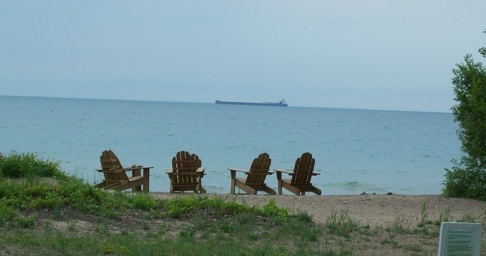RETREAT INFORMATION
Welcome to the Fall 2023 Great Lakes Stitchers Gathering Retreat Information Packet. Feel free to print this out and save information that you will need to get registered and prepared to attend this wonderful event. I am so looking forward to you joining fellow stitchers for a long weekend of Stitchy Fun.



This is an ALL-Inclusive Retreat which means that your Retreat Cost will include Six meals (Lunch and Dinner on Friday - Breakfast, Lunch and Dinner on Saturday - Breakfast on Sunday). This also means that your Friday and Saturday nights lodging will also be included in the Retreat Cost. ** If you need to arrive on Thursday evening, there will be an additional charge that will need to be added to your second invoice payment. Meals on that day will be on your own.

Cost
The Retreat will cost $450 per person and will cover all the cost of attendance AND the cost of your meals and lodging as noted above. The Registration will open on February 18th at NOON. To Register, you will go to the website swgstitchinganddesigns.com. On that website, on February 18th at NOON, a fillable form will become active. Please complete the form in its entirety and click the submit button. Once submitted, I will send out an invoice for the deposit payment of $200, to registrants in the order that they were received. This payment will be due by February 28, 2023. Any unpaid invoices as of March 1st will be cancelled and your name will be removed from the registration list. Deposit invoices will then be sent to the next names on the Waitlist. On May 1, 2023, the second invoice will be sent out to paid attendees for the remaining $250. Prior to that date, I will need to know if you plan to arrive on Thursday, September 7. The additional charge for early arrival will be $50 per person. Because of a great deal of upfront costs, will be very difficult to be able to issue any refunds. Please make sure that you are confident that the dates of this retreat will work with your schedule.

swgstitchinganddesigns.com
Where will the retreat be held?
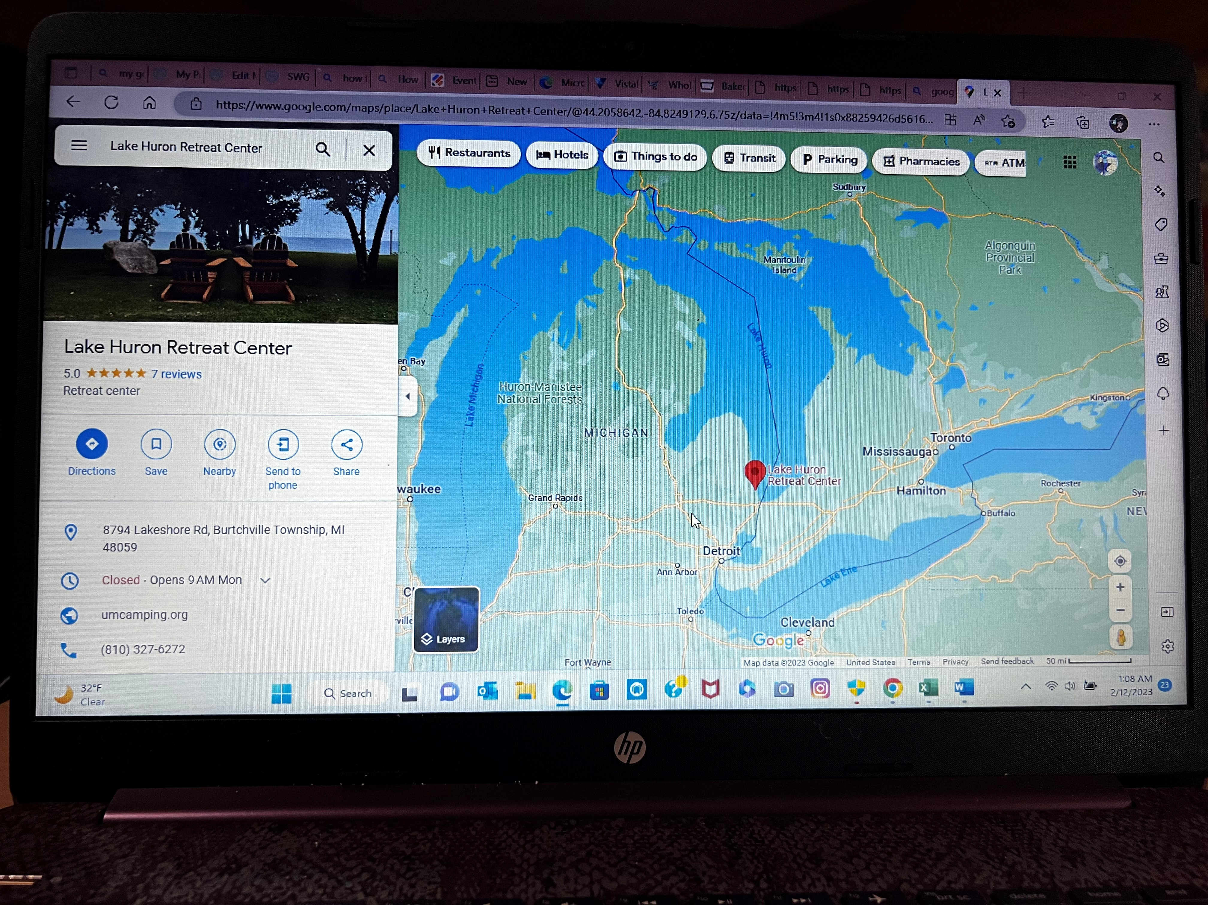
The 2023 Fall Great Lakes Stitchers Gathering will be truly a retreat. According to an online Dictionary, a retreat is defined as a “quiet or secluded place in which one can rest and relax”. It is my hope that this will be a relaxing retreat for all attendees. The Lake Huron Retreat Center, located in Lakeport (Burtchville Township) Michigan on the beautiful shores of Lake Huron, in what we call the Thumb area of our Great State. It is very close to Port Huron as well as the Blue Water Bridge to Canada.
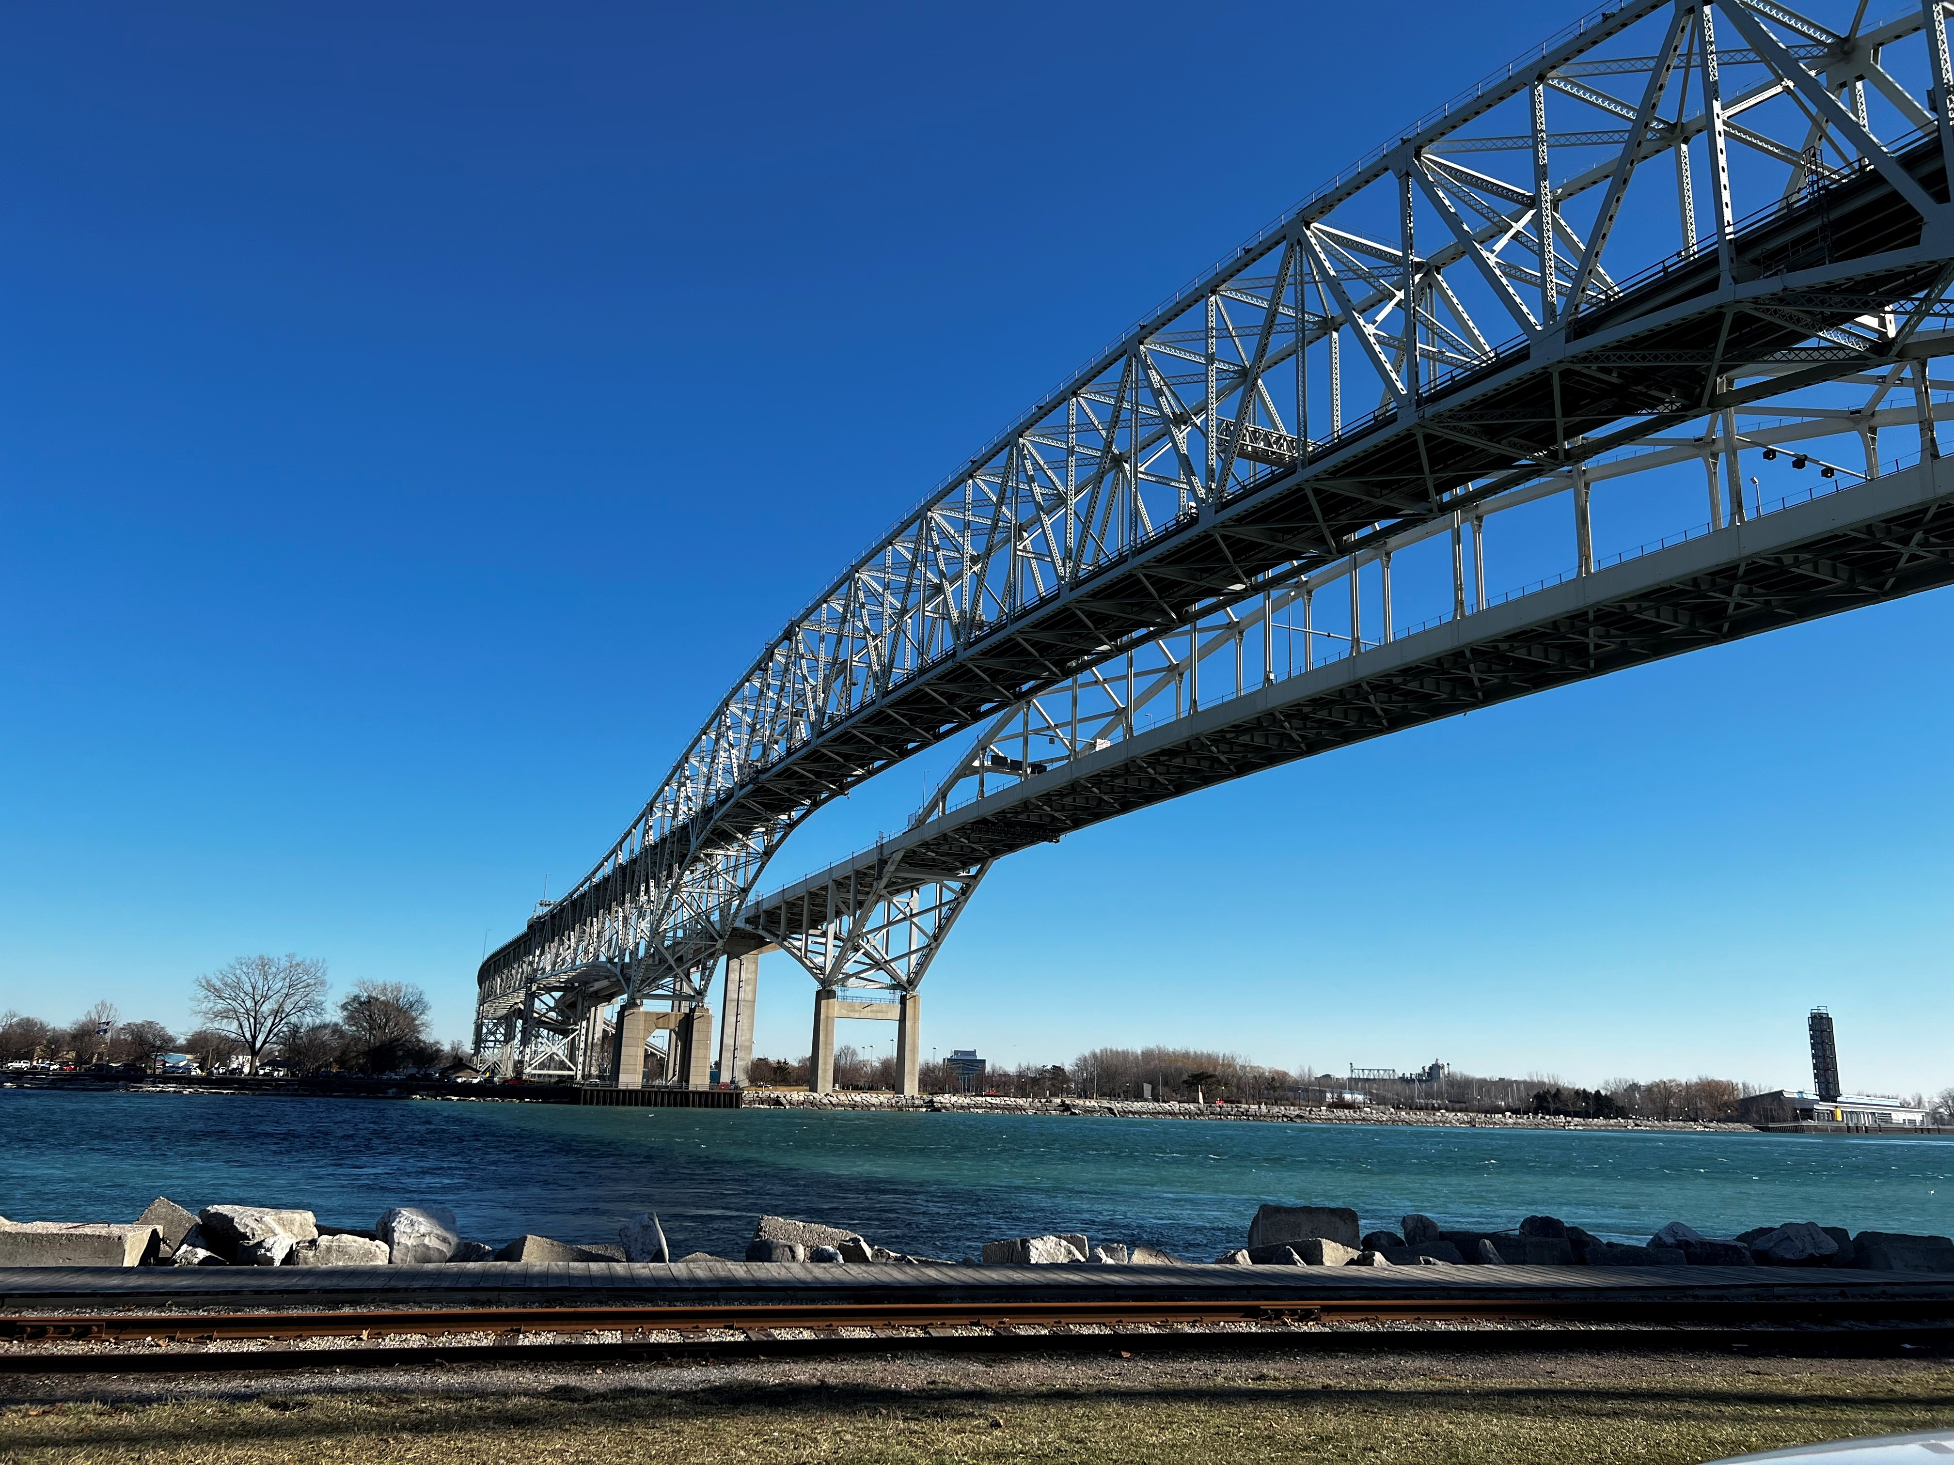

swgstitchinganddesigns.com
Do you Enjoy Camping?

The retreat will be held the weekend after Labor Day weekend. The early Fall in Michigan is beautiful, and many families are still enjoying camping well into the Fall. If you are a camper and would be interested in making your stay in the Lakeport area longer, there is a very nice State Campground located just minutes south of the Lake Huron Retreat Center. Reservations will be accepted on the DNR Campsite Reservation website https://midnrreservations.com/ up to 6 months prior to the dates of desired reservation, that would be in March. Be sure to reserve your site early because these sites, right on Lake Huron, will go very quick.
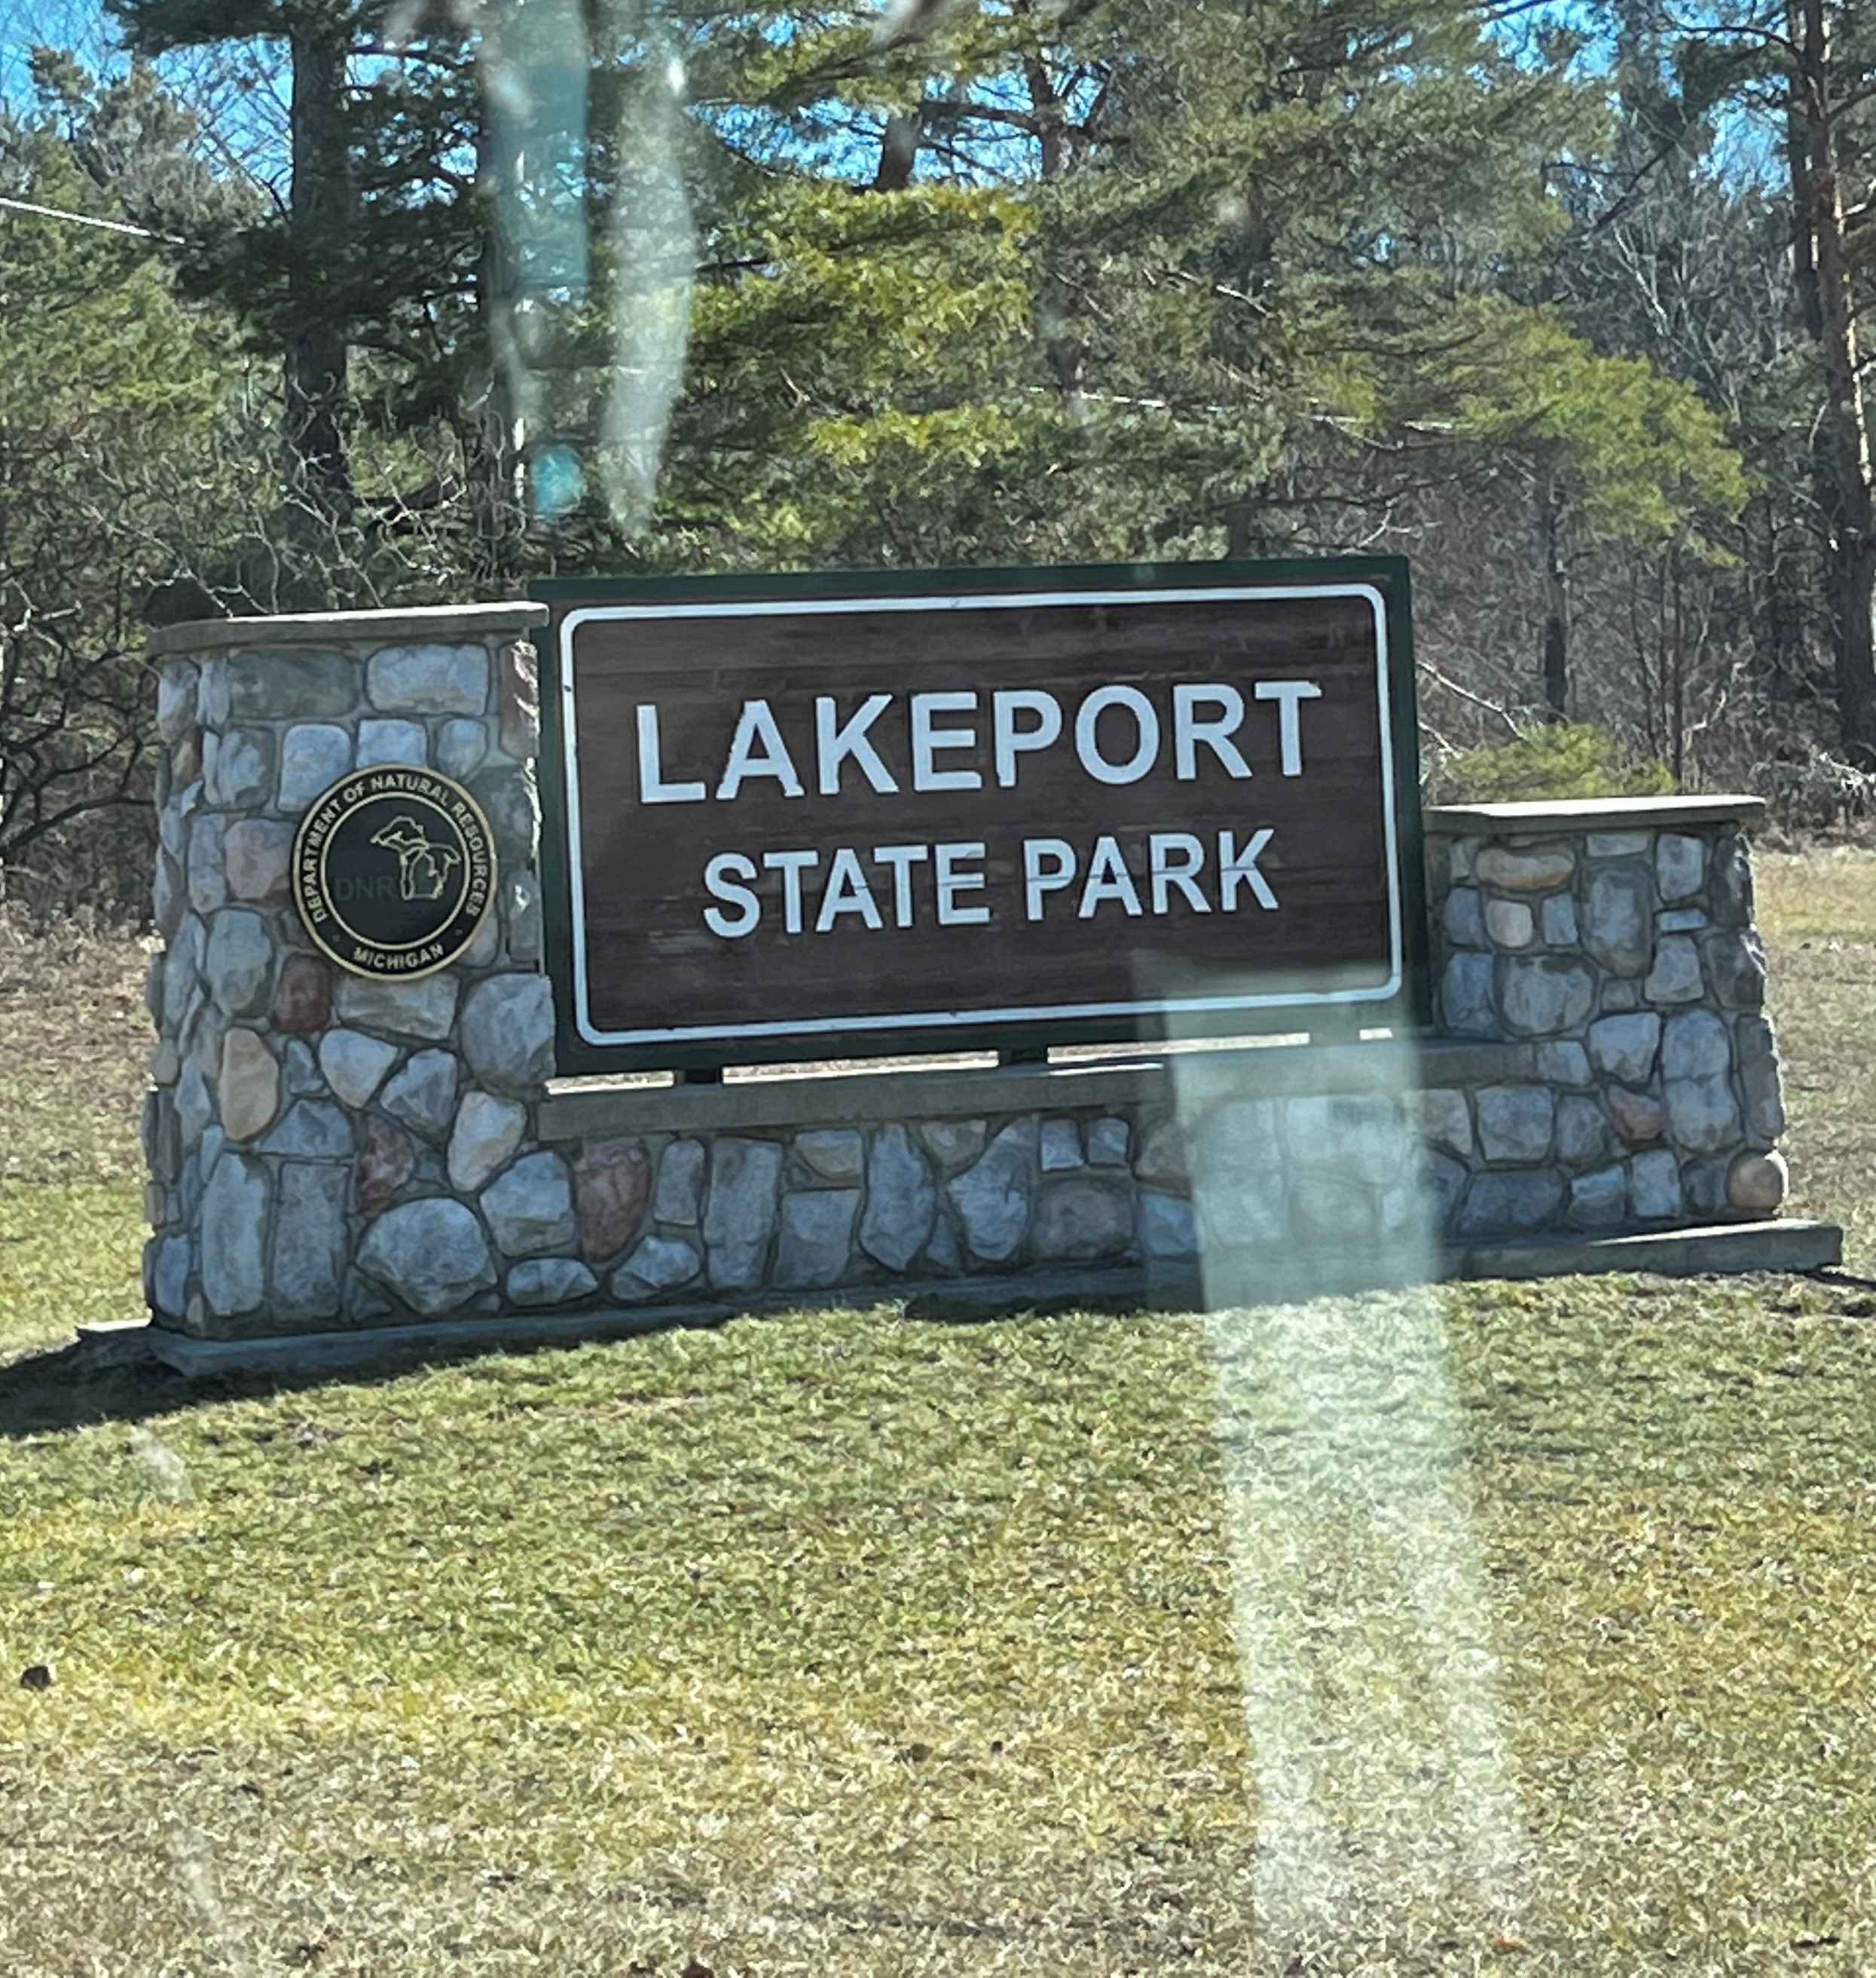

Coming with a friend?
If you have a friend or two who you want to travel with make sure you have all completed the registration form. There will be a section on the form for you to add the names of others who you may want to room with. Please fill out their names in the spaces provided. Some of the lodging rooms will have four attendees and other rooms will have three. We can also have conversations about roommate selections once we open the Facebook Great Lakes Stitchers Gathering paid attendees’ room.

THERE WILL BE MUCH MORE INFORMATION TO SHARE WITH PAID ATTENDEES ONCE OUR FACEBOOK PAID ATTENDEES GROUP IS UP AND RUNNING.
swgstitchinganddesigns.com
Schedule of Daily Activities

9/8/2023
Friday 8am Check in at Littleton Lodge
Friday 9am Stitchy Room Open
Friday 10am Welcome Message – Guest Designer Talk Time
Friday Noon – Lunch in the Dining Hall
Friday 1pm to 5pm Stitchy Room Open
Friday 5pm – Dinner in Dining Hall
Friday 6pm to 8pm Vendor Room and Games Room Open
Friday 8pm Bonfire Time and S’Mores
Friday Late Night Stitching in Littleton Lodge

9/9/2023
Saturday 8am - Breakfast in the Dining Hall
Saturday 9am to Noon Stitchy Room Open
Saturday 10am Morning Breakout Session – Littleton Lodge
Saturday Noon – Lunch in the Dining Hall
Saturday 1pm to 5pm Stitchy Room Open
Saturday 2pm Afternoon Breakout Session – Littleton Lodge
Saturday 5pm – Dinner in the Dining Hall
Saturday 6pm until 8pm Vendor Room and Games Room Open
Saturday 8pm to 11pm Late Night “Come as you are time” in Stitchy Room
Saturday 11pm Super Late Night Stitching in Littleton Lodge

9/9/2023
Sunday 8am Breakfast in the Dining Hall
Sunday 9am to 2pm Stitchy Room Open
Sunday 1pm Closing Remarks
Sunday 2pm Check Out and Departure
*** Tentative Schedule – Subject to Change ***

