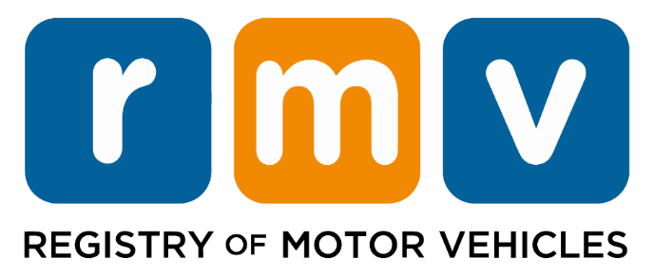

To support the RMV’s commitment to safety:

- Service Center locations and Road Test sites strictly enforce the regulations that impose severe penalties on anyone cheating on any knowledge and/or skills tests

Regulations are:

- Commonwealth of Massachusetts 540 CMR 2.06(5)(a)9; and
- Federal Motor Carrier Safety Administration’s 49 CFR 383.73

If you are caught cheating, penalties include:

For All Tests
- Disqualification from holding any Class of driver’s license or learner’s permit for 60 consecutive days
Commercial (Class A, B, & C)
- Applicants found guilty of cheating on a test will be prohibited from reapplying for a new CDL for 1 year, in addition to the 60-day disqualification

The RMV is committed to the safety of roads and highways, pedestrians and bicyclists, and the movement of goods and services across the Commonwealth. Mass.Gov/RMV

