

Finance Manager Report

District 54 District Council Meeting

October 18, 2025

Elias Hayes
District 54 Finance Manager – 2025-2026
email:elihayes194 @gmail.com

BALANCES

District Reserve Statement – as of date: 8/31/2025
The reserve account balance is $24,855.73. $211.92 in expense due to monthly Facebook ads and Storage Unit expense.
* Minimum District Reserve Required at Year End: $5 ,843.13

Bank Statement – as of date: 8/31/2025
The checking account balance is $1,967.99. We had no bank account activity this month

PROFIT & LOSS STATEMENT
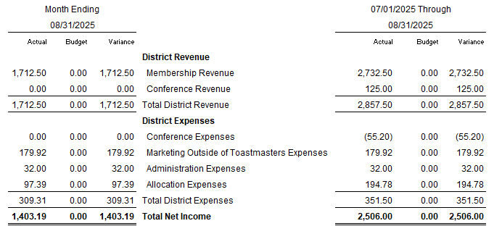

TALKING POINTS

Accruals from prior budget have been recategorized and now more accurately represented in the current budget. We budgeted to collect $918.78 in membership revenue in August and collected $1712.50, so we are back on track for membership revenue collection for the year.

