

Finance Manager Report

District 54 District Council Meeting

November 15th, 2025

Elias Hayes
District 54 Finance Manager – 2025-2026
email:elihayes194 @gmail.com

BALANCES

District Reserve Statement – as of date: 9/30/2025
The reserve account balance is $28,579.07. We had a membership revenue of $7,217.50 and had $3,494.16 in expenses for the month of September.
* Minimum District Reserve Required at Year End: $5 ,843.13

Bank Statement – as of date: 9/30/2025
The checking account balance is $1,967.99. We had no bank account activity this month

PROFIT & LOSS STATEMENT
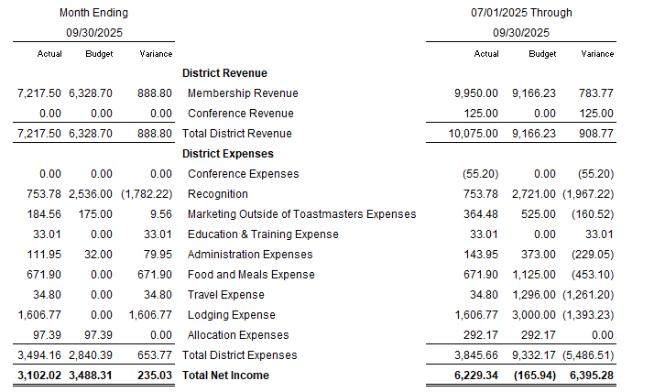

TALKING POINTS

We collected over the expected amount in membership revenue for September by $888.80 and $783.77 over all for the year so far. This is a good sign as it indicates we are maintaining strong member numbers and retention. We are under on expected budgeted by $5,486.51 for the first quarter of the year. This is due reimbursement requests coming in latter the planned and items being expensed in later month being budgeted for prior months.

