

Finance Manager Report

District 54 District Council Meeting
April 11th, 2026

Elias Hayes
District 54 Finance Manager – 2025-2026
email:elihayes194 @gmail.com

BALANCES

District Reserve Statement – as of date: 02/28/26
The reserve account balance is $12,105.73. We had a membership revenue of $1,440.00 and had $13,817.12 in expenses and reallocation to TI for the month of February.
* Minimum District Reserve Required at Year End: $5 ,843.13

Bank Statement – as of date: 02/28/26
The checking account balance is $1,203.79. No bank activity for the month of December

PROFIT & LOSS STATEMENT
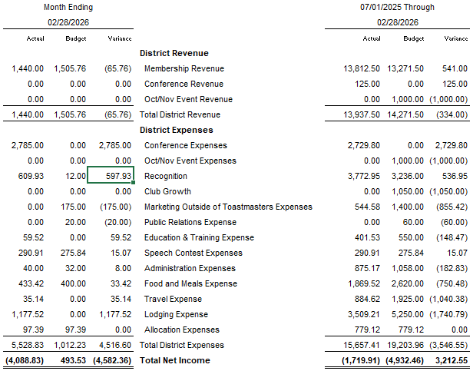

TALKING POINTS

We collected under the expected amount in membership revenue for February by $68.76, but ahead overall for the year so far by $541.00. The first conference venue payment came through($1000) but will show in the April expenses. The second conference expense has also come through($2785). Expenses reimbursement for TLIs, Mid-Year Training, and Speech Contests have come through this month as well. District reserve reduced by 8,288.29 due to TI Allocation.

