

Finance Manager Report

District 54 District Council Meeting
February 21st, 2026

Elias Hayes
District 54 Finance Manager – 2025-2026
email:elihayes194 @gmail.com

BALANCES

District Reserve Statement – as of date: 12/31/25
The reserve account balance is $24,984.59. We had a membership revenue of $202.50 and had $3,288.34 in expenses for the month of December.
* Minimum District Reserve Required at Year End: $5 ,843.13

Bank Statement – as of date: 12/31/25
The checking account balance is $1,203.79. No bank activity for the month of December

PROFIT & LOSS STATEMENT
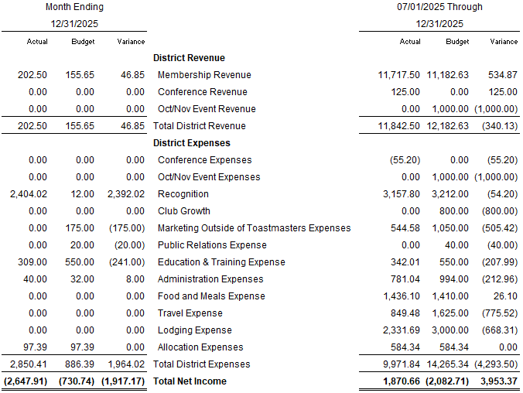

TALKING POINTS

We collected over the expected amount in membership revenue for December by $46.85 and ahead overall for the year so far by $534.87. The hall of fame recognition expense has been charged to the budget this month and has caught up with budgeted amount for the year. We have not had a Facebook ad expense in the past few months. For education and training, we paid for the room rental for TLI North.

