

District 54 Executive Committee

Meeting Minutes

Saturday, July 17, 2021

# *Virtual Zoom Meeting*

***TABLE OF CONTENTS***

OPENING ………………………………………………………………….…………………...…….…..3

WELCOME………………………………………………………………………………………………..3

INSPIRATION……………………………………………………………….…………………………….3

OUR DISTRICT VISION, MISSION AND CORE VALUES…………………………….…………….3

ROLL CALL/QUORUM CERTIFICATION...…………………………………………………………3-4

ADOPTION OF AGENDA ……….……………………….……………...…….……………….…….…4

ADMINISTRATION MANAGER …………………….………………………………………….……….4

FINANCE MANAGER…………………………………………...……………………………………….4

CONTEST ROTATION COMMITTEE …………………………………………………………………5

DIVISION A..………………………………………………………………………………………………5

DIVISION B ……………………………………………………………………………………………….5

DIVISION C …………………………….……………………………………………………..………….6

DIVISION D …..……………………………….………………………………………………………….6

PUBLIC RELATIONS MANAGER………………………………………………………………………6

CLUB GROWTH DIRECTOR…………….………….………………………………………...............6

PROGRAM QUALITY DIRECTOR……….…………………….………………………………….…6/7

DISTRICT DIRECTOR…………………….……………………………………………………………..7

OLD BUSINESS…………………………………………………………………………………………..7

OPEN DISCUSSION/Q&A………………………………………………………………………………7

NEW BUSINESS…………..…………………………………….…………………………………….7/8

DISTRICT LEADERSHIP COMMITTEE……………………………………………………………….8

CLOSING THOUGHTS ………...……………………………………………………………………….8

ADJOURNMENT ………..………….………………………….…………………………………..……8

APPENDIX …………………………………………………………………………………………….8-17

***OPENING***

Michael Bradford, Logistics Manager, called the meeting to order at 9:15 am. He led us in the Pledge of Allegiance.

***WELCOME***

Maryann Reichelt, DTM, District Director, welcomed everyone to the meeting with a quote by William Thackery- ‘whatever you are, trying to be a good one.’ She facilitated the DEC meeting.

***INSPIRATION***

Rachel Scanlon, Area 10 Director, gave the inspiration. She talked about having anxiety as a child which grew as she got older. Accepting it was a part of her, she used it to grow as life begins at the end of your comfort zone.

***OUR DISTRICT VISION, MISSION and CORE VALUES***

The reading of Our Vision and District Mission was led by Dan Kyburz, DTM, Program Quality Director.

**District Vision**We support all clubs in achieving members’ goals and strive to form new clubs to spread the Toastmasters mission.

**District Mission**We build new clubs and support all clubs in achieving excellence.

**District Core Values**

We strive to adhere to the following core values:

* Integrity
* Respect
* Service
* Excellence

***DISTRICT OFFICERS IN ATTENDANCE***

|  |  |  |  |  |
| --- | --- | --- | --- | --- |
| Present | First | Last | Designation | Office |
| X | MARYANN | REICHELT | DTM | DISTRICT DIRECTOR |
| X | DAN | KYBURZ | DTM | PROGRAM QUALITY DIRECTOR |
| X | HEATHER | BLASE | DTM | CLUB GROWTH DIRECTOR |
| X | ADAM | BOCKLER | LD5 | PUBLIC RELATIONS MANAGER |
| X | KARI | SUSAIRAJ | EC5 | ADMINISTRATION MANAGER |
|  | ABRAHAM | GUNASEELAN | IP3 | FINANCE MANAGER |
| X | BALA | SREEDHARAN | DTM | IMMEDIATE PAST DISTRICT DIRECTOR |
| X | MICHAEL | BRADFORD | ACB, ALB | LOGISTICS MANAGER |
| X | WILLIAM | SMOLA | IP1 | DIVISION A DIRECTOR |
| X | LAURA | HANSEN | LD5 | DIVISION B DIRECTOR |
| X | JENNIFER | HO | MS1 | DIVISION C DIRECTOR |
| X | MARTHA | SOJKA | IP3 | DIVISION D DIRECTOR |
| X | RACHEL | SCANLAN | IP5 | AREA 10 DIRECTOR |
|  | TBD |  |  | AREA 11 DIRECTOR |
| X | NOEL | GANAY | DTM | AREA 12 DIRECTOR |
| X | JANA | HERGERT | PM4 | AREA 20 DIRECTOR |
|  | BOBBY | DILLARD | DTM | AREA 21 DIRECTOR |
|  | LAKSHMI | GOPALAKRISHNAN | PM4 | AREA 22 DIRECTOR |
|  | TBD |  |  | AREA 23 DIRECTOR |
| X | SUSIE | RYAN |  | AREA 30 DIRECTOR |
|  | GARY | VAUGHN | DL3 | AREA 31 DIRECTOR |
|  | TBD |  |  | AREA 32 DIRECTOR |
| X | GARY | OHLER | PM1 | AREA 33 DIRECTOR |
|  | KRISTIAN | KIND | PI4 | AREA 40 DIRECTOR |
|  | DALE | POSONT | DL1 | AREA 41 DIRECTOR |
| X | DARREL | FELTY | DTM | AREA 52 DIRECTOR |

16 voting members were present – a quorum is 14; therefore, there was a quorum at the meeting.

# *ADOPTION OF AGENDA*

Maryann Reichelt, DTM, District Director, reviewed the agenda for the meeting.

Substitutions/Changes:

* Bala Sreedharan took over for Michael Bradford as timer as he had to leave early.
* The District Leadership Committee update was moved after the New Business portion.

Dan Kyburz, DTM, Program Quality Director, made the motion and Heather Blasé, DTM, Club Growth Director, seconded the motion. No opposition; agenda accepted as amended.

# *ADMINISTRATION MANAGER*

Kari Susairaj, Administration Manager, presented the June 2021 minutes (May minutes will be read at the September District Council Meeting).

The meeting minutes and all other meeting-related documents are now housed on the D54 website. The meeting minutes were reviewed and approved beforehand by the D54 Trio. Therefore, no additional approval is needed during the meeting.

# *FINANCE MANAGER*

Rabah Seffal, Immediate Past Finance Manager, gave the finance report as it was from May. Report submitted and attached.

Starting with the July statement, the District Treasurer will give the report.

Link to reports

# *CONTEST ROTATION COMMITTEE*

# Chris Boyk, DTM, Contest Rotation Committee Chair, presented a 4-year rotation on speech contests.

The committee made the following recommendations:

Our recommended schedule is as follows for a four-year cycle.

* First year – Tall Tales speech contest
* Second year – Humorous speech contest
* Third year – Table Topics speech contest
* Fourth year – Evaluation speech contest

A recommendation for when the contests should be held is as follows:

* District Contest on April 22nd and 23rd
* Division contests must be completed by April 8th
* Area contests must be complete before March 17th

Dan Kyburz, DTM, Program Quality Director, made a motion to accept the recommendations as stated. Noel Ganay, DTM, Area 12 Director, seconded the motion. Motion passed.

***Division Reports & PRM Report***

The verbal reports were submitted by Division Directors in advance of meeting. The reports were presented in alphabetical order.

# *DIVISION A*

Bill Smola, Division A Director, presented the Division A Director’s report. No written report was submitted

Division A goals are to get clubs to charter strength and share an engaged vision.

He thanked his fellow Area Directors, Jeff Metters, and Jeff Stine, for their collaboration and hard work this past year. Bill also extended a welcome to new Area Directors Noel Ganay and Rachel Scanlan.

***DIVISION B***

Laura Hansen, Division B Director, presented the Division B Director’s report. Report submitted and attached

Division B still looking to fill the Area 23 director role. Laura asks that everyone uses resources on d54tm.com site.

Link to report

***DIVISION C***

Jen Ho, Division C Director, presented the Division C Director’s report. Report submitted and attached.

The division lost 4 clubs due to a tumultuous year but 6 clubs reached distinguished status.

Link to report

# *DIVISION D*

Martha Sojka, Division D Director, presented the Division D Director’s Report. No written report was submitted.

The focus for the division will be on membership. 3 clubs were president distinguished last year.

***PUBLIC RELATIONS MANAGER***

Adam Bockler, Public Relations Manager, presented the Public Relations Manager report. Report submitted and attached.

Adam’s vision for this year is media outreach and media relations through promotion of all media. Several campaigns have already been identified, but not limited to, speech contests and the district conference.

Link to report

***CLUB GROWTH DIRECTOR***

Heather Blase, DTM, Club Growth Director, presented the Club Growth Director Report. No written report was submitted.

The district is looking for club coaches. Heather will work with VPMs. She is encouraged by the division reports and is looking forward to working with all clubs.

***PROGRAM QUALITY DIRECTOR***

Dan Kyburz, DTM, Program Quality Director, gave the Program Quality Director’s report. No written report was submitted.

* The district is still in need of a District Training Coordinator and other positions, which are listed on d54tm.com.
* TLIs 1 and 2 are done, TLI 3 coming up Monday July 19, 2021 and Tuesday July 20, 2021.
* Steve Cohen and Wendy Pesavento have been named co-chairs for the annual District 54 conference.
* The district is currently looking for Winter TLI Deans.
* Talks to restructure Pathways helpdesk are underway. Dick Poirier is Chair of the Restructured Pathways Support Team.
* Incentives will be posted on website by end of July or early August.

***DISTRICT DIRECTOR***

Maryann Reichelt, DTM, District Director, presented a District Director Report, submitted and attached.

Link to report

# *OLD BUSINESS*

Bala Sreedharan, DTM, IPDD stated that last month’s removal of division director did not pass as it requires 2/3 DEC members (20 members) and there were not enough in attendance.

# *OPEN DISCUSSION/Q&A*

Rachel Scanlan, Area 10 Director, noted she was still missing access to District Central.

District Director Maryann Reichelt, DTM, updated everyone about the delay due to year end closing. Everyone should have access by Aug 1

Jen Ho, Division C Director, acknowledged Susie Ryan as the new Area 30 Director and Susie introduced herself to the DEC members.

Bala Sreedharan, DTM, IPDD, confirmed up to 100 people can attend in-person at the grille for DEC meeting on October 16, 2021. The DEC meeting would start at 9, followed by Region Advisor, Tiffany Howard, giving the district leader training. The president’s appreciation luncheon with all presidents invited will be directly afterwards followed by the Hall of Fame ceremony after lunch.

Noel Ganay, DTM, Area 12 Director, made motion to close open discussion and move on to new business. Bill Smola, Division A Director, seconded the motion. Motion carried.

# *NEW BUSINESS*

Bala Sreedharan, DTM, IPDD, presented information on district alignment of clubs.

Bala made motion for a realignment proposal. Jen Ho, Division C Director, seconded the motion.

The following points were discussed:

* Darrel Felty, DTM, Area 42 Director, suggested the proposal be done as three separate motions instead of 1.
* Noel Ganay, DTM, Area 12 Director, wanted clarification on number of clubs in area and their distribution.
* Darrel Felty, DTM, Area 42 Director, proposed an amendment to point #2 to have 5 clubs in each area instead of 6 and 4 respectively.

Bala withdrew the motion as more discussion is needed about dissolution of clubs.

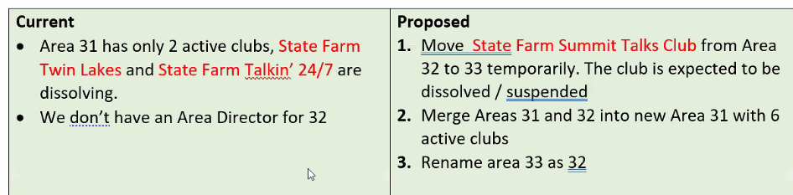

# *DISTRICT LEADERSHIP COMMITTEE*

Due to time constraints Chris Boyk, DTM, District Leadership Committee Chair, did not have an opportunity to present the committee report.

# *CLOSING THOUGHTS*

Noel Ganay, DTM, Area 12 Director, gave the closing thoughts.

Whatever you are try to be a good one;

Life begins at the end of your comfort zone;

‘What a feeling’.

All these represent the meeting and the year ahead. Directors are approaching this year differently after we’ve learned how to overcome difficult circumstances. The new year will challenge district leaders and give them a chance to shine and prove why we became Toastmasters.

# *ADJOURNMENT*

Motion to adjourn the meeting was made by Noel Ganay, DTM, Area 12 Director. Motion seconded by Bill Smola, Division A Director. Motion carried.

District Director Maryann Reichelt, DTM, adjourned the meeting at 11:02 am.

Respectfully Submitted,

Kari Susairaj, EC5

District 54 Administration Manager, 2021-2022

# *APPENDIX*

**Finance Manager Reports**

* D54 DEC Financial Report May 2021



* Allocation of remaining $1150 certificates



**Division B Report**

DivB Report July 2021

Laura Hansen

Div B Mission Statement: To create skilled leaders and communicators who enrich, impact, and inspire our society to forever improve.

Div B - what do I envision?

1. Increase our interaction with others, SHARING STRATEGIES used in Toastmasters Clubs.

2. FURTHER COMMUNICATE THE BENEFITS of Toastmasters - with people inside of and outside of the club.

3. Use those conversations to INCREASE educational goals and membership numbers.

4. TRANSFER conversations into ACTIONS while having fun.

What can D54 do?

1. Visit our clubs to help officers figure out the UNIQUE aspects of each club.

2. Celebrate and market what makes EACH CLUB unique.

3. Actively demonstrate use of the vast RESOURCES on the d54tm website.

**Division C Report**

Division C Report

The Division started t his new year with a goal t o rebuild our clubs and ensure our members are

achieving t heir professional and personal goals as a Toastmaster. As t he re-aligned Division C,

there are 4 l ess paid clubs, l ess members. However, t he Division ended with 4 clubs achieving

their DCP goals:

Select Distinguished - Talk of t he South and Four Seasons

Distinguished - State Farm Oaks; Pioneer Club, State Farm Speakeasy Club and ADM

Toastmasters.

Clubs are continuing t o meet online, exploring hybrid options and i n-person social gatherings.

Sunrise Speakers has partnered with Talk of t he South i n Aurora and Thursday Noon Talkers i s

jointly meeting with t he Landmark Toasternasters. Of note, Sunrise Speakers club i s celebrating

its 45th Anniversary as t he f irst club at Country Financial. At t his writing, t he response i s

outstanding.

Our challenge remains navigating t he new corporate workplaces and engaging a community

that i s re-opening i n t he midst of uncertain Covid outlook. We l ook t o collaborating with District

leadership f or expertise i n f orming new clubs, continuing with t he excellent t raining t hat we

experienced at t he concluding Summer TLIs.

There i s a new energy brewing i n Division C. As t he new Division Director, I am i ncredibly

blessed t o have t he drive and energy of t he new Division C Directors - Susie Ryan f or Area 30,

who aims t o build new clubs at Ameren; Gary Vaughn, t he proposed Area Director f or both Area

31 and Area 32, essentially State Farm clubs, and Gary Ohler, f or using his Scout Master

leadership skills f or Area 33. Gary Vaughn has already started his Area Director year by

inducting new officers f or Landmark and TNT.

Yours Trully,

Jennifer Ho

Division C Director

**Public Relations Manager Report**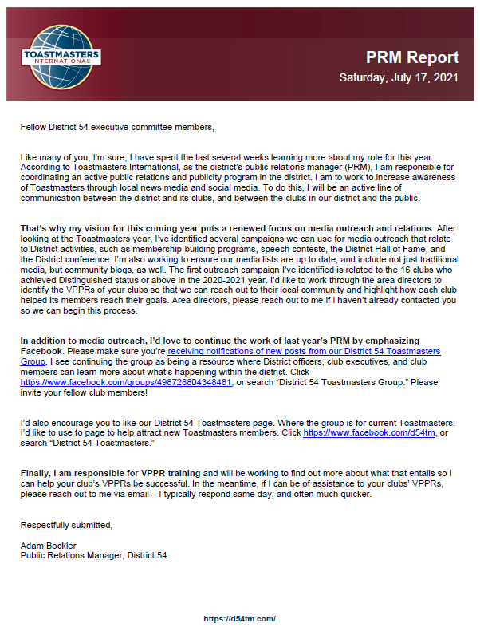

**District Director Report**

