District 54 Council
Meeting Minutes

  - Saturday, September 18, 2021

Virtual Zoom Meeting

TABLE OF CONTENTS
OPENING ………………………………………………………………….…………………...…….………3
WELCOME ……………………………………………………………………………………………………3
INSPIRATION …………………………………………………………….…………………………………..3
OUR DISTRICT VISION, MISSION AND CORE VALUES ………………………….…………………..3
ROLL CALL/QUORUM CERTIFICATION ..………………………………………………………………..4
ADOPTION OF AGENDA ……….……………………….……………...…….……………….…….……..4
VOTING PROCEDURES ……………………………………………………………………………………5
CREDENTIALS COMMITTEE REPORT …………………………………………………………………..5
ADMINISTRATION MANAGER …………………….………………………………………….…………...5
DIVISION C REALIGNMENT OF CLUBS ……………………………………………………………….5/6
APPOINTMENT OF DISTRICT OFFICERS …………………………………………………………........7
DISTRICT SUCCESS PLAN ………………………………………………………………………………..7
DISTRICT BUDGET ………………………………………………………………………………………….8
YEAR-END AUDIT …………………………………………………………………………………………...8
FINANCE MANAGER…………………………………………...……………………………………………8
DIVISION A..…………………………………………………………………………………………………..9
DIVISION B …………………………………………………………………………………………………...9
DIVISION C …………………………….……………………………………………………..………………9
DIVISION D …..……………………………….…………………………………………………………….10
PUBLIC RELATIONS MANAGER…………………………………………………………………………10
CLUB GROWTH DIRECTOR…………….………….………………………………………...................10
PROGRAM QUALITY DIRECTOR……….…………………….………………………………….………11
DISTRICT DIRECTOR…………………….………………………………………………………………..11
OLD BUSINESS……………………………………………………………………………………………..11
OPEN DISCUSSION/Q&A………………………………………………………………………………….11
NEW BUSINESS…………..…………………………………….…………………………………………..12
CLOSING THOUGHTS ………...…………………………………………………………………………..12
ADJOURNMENT ………..………….………………………….…………………………………..………..12

OPENING
Michael Bradford, Logistics Manager, called the meeting to order at 9:15 am. He led us in the Pledge of Allegiance.

WELCOME
Maryann Reichelt, DTM, District Director, welcomed everyone to the meeting by sharing a quote from J.R.R. Tolkein “The world is indeed full of peril, and in it there are many dark places; but still there is much that is fair, and though in all lands love is now mingled with grief, it grows perhaps the greater.” This reflects what clubs have been navigating in the current situation.

She facilitated the District 54 Council Meeting.

INSPIRATION
Michael Bradford, Logistics Manager, gave the inspiration. If you want to live a happy live, tie it to a goal, not a person or thing. Participate in meetings and don’t just sit and listen if you want to be a great speaker and leader. Do speeches to improve, show leadership, join the DEC team. If you want to be a great speaker, make it a goal and participate!

OUR DISTRICT VISION, MISSION and CORE VALUES
The reading of Our Vision and District Mission was led by Louis Kreppert, Area 11 Director.

District Vision
Move from a slow-moving dream to a vibrant District where all members, current and new, achieve their goals.

District Mission
We build new clubs and support all clubs in achieving excellence.

District Core Values
We strive to adhere to the following core values:
- Integrity
- Respect
- Service
- Excellence

DISTRICT OFFICERS IN ATTENDANCE

Present | First | Last | Designation | Office
X | MARYANN | REICHELT | DTM | DISTRICT DIRECTOR
X | DAN | KYBURZ | DTM | PROGRAM QUALITY DIRECTOR
X | HEATHER | BLASE | DTM | CLUB GROWTH DIRECTOR
X | ADAM | BOCKLER | LD5 | PUBLIC RELATIONS MANAGER
X | KARI | SUSAIRAJ | EC5, PM2 | ADMINISTRATION MANAGER
X | ABRAHAM | GUNASEELAN | IP3 | FINANCE MANAGER
X | BALA | SREEDHARAN | DTM | IMMEDIATE PAST DISTRICT DIRECTOR, NV
X | MICHAEL | BRADFORD | ACB, ALB | LOGISTICS MANAGER, NV
X | WILLIAM | SMOLA | IP1 | DIVISION A DIRECTOR
 | LAURA | HANSEN | LD5, VC2 | DIVISION B DIRECTOR
X | JENNIFER | HO | MS1 | DIVISION C DIRECTOR
X | MARTHA | SOJKA | IP3 | DIVISION D DIRECTOR
X | RACHEL | SCANLAN | IP5 | AREA 10 DIRECTOR
X | LOUIS | KREPPERT | DTM | AREA 11 DIRECTOR
X | NOEL | GANAY | DTM | AREA 12 DIRECTOR
X | JANA | HERGERT | PM4 | AREA 20 DIRECTOR
X | PATRICK | OLSON | DTM | AREA 21 DIRECTOR
X | LAKSHMI | GOPALAKRISHNAN | PM4 | AREA 22 DIRECTOR
 | TBD |  |  | AREA 23 DIRECTOR
 | TBD |  |  | AREA 30 DIRECTOR
X | GARY | VAUGHN | DL3 | AREA 31 DIRECTOR
 | TBD |  |  | AREA 32 DIRECTOR
X | GARY | OHLER | PM2 | AREA 33 DIRECTOR
 | KRISTIAN | KIND | PI4 | AREA 40 DIRECTOR
 | DALE | POSONT | DL1 | AREA 41 DIRECTOR
 | DARREL | FELTY | DTM | AREA 52 DIRECTOR

ADOPTION OF COUNCIL MEETING AGENDA
Maryann Reichelt, DTM, District Director, reviewed the agenda for the meeting.

Changes to the agenda included:
- Division B report will be given by Bill Smola, Division A Director.

Noel Ganay, DTM, Area 12 Director made the motion to adopt and Bill Smola, Division A Director seconded the motion. No opposition; agenda accepted as amended.

VOTING PROCEDURES
Jim Dickson, DTM, District Parliamentarian reviewed voting procedures.
Special rules listed under D54TM.com site.
Special Rules of Order

CREDENTIALS COMMITTEE REPORT

Bala Sreedharan, DTM, IPDD gave the credentials committee report. He thanked Chris Boyk for helping with role call and certification.

- 59 paid clubs in district, clubs each get 2 votes
- 1/3 need to attend for quorum- number is 39
- Number who attended meeting: 43, therefore we have a quorum.
- 17 DEC members represented- don’t count towards quorum in this meeting
- 60 ballots available- 31 votes is majority

ADMINISTRATION MANAGER
Kari Susairaj, Administration Manager, amended the May Council Meeting Minutes as follows.

- Amendments to May meeting- Jen Ho elected as Division C

Dan Kyburz, DTM, Program Quality Director, made motion to adopt changes to May 1 council minutes, seconded by Patrick Olson, Area 21 Director. Motion passed

The meeting minutes and all other meeting-related documents are now housed on the D54 website. The meeting minutes were reviewed and approved beforehand by the D54 Trio. Therefore, no additional approval is needed during the meeting.

DIVISION C REALIGNMENT OF CLUBS
Maryann Reichelt, presented the Division C Realignment to merge Areas 30 and 31.
DivCRealignmentProposalSep2021

Debra Toohill, raised the following objection
- Speech contest- with 2 clubs being eliminated will they be able to send one or two contestants?
Chris Boyk, DTM, point of order
- Clubs dissolved, but they were still included in numbers at beginning of the year.
- Speech contestants determined by numbers at beginning of year.
  - Area 32 would only be able to send 1 contestant from each club either way
- Needs motion to pass
Maryann Reichelt, DTM, District Director, spoke to TI about being able to make change mid-year.
- Normally realignment can’t occur mid-year but with 2 clubs dissolving in Oct, it leaves area with 2 clubs which isn’t acceptable.
- Therefore, motion can be made to change.
- Must have 4 active clubs in area (also no area 32 director).
Further discussion:
- Disbanded clubs cannot be moved to own area.
- With the realignment, bases for affected areas will change.
- Realignment helps area success rules- 80% of club reports done by area directors.
  - If there are only 2 clubs area success rule is impossible to meet considering disbanded clubs were counted in base number.
- From the speech contest rulebook:
  - Eight (8) weeks prior to the Area contest, if an Area has four (4) assigned clubs or fewer in good standing, Districts have the option to allow two (2) contestants from each club to compete in the Area contest.
  - Should additional clubs charter prior to the Area contest, two (2) contestants from
each club are permitted to compete.

Jana Hergert, Area 20 Director made motion to adopt the Division C realignment as presented. Dan Kyburz, DTM, PQD seconded the motion. Motion passed.
Gary Ohler will become Area 32 Director

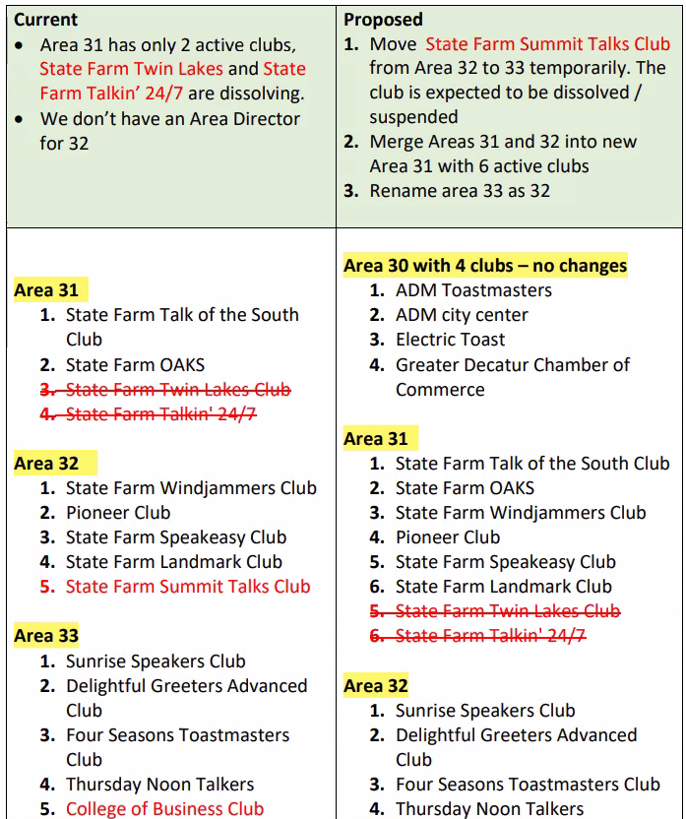

APPOINTMENT OF DISTRICT OFFICERS
Maryann Reichelt, DTM, District Director, presented slate of district officers.
Chris Boyk, DTM, asked about Area 30- Susie Ryan stepped down as Area Director

Without objection, the following officers are confirmed in the appointment positions.
District Officers to be Confirmed
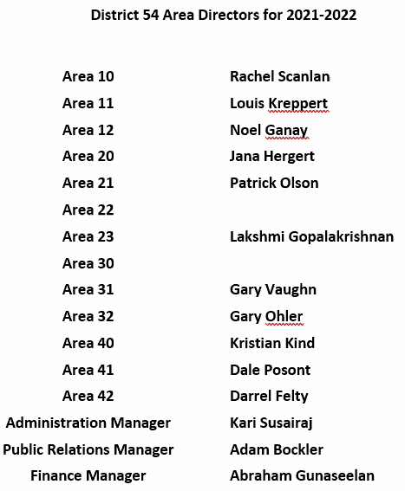

DISTRICT SUCCESS PLAN
Maryann Reichelt, DTM, District Director, presented the district success plan.

The report is posted on d54tm.com.
Toastmasters International District Success Plant

Jon Greiner, DTM, PIP, stated that Tony Koury is shown as prison club audit committee chair, but it should be Jason Heissler, DTM.

DISTRICT BUDGET PRESENTATION
Maryann Reichelt, DTM, District Director, shared the district budget.
- $5k less than last year due to declining membership.

D54 2021-2022 Annual-Budget

YEAR-END AUDIT REPORT
Abraham Gunaseelan, Finance Manager, presented the year-end audit report.

Audit committee was satisfied with outcome. All district financial records were made available and have been certified. District funds were authorized and aligned with mission.

TM-D54-2020-2021-YearEnd-AuditReport

FINANCE MANAGER
Abraham Gunaseelan, Finance Manager, gave the finance reports from July and August. Report submitted and attached.

August might need to be reviewed next meeting after fully done and reconciled.

Total available funds July- $23,164.42
Total available funds August- $23,645.50

No objections, report will move to archived.

Division Reports & PRM Report

The verbal reports were submitted by Division Directors in advance of meeting. The reports were presented in alphabetical order.

DIVISION A
Bill Smola, Division A Director, presented the Division A Director’s report. Report submitted and attached.

- Area directors have all club visits completed.
- Multiple clubs with new members in August
- Starting work on division success plan

DIVISION B
Bill Smola, Division A Director, presented the Division B Director’s report on behalf of Laura. Report submitted and attached.

- Jana Hergert, Area 20 Director, has all visits done and reports submitted.
- Patrick Olson, Area 21 Director, has all visits done and is working on reports.

DIVISION C
Jen Ho, Division C Director, presented the Division C Director’s report. Report submitted and attached.

- Creative clubs, meeting at park for hybrid meeting
- Some clubs meeting in person for employees back at work
- New members- area 30 has 5 new members

DIVISION D
Martha Sojka, Division D Director, presented the Division D Director’s Report. Report submitted and attached.

New Division D Mission: To develop sustainable and enjoyable clubs that are driven to create the best club experience for its members including progressive communication and leadership skills building, safe space environment and comradery.

PUBLIC RELATIONS MANAGER
Adam Bockler, Public Relations Manager, presented the Public Relations Manager report. Report submitted and attached.

- Focus on district success plan
  - Improve communication and awareness of what is going on in district.
  - Strengthening presence on Facebook page and group, follow on LinkedIn
  - Improve communication to members
    - Newsletter resurrected- edition will be published each month
  - Facilitate meetings with district club VPPRs

CLUB GROWTH DIRECTOR
Heather Blase, DTM, Club Growth Director, presented the Club Growth Director Report. No written report was submitted.

- Incentives are now available and can be viewed on d54tm.com site.
  - New Member Mania incentive ends October 31
  - Division Director Open House challenge ends October 31
- Call to action for club coaches
  - 4 people identified to fulfill club coach roles
  - Panel discussion with past coaches to build coaching program- late October
- Membership renewals due October 1

PROGRAM QUALITY DIRECTOR
Dan Kyburz, DTM, Program Quality Director, gave the Program Quality Director’s report. Report submitted and attached.

Highlights of report:
- Winter TLI needs 1 dean
- 75% of active clubs had 4 or more officers trained
- Trio decided area and division contests, TLI, district conference- all will be virtual for the rest of the year
- Pathways adoption
  - Leading R5 in member and officer adoption rate
  - Educations awards- 28 since last DEC meeting

DISTRICT DIRECTOR
Maryann Reichelt, DTM, District Director, presented the District Director’s Report, submitted and attached.

- District status reviewed- 59 active clubs, 1704 membership base
- Trio published district incentives on D54tm.com
  - District dollars credit will be used instead of gift certificates

OLD BUSINESS

Jen Ho, Division C Director, asked about credit for someone who served in a district level committee.
- To view a list of projects and ideas, go to the d54tm.com site

OPEN DISCUSSION/Q&A
Patrick Olson, Area 21 Director, asked about the pathways coordinator positions and what are the requirements?

NEW BUSINESS
Heather Blasé, Club Growth Director, introduced District dollars, which are new for incentives. FAQ on incentives page on d54tm.com
District Dollars Program:
- Pain of redeeming gift certificates
- New program to earn credit from incentives
- Used to purchase items on district store
- Let district know what to order to help with burden- works as a credit
- Working on dashboard/spreadsheet to show who has earned what

Reminder of the October DEC meeting, training, president’s luncheon and Hall of Fame ceremony:
October 16- Uptown Grill in La Salle will be in-person. Starts at 9, setup starts at 8:30
Hall of Fame will be done as well. Last years’ DEC members should submit nominations on the form Bala Sreedharan, DTM, IPDD, will be sending out.

High level agenda:
1) DEC Meeting 9 - 10:30
2) District Leaders Training by Region Advisor 10:45 - 11:45,
3) Lunch and DTM ceremony 11:45 - 12:45
4) Hall of Fame Ceremony 1:00 - 3:00 pm

CLOSING THOUGHTS

Gary Ohler, Area 32 Director, gave the closing thoughts. When we see people as weak, we want to help them. When we see people as broken or damaged we want to fix them. This comes with feelings of superiority. Where do you need to have a different perspective on how you view people?

ADJOURNMENT
Motion to adjourn the meeting was made by Bill Smola, Division A Director. Motion seconded by Noel Ganay, DTM, Area 12 Director. Motion carried.

Maryann Reichelt, DTM, District Director adjourned the meeting at 11:08 am.

Respectfully Submitted,
Kari Susairaj, EC5
District 54 Administration Manager, 2021-2022

*If you experience issues opening embedded WordPad Documents please check that editing is enabled in Word.

