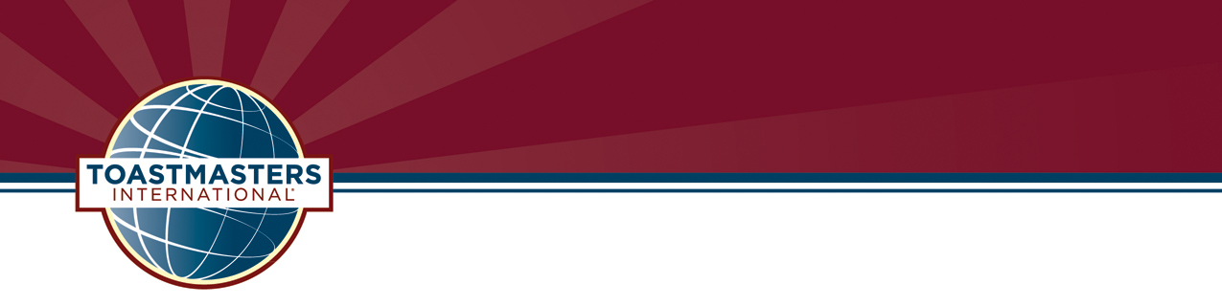

Dan Kyburz, DTM
Program Quality Director
District 54
dan.kyburz@gmail.com
https://d54TM.com
630-770-4993 (cell)

May 21, 2022

Program Quality Director Report

Team Members:

Program Quality Director – Dan Kyburz, DTM
District Training Coordinator – <open>
District Virtual Training Coordinator – Dan Kyburz, DTM
Summer 2020-2021 TLI Deans:
TLI#1 – Chris Boyk, DTM
TLI#2 – Jana Hergert, PM4
TLI#3 – Gary Vaughn, DL3
Winter 2020-2021 TLI Deans:
TLI#1 – Tony Koury, DTM
TLI#2 – Edward Slininger, DTM
TLI#3 – Bill Smola, VC3
Summer 2021-2022 TLI Deans:
TLI#1 – Darrel Felty, DTM, PDG
TLI#2 – Jana Hergert, PM5
TLI#3 – Abraham Gunaseelan, IP3
Spring 2021-2022 Conference Chairs:
Steve Cohen, DTM
Wendy Pesavento, DTM
Spring 2022-2023 Conference Chairs:
<Open>
<Open>
Pathways Support Coordinator – Ron Wroblewski, SR3 & Ceci Wroblewski, DTM
Youth Leadership & Speechcraft Coordinator – Wendy Pesavento, DTM

If you think you might be interested in one of the open positions, please see me, or download the job descriptions from the D54 website at https://img1.wsimg.com/blobby/go/1ce292cd-68e6-4e6a-a782-e34d1d55328b/District%2054%20Leadership%20Positions%20and%20Job%20Descr.pdf

Executive Summary:

We still have several open staff positions. Please check out the website for more information. Most important are the District Training Coordinator, and District Virtual Training Coordinator.

Since the Dashboard has not been updated since April 24 we don’t know the current status of our clubs. As of the last update we have 14 clubs with 5-6 DCP goals, two clubs with 7-8 DCP goals, and one with 9 DCP goals. We have one club, State Farm Windjammers which is Distinguished, and one club New Lenox which is President’s Distinguished.

Dues were due by March 31, 2022, for April 1, 2022, to September 30, 2022 period. Unfortunately, we have not been able to enter new members or renewals since April 24. it will be at least May 23 before you can enter new members and renewals. Now is the time your clubs should be reaching out to the members to renew. We have 46 paid clubs and 7 unpaid clubs. Of the 7 unpaid clubs, I believe we will be able to retain 6 of them.

Officer elections should have been held at the first meeting in May. If you had your elections don’t forget to update the officer list in Club Central. If you have not had your elections yet, you need to do so ASAP. A club is required to have a minimum of three officers: President, Vice President, and Secretary or Secretary/Treasurer, and each of these offices must be held by a different person.

All Area Directors submitted at least 75% of their Round 1 Area visit reports, which is the minimum required to qualify for the DCP. Round 2 Area visits should be made between December and May, preferably December through the end of April. Forty-six (46) Area Director reports have been submitted. Eleven (21%) of them are incomplete. Fifteen (23%) have not been entered. Area Directors, please verify your reports are complete when submitted. They must be entered and completed by May 31 to get credit for the DCP.

2022 Summer TLI. Planning for the Summer TLI has started, but we still have a long way to go. The TLI Deans are Darrel Felty, DTM, PDG for TLI# (June 25, 2022), Jana Hergert, PM5, for TLI#2 (July 18 & 19, 2022), and Abraham Gunaseelan, IP3, for TLI#3 (July 24, 2022). If you are interested in participating in the planning and execution of the 2022 Summer TLI, please let me, or Bonnie Tippey, DTM.

The 2023 Conference is on April 21 & 22, 2023. We are looking for two co-chairs. This is a great opportunity to earn your High Performance Leadership Project (HPL) or to complete your Distinguished Toastmaster Project. Please let me or Bonnie Tippey, DTM, know if you are interested.

*** No Pathways Adoption Rate Update Available ***

*** No Education Goals Update Available ***

Next month’s Area and Division Director training at the DEC is Turn Over between the outgoing and incoming officers.

Please let me, or Bonnie Tippey, the incoming PQD, know what training you would like to see at the monthly DEC meeting. Also, reach out to your clubs and find out what training they would like to see the district provide at our monthly webinars.

Program Quality Incentives: Please visit the District 54 website to view the incentives - https://d54tm.com/incentives

District Dollars Tracking Report: Embedded. Check out the clubs and the incentives they have earned.

Sharing Ideas: One of the great things about Toastmasters is their willingness to share ideas. I would like to have monthly training webinars to help members, and clubs with ideas to improve club quality and enhance the member experience. Please let me know what you want to see.

Respectively Submitted,
Dan Kyburz, DTM
Program Quality Director
630-770-4993 (cell)

“Where Leaders are Made.”

