Your Assignment: Distinguished Club Status:
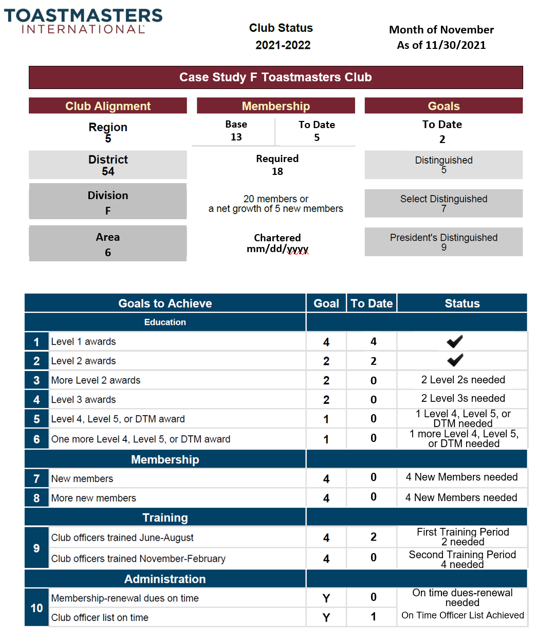
- Situation Analysis
  - Review the Distinguished Club Plan status ➔
  - Review the highlighted “What Could Be Improved” areas in your assigned Case Study
  - Determine the underlying reasons for each of the identified issues
- Solution Analysis
  - What are the potential causes and solutions for each area?
  - What resources are needed to implement those solutions?
  - What is your action plan? Please be specific
- Plan Documentation, Reporting, and Action Plan
  - What are the next steps to implement the above action plan?
  - Where can you document the above findings and action plan?
  - How will you assure follow up and action is being taken?
  - Please be prepared to share your findings with the general session (2 minutes max). Be sure to select a spokesman before returning to the general session.
