

Finance Manager Report

District 54 District Council Meeting

December 20th, 2025

Elias Hayes
District 54 Finance Manager – 2025-2026
email:elihayes194 @gmail.com

BALANCES

District Reserve Statement – as of date:10/31/2025
The reserve account balance is $27,965.92. We had a membership revenue of $1,315.00and had $1,928.15 in expenses for the month of September.
* Minimum District Reserve Required at Year End: $5 ,843.13

Bank Statement – as of date: 10/31/2025
The checking account balance is $1,967.99. We had no bank account activity this month

PROFIT & LOSS STATEMENT
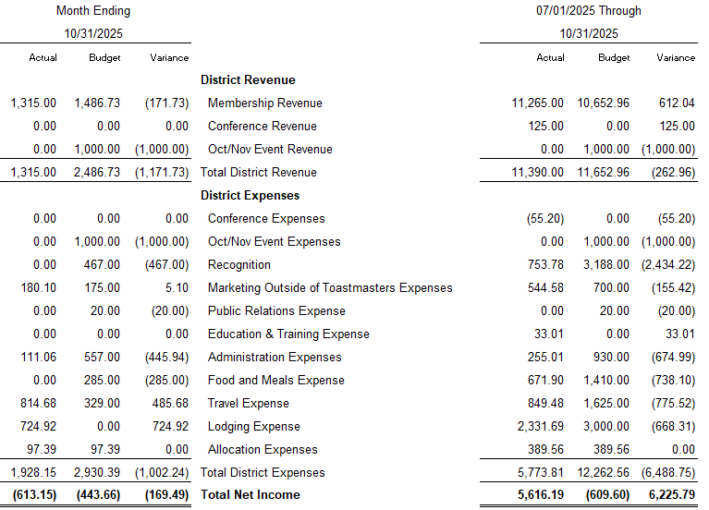

TALKING POINTS

We collected under the expected amount in membership revenue for October by $171.73, but still ahead over all for the year so far by $612.04. We did not end up host an Oct/Nov Event this year, so we did not receive any revenue or cost any expenses for this event to the budget. Hall of fame recognitions item and food/meal will be expensed in November. Outstanding convention expenses have been reimbursed. Partial administration expenses budgeted for the month of October unused due to when budgeting expect higher website costs and Hall of fame room rental combined with food/meal expenses.

