

Finance Manager Report

District 54 District Council Meeting
March 21st, 2026

Elias Hayes
District 54 Finance Manager – 2025-2026
email:elihayes194 @gmail.com

BALANCES

District Reserve Statement – as of date: 01/31/26
The reserve account balance is $24,482.85. We had a membership revenue of $655.00 and had $1,156.74 in expenses for the month of January.
* Minimum District Reserve Required at Year End: $5 ,843.13

Bank Statement – as of date: 01/31/26
The checking account balance is $1,203.79. No bank activity for the month of December

PROFIT & LOSS STATEMENT
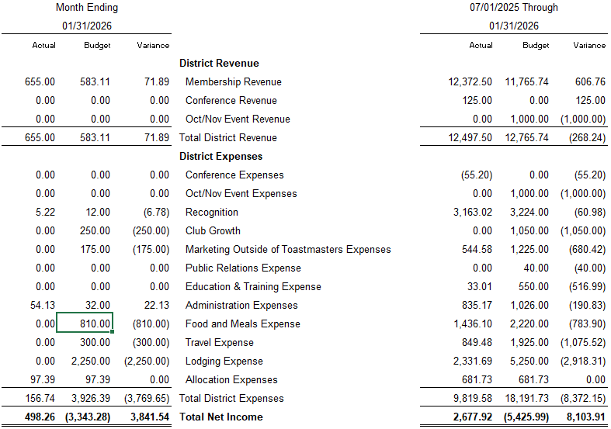

TALKING POINTS

We collected over the expected amount in membership revenue for January by $71.89 and ahead overall for the year so far by $606.76. The first conference venue payment came through $1000, but not showing in the profit and loss. We had a $40 dollar storage rental cost and $19.35 for shipping education rewards.

