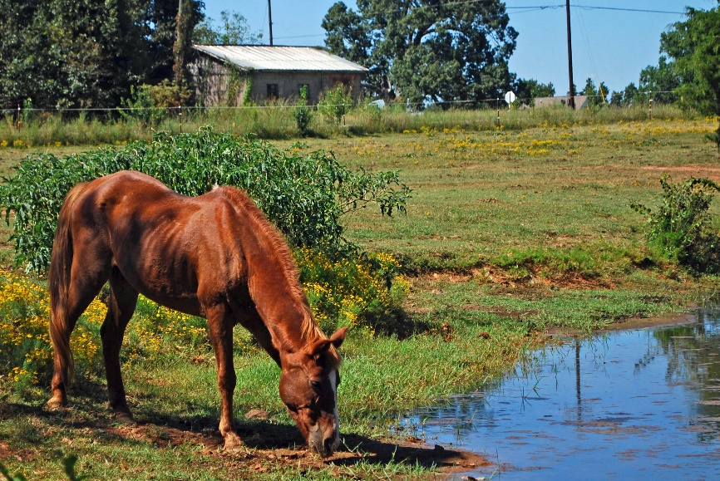
Visitation Policies
​
For the safety of our members and all others who may visit the Horse Protection Society, we have set the following guidelines regarding visitation to the sanctuary:
- ​Any child, whether a member, visitor, or someone touring the facility, must be accompanied and supervised by their parent or guardian at all times.
- If you are a volunteer and considering becoming a member, please limit your visits to the ranch to Saturdays only and call to schedule a time.
- Wear closed-toed shoes for safety.
- Leave all food and drinks in the car.
- Visitors must sign a waiver and the visitor sign-in sheet.
​
Member Visitation Policies
- Members of the Horse Protection Society are welcome any day during daylight hours.
- Members are allowed to bring adult guests, however; you must have each of your guests sign-in on the “Visitors Sheet”.
- Drinks and snacks may be left in the office. The horses are on strict diets so please do not bring food to barns/pastures.
- Wear closed-toed shoes for safety.

