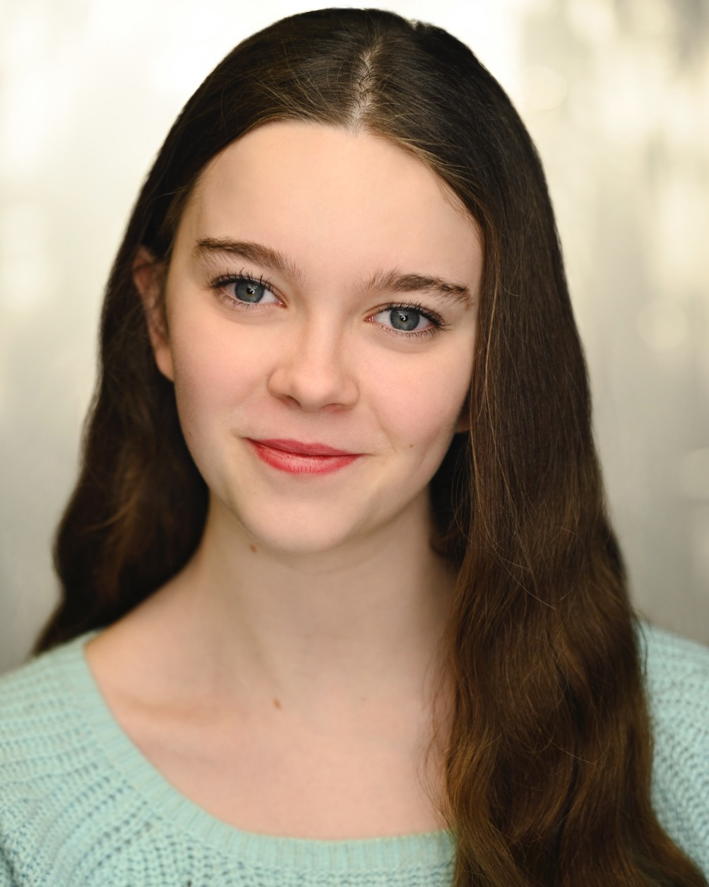
TALITHA LANG
D.O.B: 10 July 2008
Height: 5ft4 (165 cm)
Eyes: Blue- Grey
Hair: Medium brown
Accents: RP, London, French, Cockney, American, Australian
Voice: Soprano
School: Central London – Year 12
Nationalities: British, Belgian, Australian

Sharp, sporty and professional 16-year-old girl, qualified by directors as an “exceptional talent”, with “the voice of an angel”, who has “a great future ahead”.

Artistic Education
- Guildhall School of Drama, Double Drama Class, September 2023 – present
- National Youth Theatre, London, Summer drama classes, 2024
- Drama Scholar & A level Drama student, Francis Holland School
- Senior Chamber Choir member, Francis Holland School

Commercial Castings (2021, 2022, 2023)
- A1 Telekom, Christmas Commercial 2023
- NUTELLA, Main character, Love is the most precious gift, Christmas Commercial 2022
- McDonald’s, Teenage Matilda, Christmas Commercial 2021

Musical Castings (2020 to 2024)
- Audrey, Little Shop of Horrors, FHS Production, 2024
- Serena, Legally Blonde, FHS Production, 2023
- Wendy, Peter Pan in the Park, Chameleon Productions, Director: Steve Hulse, 2021
- Wizard of Oz, Child Ensemble, Brookside Theatre, 2020

Short-film Castings
- Lily (Lead), Boxes and Blankets (Student short film), Screenwriters Observations, Director: Bradley Rogers, 2021
- Aspen Larkins, Virtual Insanity (TV Series), The Black Swan Productions Director: Ethan Greene, 2021 (online)

Awards
- BEST ACTRESS for “Boxes and Blankets”, January 2022, Europe Festival UK
- Best short drama (cast) for “Boxes and Blankets”, Halicarnassus Film Festival, 2021
- Winner of the “KS Got Talent” senior school competition for a solo ventriloquism act, 2018

Skills
- Voice: Soprano, member of the school chamber choir
- Languages and accent: Fluent passive and strong active knowledge of French, perfect French accent
- Performing skills: ventriloquism, comedy, drama
- Sports: Tae Kwon Do Black Belt, third DAN, Competitive Swimmer & Skier

