InterStim® – Treatment

for Over-active Bladder

Bladder control problems affect millions of Australians.  If you’re one of them, you know how these conditions, like over-active bladder (OAB), faecal incontinence (involuntary loss of stool), and urinary retention can interrupt your life.

You may have tried changing your diet.  Or Kegal exercises and physical therapy.  Or medications with unpleasant side effects.  But the results just aren’t what you hoped.

Communication between your brain and bladder is critical.  That’s why conventional treatments may not produce the results you want- they don’t target the miscommunication between your bladder and brain.  
[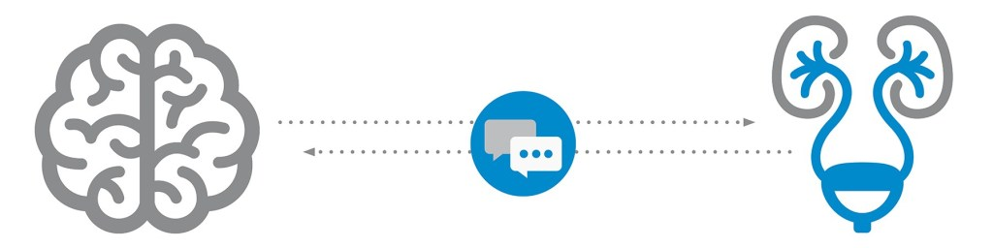](https://i2.wp.com/ouassociates.com/wp-content/uploads/2020/08/brain-bladder-communication-small.jpg?ssl=1)  
Unlike conventional treatments, Medtronic Bladder and Bowel Control Therapies delivered by the InterStim system uses gentle nerve stimulation to correct the bladder/bowel-brain communication pathway and restore bladder and bowel function.

Medtronic Bladder and Bowel Control Therapy delivered by the InterStim system restore bladder and bowel function by gently stimulating the sacral nerves.  It’s sometimes called sacral neuromodulation (SNM).  With this therapy, you may experience fewer trips to the bathroom, fewer accidents and more confidence as you get back to the activities you enjoy.

InterStim is safe, FDA/TGA-approved and minimally invasive.  It’s been helping people improve their quality of life for more than 20 years.

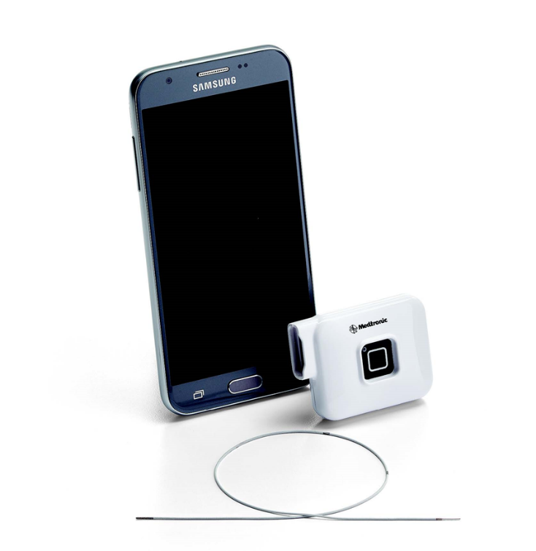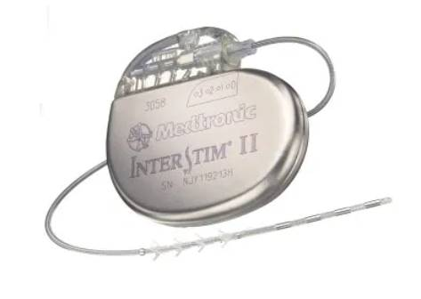

* 84% satisfaction among those who use it
* 3x greater improvements in quality of life compared to medications
* 82% of people have achieved success at 5 years with InterStim therapy
* 45% of people achieve complete continence at 5 years with In InterStim therapy

Unlike other bladder and bowel control therapies, InterStim is the only therapy that allows you to try it first.  It’s called an evaluation- like a test run, not a long-term commitment.

Here’s how it works

* The simple evaluation starts as day procedure
* A lead (thin wire) is placed in your upper buttock along the nerves that control your bladder
* The lead attaches to a small external device worn discreetly under your clothes
* Stop, start or adjust the therapy with a Samsung controller
* Go about most of your normal activities for 7 days
* Track your symptoms in a diary to see if they improve

After the end of your trial, talk with our team about the results.  Did it feel successful?  Did you see symptom improvement?  Together, we will decide if the long-term therapy is the right choice.  If it is, we can replace the external device with an implantable device called a neurostimulator during a short, day procedure.

FAQs

**Q: What is Medtronic Bladder and Bowel Control Therapy delivered by the InterStim system?**

A: This therapy targets the nerves that control your bladder and bowel to help it function normally again.

**Q: How does it work?**

A: Medtronic Bladder and Bowel Control Therapy delivered by the InterStim™ system restores bladder and bowel function by gently stimulating the sacral nerves.

**Q: Why does it treat the sacral nerves?**

A: It’s thought that bladder and bowel control problems are caused by miscommunication between the brain and the sacral nerves, which control the bladder and bowel and muscles involved in urination.

**Q: What are the benefits of this therapy?**

A: With this therapy, you may experience fewer trips to the bathroom, fewer accidents, and more confidence as you get back to the activities you enjoy.

**Q: What are the potential side effects or complications?**

A: Implanting an InterStim system has risks similar to any surgical procedure, including swelling, bruising, bleeding, and infection. Talk with your doctor about ways to minimize these risks.

**Q: What makes this therapy different than other options?**

A: It is the only advanced therapy for OAB that is clinically superior to oral medication. And it’s the only therapy that lets you try it first during an evaluation.

**Q: How long does the relief last?**

A: This therapy significantly reduced symptoms of OAB and non-obstructive urinary retention in people treated for 5 years. Your experience may be different.

**Q: Will this therapy cure my condition?**

A: No. It can be effective, but it’s not a cure. If the neurostimulator is turned off or removed, symptoms can return.

**Q: What does the stimulation feel like?**

A: Most people describe it as a slight pulling, tingling, or fluttering sensation in the pelvic area. It should not be painful. Stimulation settings can be adjusted, and sensations will vary from person to person.

**Q: Can I get an MRI when I receive this therapy?**

A: ONLY a Head MRI may be possible under specific conditions. For more information, talk with your doctor.

**Q: Will insurance cover the costs?**

A: Medicare and most private insurance companies cover this therapy. Speak with our team to learn more about your insurance coverage.

**Q: How long has this therapy been around?**

A: It is an FDA/TGA-approved therapy doctors have used to treat bladder and bowel control problems for nearly 20 years. More than 300,000 people have received this therapy.