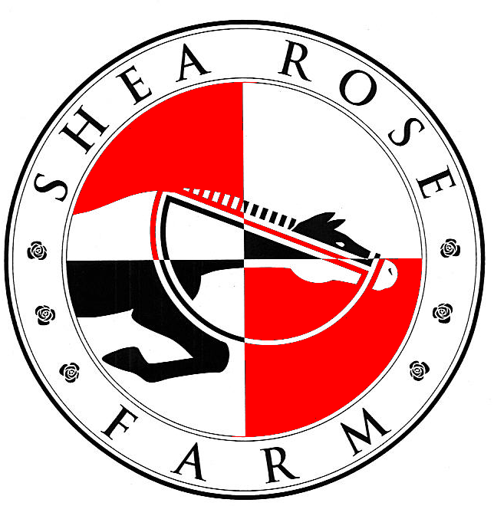
2021 SHEA-ROSE FARM SUMMER RIDING PROGRAMS

During the summer months, the regular lesson schedule is suspended due to hot weather and vacation schedules. There will be evening classes offered for adults and interested students at our regular rates ($100 Private, $50 Group). We accept new riders with no previous riding experience in the Standard Clinics and evening lessons.
Standard Clinics: are offered in the mornings to take advantage of the cooler weather and to allow for a more concentrated learning program. Students will spend one full day on Wednesday during the week to help prepare for a cookout that evening, at which the evening meal will be cooked over an open fire. The student will be responsible for the care of their horse and tack. Ring riding, trail riding, mounted games, vaulting and ground lessons are included. Groups are limited to 8 riders. No fluff, lots of time in the saddle! Ages 7 and up for riding, including adults!

Farm/Cook/Ride Clinic: will be standard morning rides and organic farming/cooking-taught by Carol Land, registered dietician and organic farmer with 50 years of experience.
Assistant Instructor Clinic: This is for older, more experienced students who want to assist at our Standard Clinics and who want to learn how to teach. Certified Horsemanship Association curriculum is followed, candidates teach lessons, role play students and are evaluated. There are 4 levels within this certification program. For more info: go to www.cha-ahse.org .
Mountain Trail Week: We will be offering a mountain trail riding session to ride at Pisgah Forest and DuPont Forest. Camping and riding in the cooler mountain areas of Brevard. Meals provided for the week. This trip is limited to 4 riders and riders should be at least an intermediate level for this trip.
Local Trail Clinic: We will take riders to local parks and greenways for trail riding.
Fees:
$350/rider for Standard and Assistant Instructor Clinics, $475 for Ride/Farm/Cook week, $450/rider for Local Trail Riding Clinic, $850 for Mountain Trail week, meals included.

Schedule:
Standard and Local Trail Clinics - 8:00 AM to 1:00 PM, Wednesday- the whole day. Ride/Farm/Cook -8:00 AM-5:00 PM, Assistant Instructor Clinic - 8:00AM to 3:00 PM.
Dates:
Session 1: May 31-June 4th Assistant Instructor Clinic-Carol
Session 2: June 7th-11th Local Trails Clinic – Carol
Session 3: June 7-11th Standard Clinic-Arleen
Session 4: June 14-18th Farm/Cook/Ride-Carol
Session 5: June 21-25th Standard Clinic- Carol
Session 6: June 28-July 2nd Standard Clinic- Arleen
Session 7: July 5-9th Standard Clinic- Arleen
Session 8: July 12-16th Standard Clinic-Arleen
Session 9: July 19-23rd Ride/Farm/Cook Clinic-Carol
Session 10: July 26-30th Local Trail Clinic- Carol
Session 11: August 2-6th Mountain Trail Week- Carol
Session 12: August 2-6th Standard Clinic- Arleen
Session 13: August 9-13th Adult Local Trail Clinic- Carol
Session 14: August 16-20th Mountain Trail Week- Carol

Special trip: Carol Land will be taking a group of riders to Devon, England June 26-July 3 for a week trail ride- https://www.dartmoorridingholidays.co.uk/ Riders must be 14 years or older to go! Point to point, western saddles on Quarterhorses and Paints!

REGISTRATION FORM FOR SUMMER CLINICS

Name:______________________________________________Age:___________

Address:________________________________________________________________

Phone:______________ Work Phone:______________ Cell Phone:____________________

Email Address: __________________________________________________________

Parent’s Names:__________________________________________________________

Describe Previous Riding Experience:_________________________________________

________________________________________________________________________

List Session Numbers you wish to attend:____________________

Pre-registration fee: $100.00 per rider per week (non-refundable, to be subtracted from remainder of clinic fee due on the first day of clinic).

Registration fee enclosed? ____________

Hold Harmless form with both parent’s signature enclosed? (if not already on file)______

Students are required to wear SEI/ASTM approved helmets, pants, shirts with short sleeves and boots with a small heel while riding.

Send form with payment [check made out to: SHEA-ROSE FARM, Inc.]

Shea-Rose Farm
2411 Waxhaw Marvin Road
Waxhaw, NC 28173

Any questions? Call Arleen at 704-607-6037 or email at Arleen321@yahoo.com Visit us on the web at: www.shearosefarm.com.

