

Integrative Path Therapies, LLC
Acupuncture & Massage

Dear New Patient,
Thank you for choosing Integrative Path Therapies for your acupuncture needs. We do our best to ensure that you will receive the highest quality of care.
My name is Gisela Herrera Pardo. I am an acupuncture physician. I have special interest in treating people who have musculoskeletal pain and disorders. These include neck and low back pain as well as more complicated conditions such as fibromyalgia, stenosis, and herniated disks causing chronic pain. I also enjoy treating people with emotional disorders, such as anxiety, depression, mild obsessive-compulsive disorder, and those individuals grieving. I believe emotions are a key component in most diseases. I like to guide people with nutrition, especially since there is so much information that contradicts itself.
Enclosed are 3 forms for you to print and fill out. Please bring these to your initial appointment. These forms include:
1. Initial visit intake form (pages 2-5)
2. Notice of privacy Policies (pages 6-7)
3. Arbitration/consent (pages 8-9)
Please eat at least two hours before your treatment. When you arrive, please let me know if you are nervous about the treatment, as it is common to be anxious.
Our address is 5190 26th Street West, Bradenton, FL 34207, Suite G. We look forward to meeting you!
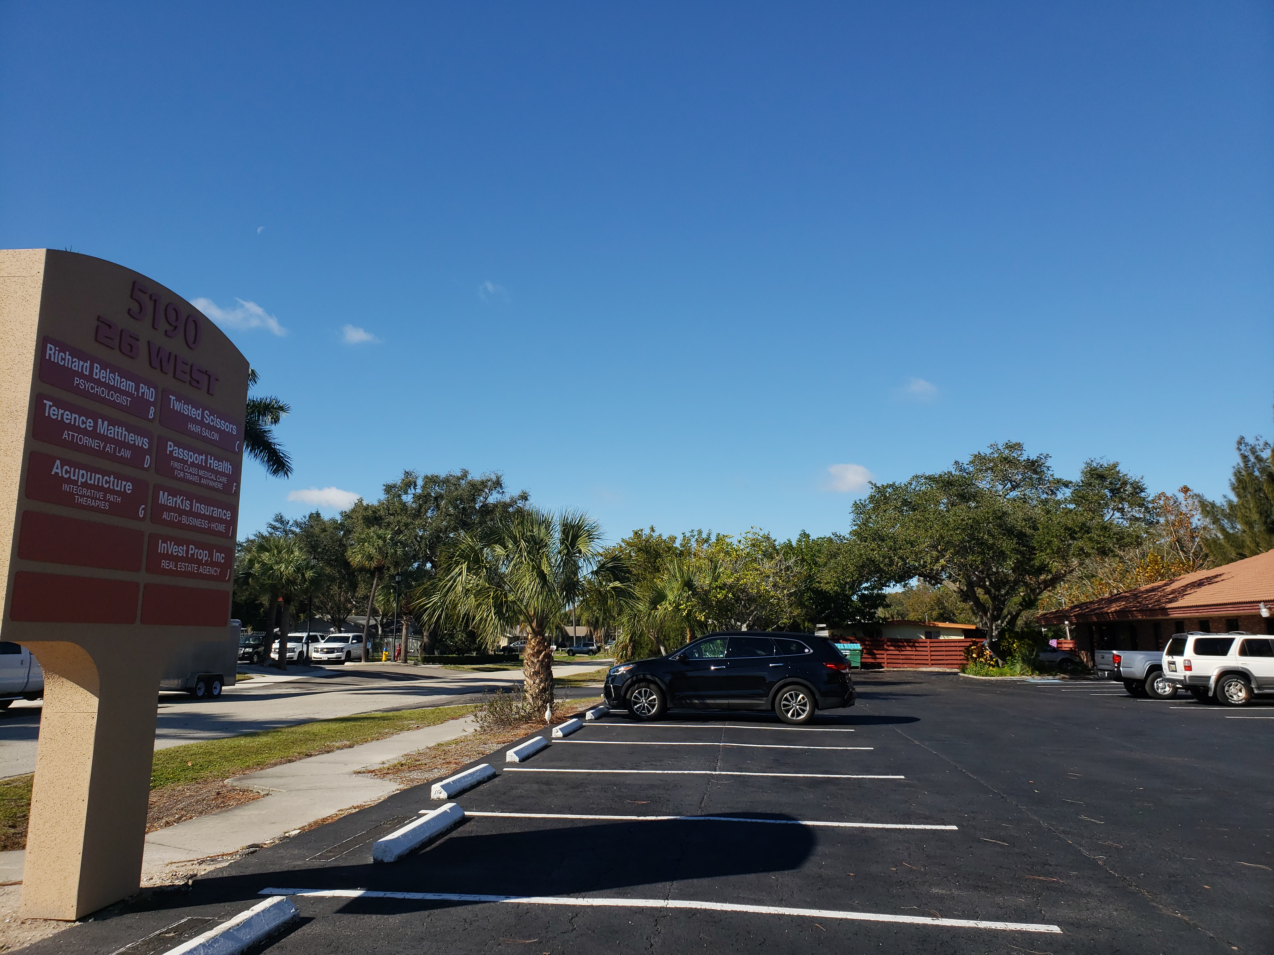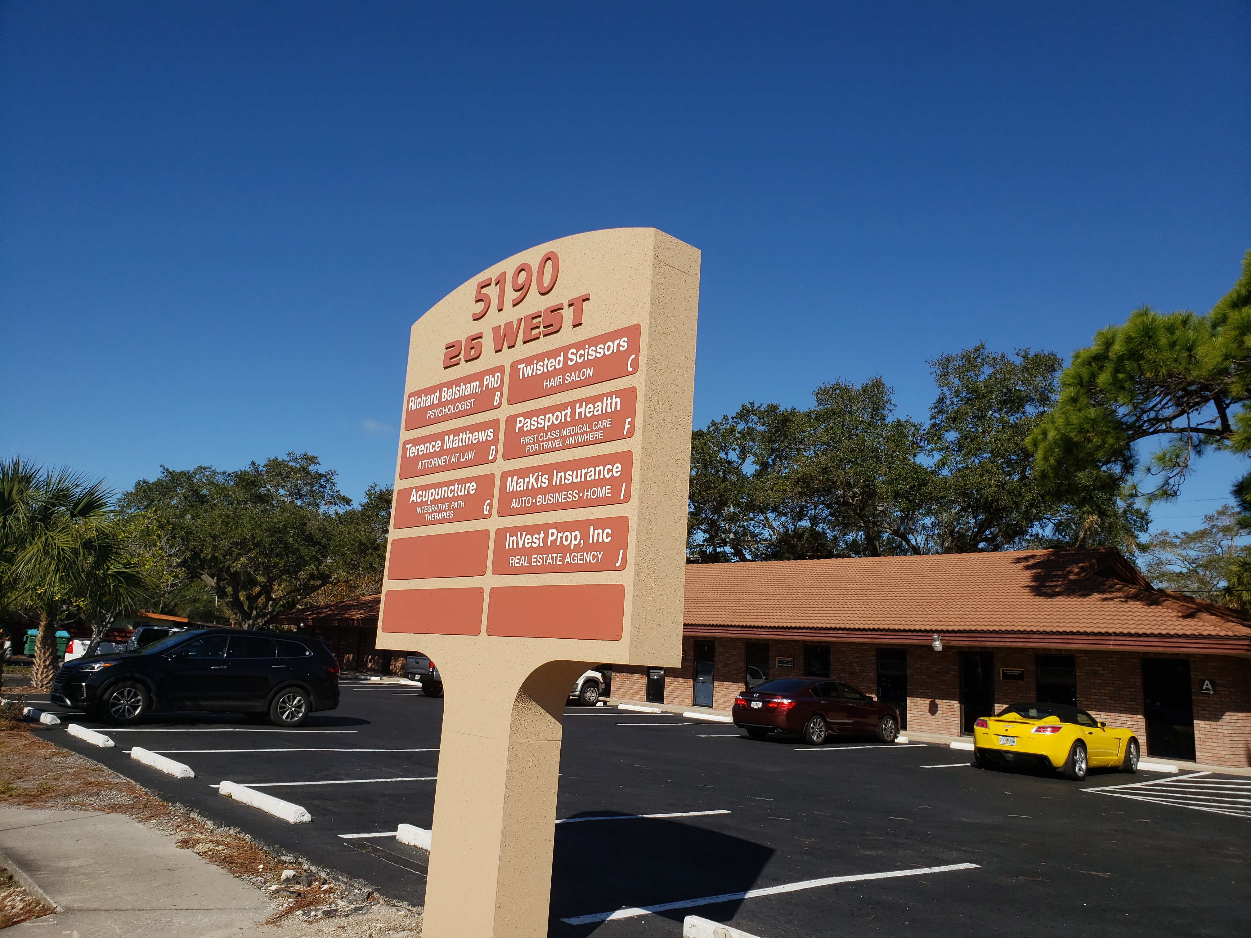
Warmly,
Gisela Herrera Pardo, DOM
Acupuncture Physician
Integrative Path Therapies, LLC
Acupuncture & Massage

Intake Form

Personal Information

Patient Name: _______________ __

Age: Birth Date: / / Gender: _ __
Address: _________________________________________________
City: _________________________ State: ______ Zip: ___________
Telephone (Day): (_______) ________ - _____________________
Telephone (Night): (_______) _______ - _____________________
Telephone (Mobile): (_______) _______ - ____________________

Email Address: _______________________________
Occupation: __________________________________
Referral Source: ________________________________
Emergency Contact: _____________________________
Phone: ________________________________________

Who is your primary health care provider/MD?
____________________________________________
Ins Carrier: ____________________________________
Member ID#: ___________________________________
Insured’s name: ________________________________
Group #: __________________________
Main Complaint
Please identify your 3 major health concerns
1.________________________  _________________________  How Long have you had this problem?  _________________________ | 2.________________________  _________________________  How Long have you had this problem?  _________________________ | 3.________________________  _________________________  How Long have you had this problem?  _________________________

- Have you been given a diagnosis for these problems? _______________________________________________
- What other treatments have you tried and what were the outcomes? __________________________________
__________________________________________________________________________________________

Personal Medical History (Please include your childhood history)

Illnesses
Surgeries
Significant Trauma (i.e. motor vehicle accidents, fractures, etc.)
Do have a history of current or past infectious disease? Please describe
Medicines (please list all medications, herbs, vitamins and over the counter drugs)
Allergies/Sensitivities (Please list any foods, drugs, medications or environmental factors which you are sensitive or allergic to)
General (please check all that apply)
❑ Poor Appetite | ❑ Changes in Appetite | ❑ Weakness | ❑ Tremors | ❑ Easy to Bleed or Bruise
❑ Hearing Loss | ❑ Night Sweats | ❑ Fevers | ❑ Cravings | ❑ Puffiness or Swelling
❑ Strong Thirst | ❑ Poor Sleep | ❑ Chills | ❑ Weight Loss | ❑ Sudden Energy Drops
❑ Poor Balance | ❑ Sweat Easily | ❑ Fatigue | ❑ Wight Gain | ❑ Other:

Skin and Hair
❑ Rashes | ❑ Hives | ❑ Eczema | ❑ Dandruff | ❑ Recent Moles
❑ Skin Ulcers | ❑ Itching | ❑ Pimples | ❑ Hair Loss | ❑ Other:

Head, Eyes, Ears, Nose and Throat
❑ Night Blindness | ❑ Dizziness | ❑ TMJ Pain | ❑ Smell Problems | ❑ Spots in front of eyes
❑ Cataracts | ❑ Headaches | ❑ Toothache | ❑ Sinus Problems | ❑ Recurrent Sore Throat
❑ Eye Strain/Pain | ❑ Concussions | ❑ Taste Problems | ❑ Ear Aches | ❑ Other:
❑ Blurry Vision | ❑ Migraines | ❑ Lip or Tongue Sores | ❑ Ear Ringing
❑ Floaters | ❑ Facial Pain | ❑ Nose Bleeds | ❑ Poor Hearing

Cardiovascular
❑ High Blood Pressure | ❑ Cold Hands or Feet | ❑ Swelling of Hands | ❑ Phlebitis | ❑ Low Blood Pressure
❑ Blood Clots | ❑ Swelling of Feet | ❑ Fainting | ❑ Irregular Heartbeat | ❑ Palpitations
❑ Chest Pain | ❑ Lightheadedness | ❑ Other:

Respiratory
❑ Cough | ❑ Phlegm | ❑ Asthma | ❑ Bronchitis | ❑ Coughing up Blood
❑ Pneumonia | ❑ Painful breathing | ❑ Easily Winded | ❑ Difficulty breathing | ❑ Other:

Gastro-Intestinal
❑ Nausea | ❑ Bad Breath | ❑ Chronic Laxative Use | ❑ Indigestion | ❑ Blood in Stools
❑ Constipation | ❑ Ulcers | ❑ Vomiting | ❑ Rectal Pain | ❑ Hemorrhoids
❑ Diarrhea | ❑ Abdominal Pain | ❑ Intestinal Gas | ❑ Belching | ❑ Other:

Urology
❑ Painful Urination | ❑ Decrease in Urine Flow | ❑ Cloudy Urine | ❑ Pain in Groin Area | ❑ Urgency to Urinate
❑ Frequent Urination | ❑ Kidney Stones | ❑ Sexually Transmitted Diseases | ❑ Unable to Hold Urine | ❑ Blood in Urine
❑ Frequent Night Urination | ❑ Other:

Neuro-Psychological
❑ Seizures | ❑ Twitches | ❑ Irritability | ❑ Poor Memory | ❑ Tremors
❑ Areas of Numbness | ❑ Lack of Coordination | ❑ Loss of Balance | ❑ Anxiety | ❑ Concussion
❑ Depression | ❑ Stress | ❑ Mood Swings | ❑ Other:

Gynecology
❑ Irregular Periods | ❑ Spotting | ❑ PMS | ❑ Fertility Problems | ❑ Menopausal
❑ Painful Periods | ❑ Vaginal Discharge | ❑ Clots | ❑ Yeast Infections | ❑ Breast Lumps
___ Age of menses
___ Duration of menses
___ Date of last menses
___ # of pregnancies
___ # of births

Musculo-Skeletal
❑ Arthritis | ❑ Muscle Spasms | ❑ Pain with Weather Changes | ❑ Muscle Weakness | ❑ Scoliosis
❑ Weak Joints | ❑ Pain with Activity | ❑ Pain after Waking | ❑ Other:
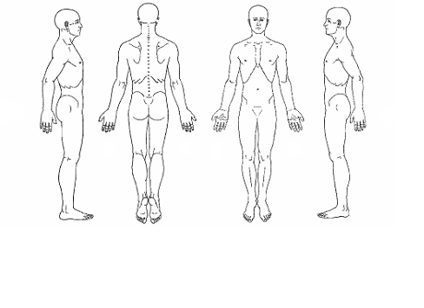

Please mark any areas of pain or discomfort:

AUTHORIZATION AND RELEASE
I authorize the release of any information including the diagnosis and the records of any treatment or examination rendered during the period of such care to third party payers and/or other health practitioners.
I authorize and request my insurance company to pay directly to the provider for any insurance benefits. If payments are issued to patient, patient will endorse check to provider and forward to provider upon receipt.
I understand that my insurance carrier may pay less than the actual bill for services. I agree to be responsible for payment of all services rendered. I understand and accept that I am financially responsible for any, and all charges incurred for professional services rendered to me. I also understand and accept that I am responsible for any charges incurred should collection proceedings become necessary to enforce this agreement.

FINANCIAL POLICY AND ARRANGEMENTS
We will be happy to bill your insurance and will accept their payment; however, any coinsurance and copay will be collected at the time service is rendered. Any difference will be included in our monthly statements and payments are expected upon receipt. Payment for service is due at the time services are rendered. Any patient responsibility transferred by your insurance is due immediately after is determined by your insurance and communicated by us through our monthly statements.

Cancelations: There will be a fee of $25.00 to the patient’s account for any last-minute cancelations. Any cancellations must be made at least 24 hours prior to your appointment.

No-Show: There will be a fee of $50.00 to the patient’s account for missed appointments. If a patient does not arrive 20 minutes after their appointment, it will automatically be considered a no show.

All returned checks are subject to an additional $35 fee.

I have read and understood the above.

Patients Name ____________________________________ Date ______________________

X____________________________________________

Integrative Path Therapies, LLC
Acupuncture & Massage

Notice of Privacy Practices
Our Clinic Protects Your Health Information and Privacy
Dear Valued Patient,
This notice describes our office’s policy for how medical information about you may be used and disclosed, how you can get access to this information, and how your privacy is being protected. Your health information may be used and disclosed by your acupuncture physician, our office staff and others outside of our office that are involved in your care and treatment for the purpose of providing health care services to you. Your protected health information may also be used and disclosed to pay your health care bills and to support the operation of the acupuncture physician’s practice.
In order to maintain the level of service that you expect from our office, we may need to share limited personal medical and financial information with your insurance company¸ with Worker’s Compensation (and your employer as well in this instance), or with other medical practitioners that you authorize.
Safeguards in place at our office include:
• Limited access to facilities where information is stored.
• Policies and procedures for handling information.
• Requirements for third parties to contractually comply with privacy laws.
• All medical files and records (including email, regular mail, telephone, and faxes sent) are kept on permanent file.
In administering your health care, we gather and maintain information that may include non-public personal information:
• About your financial transactions with us (billing transactions).
• From your medical history, treatment notes, all test results, and any letters, faxes, emails or telephone conversations to or from other health care practitioners.
• From health care providers, insurance companies, workman’s comp and your employer, and other third part administrators (e.g. requests for medical records, claim payment information).
In certain states, you may be able to access and correct personal information we have collected about you, (information that can identify you - e.g. your name, address, Social Security number, etc.).
We value our relationship and respect your right to privacy. If you have questions about our privacy guidelines, please call us during regular business hours at (941) 896-9328.

Patient acknowledgement of privacy practices:

_________________________________________________________ _____________
Patient name Date

_________________________________________________________
Signature: patient or representative

_________________________________________________________
Relationship to patient (if other than patient)

