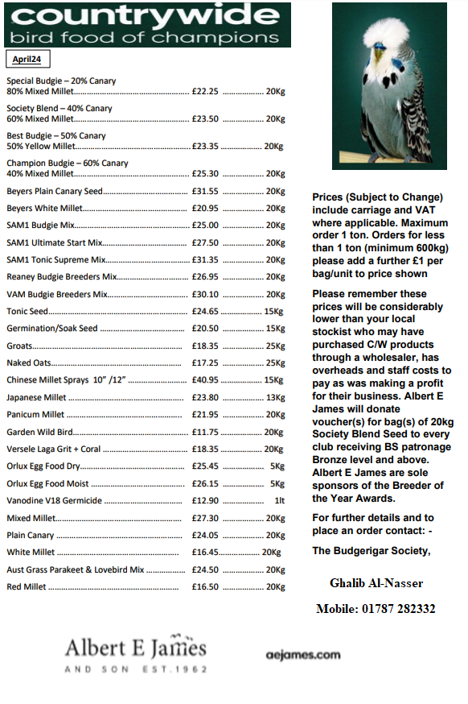
The Welsh Budgerigar Society
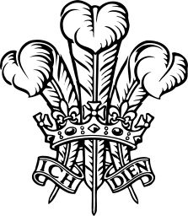

Area Championship Show 2024
To be held at
Llanwern High School, Hartridge Road,
Newport
NP18 2YE
On
Sunday 13th October 2024
(New date)
Judges :-
B.Reese,M.Gulley,R.Hooper & S.Rich

