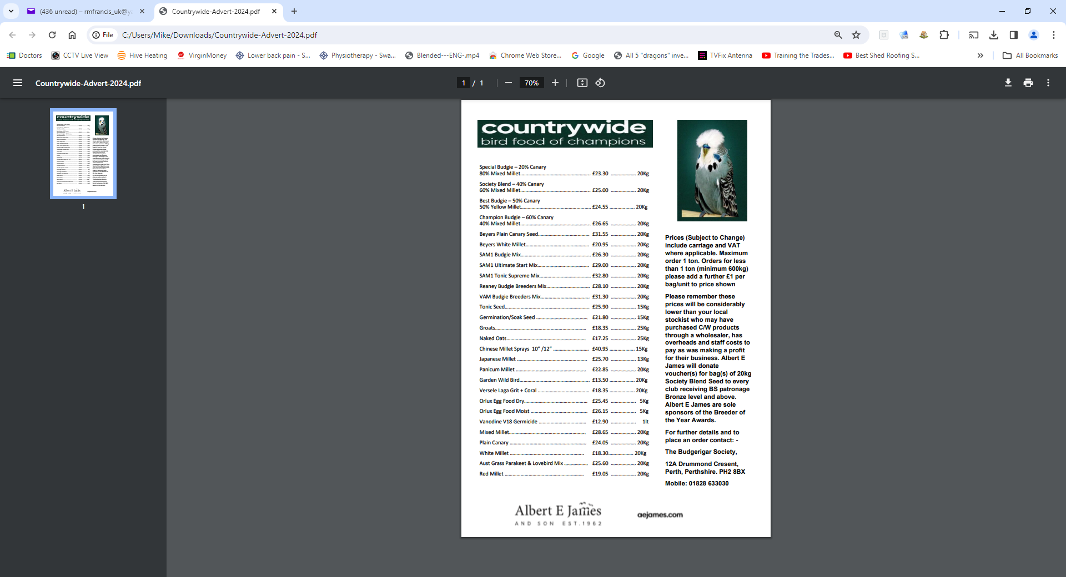

The Welsh Budgerigar Society


Young Stock Show 2024
To be held at
The Memorial Hall
Morriston, Swansea.SA6 6JR
On
Saturday
10th August 2024

Judge :- R.Hughes
Speaker :- C.Green

