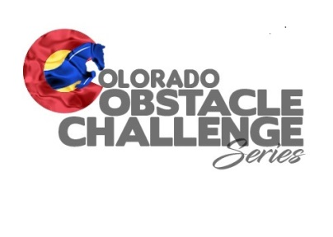
Competitor Information

- You may ride using tack from your chosen discipline.
- You are not expected to purchase any specific attire or tack, you are required however, when you compete, to wear the Show attire of your chosen discipline.
- A competitor will not be allowed to enter the course wearing T shirts, inappropriate shoes, worn out jeans, etc. This WILL result in a disqualification. This event is your chance to show yourself and your horse at your best.
- Your horse must be sound. The show host or judge of the Event has the final say as to whether or not a horse is deemed sound. If it is deemed unsound, any entry fees for that Event will be forfeited.
- Good Sportsmanship is mandatory. Any display of poor sportsmanship is subject to being removed from the grounds, with any entry fees for that Event being forfeit. This includes threatening or aggressive behavior to any Host, Judge, another rider, spectator, or any other person on the Event grounds. Tampering with another person’s horse or tack. Showing disrespect to any Host, judge, or any other person on the Event grounds.
- Alcohol is not allowed during Event hours. Any drugs other than prescription are never allowed.
- Each Event host will post details of their event, deadlines (if any) for entry fees, and pertinent information about their facility at least 2 weeks prior to the event. It is the competitors responsibility to keep updated and reach out to the host if there are any questions or concerns. *Any host club has the right and responsibility to call a show due to weather conditions or conditions beyond their control. Refunds of event fees will be part of the details of that event. It is up to the competitor to familiarize themselves with the event details prior to registration.
- It is the rider’s responsibility to be familiar with the current Colorado Obstacle Challenge Series rules. These are conveniently located on the website under the info tab, as well as on the Facebook page under files.

