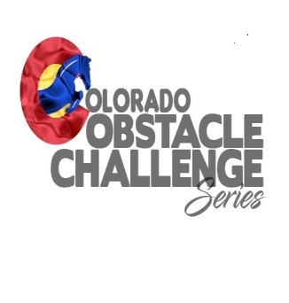2020 Host Information
As a host / facility you are representing Colorado Obstacle Challenge Series, as such, certain standards and expectations must be met.
Minimum expectations are as follows:
- As a host, you will determine if you wish to run an Arena event, or a Trail event or a combination of both.
- You are required to sign Hold Harmless waivers provided by Colorado Obstacle Challenge Series.
- You are required and expected to have ample parking for attendees, along with restroom facilities. Porta potties will be acceptable for the event if you do not have existing facilities.
- You are NOT required to have concessions, but, the Host must make it known at time of scheduling the Event whether concessions will be available. We suggest for concessions, contacting your local 4H or FFA Club, they typically can provide hamburgers, hot dogs, etc.…This is a great fund raiser for them, and is a great way for your location to be involved with your community.
- There shall be 2 judges per arena Event, provided by you, or provided by Colorado Obstacle Challenge Series to you for a fee. For a Trail Event or a combination of both, there shall be an adequate number of judges, with a minimum of 2.
- All judges will follow the approved Colorado Obstacle Challenge Series judging matrix. Judges need not be certified and are not required to pay any fees in order to judge.
- If the Host competes in their venue, they MUST make arrangements for non partial judges for the Division the Host rides in.
- You must use the registration sheets and judges score sheets provided by Colorado Obstacle Challenge Series. At the end of Event, you will turn in the sheets to the designated Colorado Obstacle Challenge Series Board member. If no board member is in attendance, you will mail them to: Cindy Williams 13660 US Highway 287 Eads CO 81036 within 3 days of the event.
- Host location will provide all obstacles, unless, prior arrangements for an obstacle(s) is made with Colorado Obstacle Challenge Series. We do have some portable items, however, there is no guarantee of availability.
- Host locations are responsible for collecting all registration fees and will receive 75% of the registration fees for all divisions except for the end of day jackpot race. Colorado Obstacle Challenge Series will receive 25% of registration fees for all divisions except for the end of day jackpot race. This 25% is used by Colorado Obstacle Challenge Series for end of year awards and operating expenses.
- The end of day Jackpot race is 100% payout to the Riders registered for that Event, with no monies from this race going to EITHER the Host OR Colorado Obstacle Challenge Series. Placings are for riders 1st through 3rd, 50%, 30%, 20% of the fees collected from the entries for the Jackpot race.
- Host site agrees to provide ribbons for placings 1st – 3rd for each Division except Leadline, There should be ribbons for leadline, but, they do not have to be the same ribbons as for the other Divisions. This of course, is the Hosts choice on which to provide for leadline,
- Colorado Obstacle Challenge Series will post every Event on the website calendar, and on the Facebook page. Hosts are encouraged to promote their Event as well.
- There is a 2 day limit per Event.NO MAJOR HOLIDAY WEEKENDS. Once Event is approved, Hosts of Colorado Obstacle Challenge Series are responsible for providing information for the promotional flyer with the following minimum details:
Host name, Event Date, Registration and Start time of event, Facility location with full physical
address, if concessions will be provided, point of contact info and logo.
- Colorado Obstacle will provide the template for information required for the website calendar as well as fb page.
- All flyers, forms, etc. used for each Event will be produced br Colorado Obstacle Challenge Series.

- Host / Facility is responsible for providing all support staff and volunteers.

